**UPPER MISSOURI WATERSHED ALLIANCE**

**UPPER MISSOURI RIVER WATER QUALITY**

**MONITORING PROJECT**

**Sampling and Analysis Plan**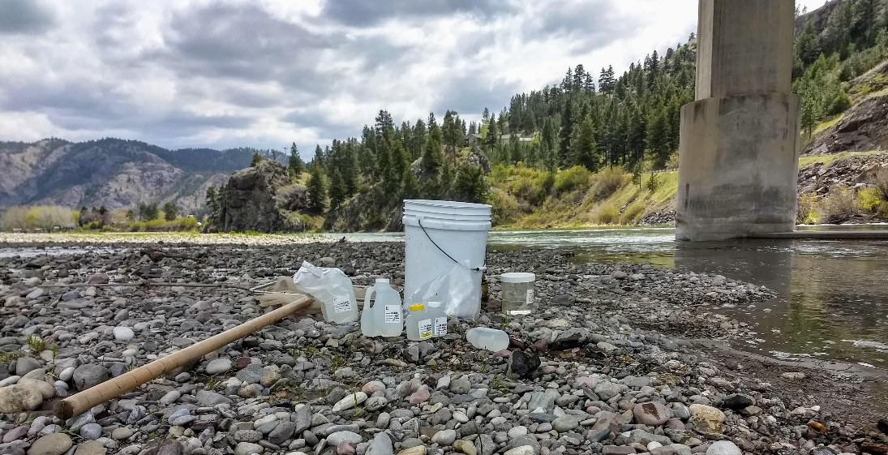

February 2022

**Prepared by:**

**Sherry Meador, Chair**

**Upper Missouri River Watershed Alliance**

68 Hill Brothers Road

Clancy, MT 59634

**Approved by:**

/s/ Abbie Ebert_____________________________________________ 5/4/2022____________

Abbie Ebert (Montana DEQ VM Lab Analysis Program Manager) Date

/s/ Katie Makarowski________________________________________ 5/4/2022____________

Katie Makarowski (Montana DEQ Quality Assurance Officer) Date

# Table of Contents

Table of Contents 1

1.0 INTRODUCTION 3

1.1 Project Overview 3

1.2 Project Area Overview 3

1.3 Project Team and Responsibilities 4

2.0 Objectives and Sampling Design 4

2.1 Project Goals and Objectives 5

2.2 Monitoring Locations 6

2.4 Water Quality Parameters 8

3.0 Field Procedures 8

3.1 Order of Operations 8

3.2 Field Forms 8

3.3 Data Collection Standard Operating Procedures 9

4.0 Laboratory Analytical Requirements 10

5.0 Quality Assurance/Quality Control (QA/QC) 10

5.1 Overview 10

5.2 Training 10

5.3 QC Samples: Field Duplicates 11

5.4 QC Samples: Field Blanks 11

5.5 Instrument Calibration and Maintenance 12

5.6 Data Quality Indicators 12

5.7 Field Health and Safety 13

6.0 Data Management, Record Keeping & Reporting 14

6.1 DEQ’s MT-eWQX database and Data Quality Review 14

6.2 Other Data Management Approaches 15

7.0 Data Analysis and Reporting 15

7.1 Data Analysis 15

7.2 Reporting 15

8.0 References 15

Appendix A – PROJECT Budget 17

Appendix B – Field Forms 18

Appendix C – EQUIPMENT AND SUPPLIES 19

APPENDIX d - QA/QC Terms and Definitions 19

# 1.0 INTRODUCTION

## 1.1 Project Overview

In 2016, the Upper Missouri Watershed Alliance (UMOWA) began collecting water quality data at seven sites on the mainstem Missouri River between Wolf Creek and Cascade. The program originally sampled water quality (WQ) three times seasonally in 2016 and 2017, but only once and twice annually in 2019 and 2018, respectively. In 2020, we returned to our originally proposed 3 seasonal WQ sampling visits (UMOWA report 2021). In 2021, the original 7 sites were sampled 3 times and an additional 6 sites were tested above Canyon Ferry Reservoir.

The goals of the project in 2022 are: 1) to continue collecting baseline mainstem Missouri River water quality data seasonally (May, July, and September) at the original 7 sites as it may affect benthic macroinvertebrate, algae, and aquatic plant communities and 2) to evaluate sediments and nutrients as they allow for spatial and temporal comparisons of water quality (***Table 1***, ***Map 1***).

Additionally, seasonal WQ sampling (July and September) will be taken on 9 Missouri River tributaries that are on the Upper Missouri Watershed 303(d) Impaired Waters List with nutrients: total nitrogen (TN), total phosphorus (TP) and/or nitrate-nitrite (NO2+3) listed as at least one cause of Aquatic Life impairment (MDEQ Appendix A 2020), and tributaries that represent water quality issues (***Table 2, Map 2***):

The WQ monitoring project will provide baseline scientific data to identify areas of high nutrient concerns, analyze the cause and effect, and determine ways to mitigate detrimental changes to the Missouri River’s water quality. UMOWA will use this information for more active participation in local watershed planning especially upstream of Holter and Hauser Reservoirs where the majority of WQ issues are occurring, ultimately providing the community a healthy river system for recreation, agriculture, and wildlife.

A budget table for laboratory analytical costs is included in **Appendix A**.

## 1.2 Project Area Overview

The Missouri River is one of the longest rivers in the world at 2,341 miles and is very well known as the focus of the Lewis and Clark expedition of 1804-1806 and its subsequent use as a westward expansion corridor. Trout fishermen are familiar with the 40-mile section below Holter Dam flowing near or through the towns of Wolf Creek, Craig, and Cascade. It is one of the most popular and heavily fished trout fisheries in Montana with >150,000 angler days per year; this section is routinely ranked in the top 3 for fishing pressure in the state (MTFWP 2016). Despite the pressure, the Missouri River continually produces some of the best fishing in the state, along with the largest-sized fish, on average.

The 20.9-mile reach of the Missouri River from Little Prickly Pear Creek to Sheep Creek is listed as impaired for Aquatic Life Use due to Arsenic, Total Nitrogen, Flow Regime Alterations and Sedimentation/Siltation (USEPA 2020). Similar impairments are listed for the next Missouri River section from Sheep Creek to the Sun River (USEPA 2020). With a cursory assessment of the first four years, nutrient levels in the mainstem Missouri River have been trending upward, most notably in the Spring and Fall samples, while below tributaries, concentrations are somewhat mediated by the inflows (UMOWA 2021). Significant grazing, irrigation and farming activities occur in the Missouri River basin upstream of Canyon Ferry Lake within the UMOWA project area. Subdivision and housing construction has recently expanded adjacent to the Silos (Canyon Ferry) and within some Missouri River riparian areas as recreational properties increase in size and popularity.

We propose to study the main stem of the Upper Missouri River from Holter Dam to Cascade, Montana and nine of the tributaries feeding into Canyon Ferry and Toston Reservoirs. The main tributaries that flow into this section of the river are Little Prickly Pear Creek, Sheep Creek, and the Dearborn River (***Map 1***). The Missouri River originates approximately ~50 miles upstream at the confluence of the Madison, Gallatin and Jefferson Rivers near Three Forks, Montana. Subsequently it flows through four reservoirs: Toston, Canyon Ferry, Hauser, and Holter before it reaches our study reach.

## 1.3 Project Team and Responsibilities

***Table 1. Project Team Roles and Responsibilities***

| **Role** | **Person(s)** | **Contact phone, email** |
| --- | --- | --- |
| Develop Sampling and Analysis Plan (SAP) | Sherry Meador, Dave Stagliano | [REDACTED] 406.431.7638  [REDACTED] |
| Oversee monitoring personnel | Dave Stagliano | Same as Above |
| Training monitoring personnel | Dave Stagliano | Same as Above |
| Review field forms | Dave Stagliano | Same as Above |
| Lab coordination (e.g., bottle orders, shipping notifications, lab EDDs) | Sherry Meador, Dave Stagliano | Same as Above |
| Ship or deliver samples to lab | Dave Stagliano | Same as Above |
| Review data quality | Sherry Meador, Dave Stagliano | Same as Above |
| Upload data into MT-eWQX database | Dave Stagliano | Same as Above |
| Write final report | Dave Stagliano | Same as Above |

# 2.0 Objectives and Sampling Design

UMOWA is presently studying three areas of scientific importance to the health of the river:

1. Macroinvertebrate populations and community assemblage structure
2. Aquatic flora, both native and exotic species

3. Water quality sampling on a periodic and consistent basis in concert with the above biological studies

The goal of the committee’s work is to collect baseline data in the three areas and to continue assessing this information to establish trends affecting the overall health of the river. UMOWA will collect water quality data using standardized methods to identify trends that affect these areas. Our goal is to better understand variation in macroinvertebrate and aquatic plant communities from a period of time to determine how to promote the long-term health of the river.

## 2.1 Project Goals and Objectives

***Table 2. Project Goals, Objectives and Analyses***

|  |  |  |
| --- | --- | --- |
| **Goal** | **Objective** | **Data Analysis** |
| To assess current conditions and ultimately to evaluate trends over time for sediment, nutrient, nuisance algae, and macroinvertebrate assemblages in the Upper Missouri and local tributaries. | To collect nutrient samples (TN, TP and NO2+3) at seven sites along the mainstem Missouri river prior to run off and during the summertime growing season from July 1 - September 30. 8 tributary sites will be sampled twice during the DEQ Index Period | Compare nutrient concentrations to protective ranges of nutrients. |
| Graph nutrient concentrations from upstream to downstream and observe spatial patterns among sites. |
| To measure or procure flow data to calculate nutrient loads for the mainstem and tributaries in order to characterize sources and evaluate changes in loads over time. | Multiply concentrations for each sample site with the best available discharge data for that site to calculate loads in units of kg per year. Compare the loads among tributaries and to the mainstem across sample dates and across years. |
| Periodically collect aquatic plant species and macroinvertebrates over project area | Compare nutrient concentrations to macroinvertebrate and aquatic plant seasonally and over time. |

## 2.2 Monitoring Locations

***Table 3.*** *Seven original mainstem monitoring sites on the Missouri River 2016-2021\**

|  |  |  |  |  |  |  |  |
| --- | --- | --- | --- | --- | --- | --- | --- |
| **Station ID** | **Agency** | | **Site Name** | **Latitude** | | **Longitude** | **Parameters to Collect\*\*** |
| **MO_LPPC_US** | **UMOWA** | **MISSOURI RIVER U/S Little Prickly Pear** | | **47.02281** | **-112.01527** | | **Macro, WQS** |
| **MO_LPPC_DS** | **UMOWA** | **MISSOURI RIVER D/S Little Prickly Pear** | | **47.02345** | **-112.01523** | | **Macro, WQS** |
| **MO_CRAIG** | **UMOWA** | **MISSOURI RIVER U/S of Craig** | | **47.05415** | **-111.96701** | | **Macro, WQS** |
| **MO_DEAR_US** | **UMOWA** | **MISSOURI RIVER U/S of Dearborn River** | | **47.12819** | **-111.91174** | | **Macro, WQS** |
| **MO_DEAR_DS** | **UMOWA** | **MISSOURI RIVER D/S of Dearborn River** | | **47.12336** | **-111.9109** | | **Macro, WQS** |
| **MO_HARDY** | **UMOWA** | **MISSOURI RIVER U/S of Sheep Creek (Hardy Br.)** | | **47.16781** | **-111.83366** | | **Macro, WQS** |
| **MO_CASCADE** | **UMOWA** | **MISSOURI RIVER at the Cascade FAS** | | **47.28062** | **-111.69113** | | **Macro, WQS** |

**Macro = Macroinvertebrates, WQS = Water quality samples (TSS, TDS, NO2+3, TP, TN)

***Table 4.*** *Tributary stream locations proposed for WQ Sampling in 2022.*

|  |  |  |  |  |  |
| --- | --- | --- | --- | --- | --- |
| **Station ID** | **Agency** | **Site Name** | **Latitude** | **Longitude** | **Parameters to Collect\*\*** |
| **MO_BEAV_DS**  **12** | **UMOWA** | **Beaver Creek, headwaters to mouth, sample D/S of HWY 12** | **46.5134** | **-111.5995** | **WQS** |
| **MO_CONF_DS284** | **UMOWA** | **Confederate Gulch, Hunter Gulch to mouth (Canyon Ferry Reservoir)** | **46.5003** | **-111.5106** | **WQS** |
| **MO_GRAYSON** | **UMOWA** | **Grayson Creek** | **46.2602** | **-111.4841** | **WQS** |
| **MO_DRY_DS12** | **UMOWA** | **Dry Creek, National Forest boundary to Missouri River** | **46.2436** | **-111.4509** | **WQS** |
| **MO_MAGPIE** | **UMOWA** | **Magpie Creek, headwaters to Canyon Ferry Reservoir** | **46.6449** | **-111.6809** | **WQS** |
| **MT41I002_120** | **UMOWA** | **Sixteenmile Creek, Lost Creek to Missouri River** | **46.1066** | **-111.3966** | **WQS** |
| **MO_DEEP_DS12** | **UMOWA** | **Deep Creek** | **46.2881** | **-111.5233** | **WQS** |
| **MO_SPRING_PPC** | **UMOWA** | **Spring Creek, Corbin Creek to mouth (Prickly Pear Creek)** | **46.3885** | **-112.0306** | **WQS** |
| **MO_TOWNS_DS** | **UMOWA** | **Missouri River at Townsend at Hwy 12 Bridge** | **46.1245** | **-111.3927** | **WQS** |

**WQS=Water quality samples (TSS, TDS, NO2+3, TP, TN)

***Map 1.*** *Seven original mainstem monitoring sites (Blue Triangles) on the Missouri River 2016-2021*

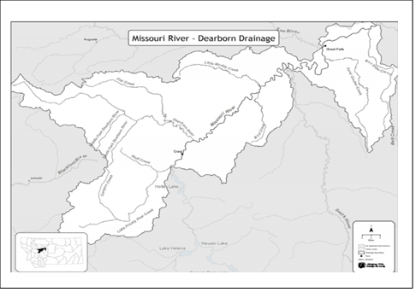

***Map 2.*** *Tributary locations for Sampling in 2021-2022*

**2.3 Monitoring Schedule**

***Table 5. Monitoring Schedule. Monitoring will occur between May 1 and September 30.***

|  |  |  |
| --- | --- | --- |
| **Date** | **Parameters** | **Rationale for Timing** |
| First week of May | Nutrients, TSS, TDS, Streamflow | Pre-Snowmelt Run-off |
| Mid-July | Nutrients, TSS, TDS, Streamflow | Baseflow, summer growing season, DEQ Index Period |
| Late-September | Nutrients, TSS, TDS, Streamflow | Baseflow; post summer growing season, DEQ Index Period |

## 2.4 Water Quality Parameters

***Table 6. Water Quality Parameters***

| **Parameter or Data Type** | **Collection Approach** | **Justification for Collecting** |
| --- | --- | --- |
| Total Persulfate Nitrogen (TN) | Parameters measured via water samples analyzed by an analytical lab | Protective ranges of nutrients to determine impairment. |
| Total Phosphorus (TP) |
| Nitrite plus Nitrate (N) |
| Total suspended solids (TSS), total dissolved (TDS) | TSS can help evaluate nutrient patterns |
| pH | Parameters measured *in situ* with YSI field meter | Common descriptive water quality parameters |
| Water temperature |
| Dissolved Oxygen (DO) |
| Turbidity |
| Specific conductance (SC) |
| Discharge (flow) | Measured with OTT flow meter, otherwise, use USGS gage below Holter Dam and calculate additional flow from tributary creeks downriver | Necessary to pair concentrations with flow data to calculate loads. |
| Photos | Taken with digital camera | Tracking riparian conditions, benthic algae conditions, and other site conditions; low-cost. |

# 3.0 Field Procedures

## 3.1 Order of Operations

Deploy water chemistry meter probe, perform water chemistry grab samples first, followed by the bug samples, followed by aquatic plant grabs when taken. Place water quality sample bottles in the cooler with ice. Return from the field and immediately drop WQ samples off at Energy Laboratories in Helena.

## 3.2 Field Forms

UMOWA will use the Site Visit/Chain of Custody forms provided by Energy Labs.

Copies of field forms are included in **Appendix B**.

## 3.3 Data Collection Standard Operating Procedures

**In situ measurements using field meters:** During each sampling event at each sampling site, an Oakton PC35 TESTER or YSI 6920 water quality multi-meter will be used to collect *in situ* measurements of water temperature, dissolved oxygen, specific conductance, turbidity, and pH. Air temperature will be recorded with a thermometer. These measurements will be collected prior to the collection of water samples or other physical disturbances to the water column or substrate.

**Water sample Collection:** For each sample, the bottle and lid will be triple rinsed with a small amount of ambient stream water prior to grabbing the final sample. Sample bottles will be submerged upstream from where the sampler is standing in a well-mixed portion of the water column. TN will be collected in a single 250ml HDPE bottle and kept on ice (not frozen) until analyzed. TP and NO2+3 will be collected in a single 250ml HDPE bottle, will be preserved with sulfuric acid and kept on ice (not frozen) until analyzed. TSS/TDS will be collected in a single 1000 ml HDPE bottle and kept on ice (not frozen) until analyzed.

**Flow (discharge) method:** Flow data will be recorded at the sampling times from the USGS gage station on the Missouri River below Holter Dam near Wolf Creek and a on the Missouri River at Cascade. The OTT flow meter will be adjusted to 80% of the depth with an average of three flow measurements taken.

**Site photographs:** Digital photographs will be taken at each site and during each sampling event. Additional photos will be taken as deemed necessary by field crews to document changes in riparian vegetation condition, land uses, stream flora, flow conditions, water clarity, etc. Photos will be a combination of close‐ups of water and substrate conditions as well as stream panoramas. The photo number and pertinent photo location notes or other pertinent information will be recorded for each photo.

# 4.0 Laboratory Analytical Requirements

|  |  |  |  |  |  |  |
| --- | --- | --- | --- | --- | --- | --- |
| **Parameter** | **Preferred Method** | **Alternate Method** | **Required Reporting Limit ug/L** | **Holding Time Days** | **Bottle** | **Preservative** |
| **Water Sample - Common Ions, Physical Parameters, Miscellaneous** | | | | | | |
| Total Suspended Solids (TSS) | A2540 D | N/A | 4000 | 7 | 1000 ml HDPE | ≤6oC on ice |
| Total Dissolved Solids (TDS) | A2540 C | N/A | 4000 | 7 |
| **Water Sample - Nutrients** | | | | | | |
| Total Persulfate Nitrogen (TPN) | A4500-N C | A4500-N B | 40 | 28 | 250ml HDPE | ≤6oC on ice |
| Total Phosphorus as P | EPA 365.1 | A4500-P F | 3 | 28 | 250 ml HDPE | H2SO4, ≤6oC on ice |
| Nitrate-Nitrite as N | EPA 353.2 | A4500-NO3 F | 10 |

# 5.0 Quality Assurance/Quality Control (QA/QC)

## 5.1 Overview

Projects require adequate documentation, proper sample collection, handling, and analysis, and other measured to produce high quality, credible data that accurately represent conditions in the watershed and can be used to answer scientific questions or guide resource management decisions.

Quality Assurance (QA) is the overall system used to ensure a monitoring project produces data of the desired level of quality necessary to meet project goals and objectives. For example, QA activities include developing a sampling and analysis plan, properly training volunteers, communicating analytical requirements to the lab, and adhering to standard operating procedures.

Quality control (QC) are technical activities used to detect and control errors. For example, QC activities include collecting field duplicates, preparing field blanks, reviewing field forms for accuracy, and calibrating equipment. Good QC will help to identify problems with the data if they arise and help identify what the cause of the problem likely is.

A list of QA/QC terms and definitions is included in **Appendix C**.

## 5.2 Training

The Contract Sampler is trained in all field methods, including field meters, sample collection and handling. Volunteer members of Sample Team will be trained by Contracted Sample Team in all field methods. The Sample Team will be required to bring a copy of this SAP as well as any supplemental documentation of detailed field methods and/or standard operating procedures (Table 5).

## 5.3 QC Samples: Field Duplicates

Field duplicates are two samples (i.e., a routine sample and a duplicate sample) of ambient water collected from a waterbody as close as possible to the same time and place by the same person and carried through identical sampling and analytical procedures. Field duplicate samples are labeled, collected, handled, and stored in the same way as the routine samples and are sent to the laboratory at the same time.

Field duplicates are typically collected at a rate of approximately 10% of the total number of routine samples collected. Therefore, to achieve this, one set of field duplicates will be collected during each sampling event. Duplicates may be collected at any of the monitoring locations shown in **Section 2.2**. See **Section 3.4** for information about duplicate sample labelling, and **Section 4.0** for analytical requirements.

Field duplicates are used to determine field precision to ensure that proper procedures are followed consistently. For each field duplicate set collected, the relative percent difference will be calculated:

Relative Percent Different (RPD) = ((D1 – D2) / ((D1 + D2)/2)) x 100

where: D1 = routine sample result value

D2 = duplicate sample result value

Precision will be assessed by ensuring that relative percent difference (RPD) between duplicates is less than 25%. If the RPD of field duplicates is greater than 25% and the parent and duplicate result values are greater than five times the lower reporting limit, the result values will be flagged with a “J”.

## 5.4 QC Samples: Field Blanks

Field blanks are samples of analyte-free, laboratory-grade deionized water poured into a sample container in the field using the same method, container, and preservation as routine samples, and shipped to the lab along with other field (i.e., routine and duplicate) samples. All labeling, rinsing, preservation, and storage requirements applied for routine and duplicate samples are applied to field blanks; the only difference is that the water is deionized water rather than ambient stream water. Field blanks must be prepared while in the field.

One set of field blanks is submitted to the laboratory with each batch of samples delivered to the laboratory. Therefore, one set of field blanks will be prepared at or near the end of each monthly sampling event and submitted to the laboratory alongside the other routine and duplicate samples from that trip. See **Section 3.4** for information about field blank sample labelling, and **Section 4.0** for analytical requirements.

Field blanks are used to determine the integrity of the field personnel’s handling of samples, the condition of the sample containers supplied by the laboratory, and the accuracy of the laboratory methods. Accuracy will be assessed by ensuring that field blanks return values less than the lower reporting limit (i.e., non-detects) (shown in **Section 4.0**). If an analyte is detected in a field blank, all result values for that analyte from that batch of samples associated with the field blank will be qualified with a “B” flag. The exception is that data with a value greater than 10 times the detected value in the blank does not need to be qualified.

## 5.5 Instrument Calibration and Maintenance

Keep YSI 6920 and/or Oakton PC Tester 35 calibrated with standard conductivity and pH buffer solutions prior to each sampling event.

## 5.6 Data Quality Indicators

Data quality indicators (DQIs) are attributes of samples that allow data users to assess data quality. Because there are large sources of variability in streams and rivers, DQIs are used to evaluate the sources of variability and error and thereby increasing confidence in our data.

This section describes how the sampling and analysis plan and study design aims to achieve data quality for each data quality indicator (representativeness, comparability, completeness, sensitivity, precision and accuracy).

**Representativeness**

Representativeness refers to the extent to which measurements represent an environmental condition in time and space.

**Spatial representation**

Sample sites represent the entire reach of the Missouri River from the confluence of Little Prickly Pear Creek to the Cascade Fishing Access Site (FAS). These sites were chosen to represent the upstream and downstream extents of the entire reach. Sample sites were also chosen above and below three major tributary streams (Little Prickly Pear Creek, the Dearborn River, and Sheep Creek) to examine how these tributaries, influence water quality, aquatic plant growth, and macroinvertebrate assemblages.

**Temporal representation**

Sampling dates are chosen to represent 3 distinct seasonal times and are to be sampled within a week of those from year to year. Samples at different sites will be collected within one or 2 days of each other. Three sampling dates were chosen to represent the pre-runoff period (end of April to mid-May), the baseflow summer growing period (mid- July), and the baseflow post growing period in autumn (late-September). This timing best represents the impacts of spring high water, summer low water, and impacts on vegetative growth.

**Comparability**

UMOWA will follow standard operating procedures (2019 WQDWQPBFM-02, Version 1.0), collecting data consistently as was collected during the previous years’ monitoring efforts, collect the same analytes used by DEQ to assess water quality, and use the laboratory detection limits used by DEQ.

**Completeness**

Prior to leaving a sampling site the Contract Sampler will be required to fill out a data sheet; this will reduce the occurrence of empty data fields. The overall project goal is 90% completeness. Because of the limited funding for laboratory analysis, collection of additional samples in the event of breakage of sample bottles in route to the laboratory is not planned.

**Sensitivity**

Sensitivity refers to the limit of a measurement to reliably detect a characteristic of a sample. Related to detection limits, the more sensitive a method is, the better able it is to detect lower concentrations of a variable; for analytical methods, sensitivity is expressed as the method detection limit (MDL).

Detection and reporting limits are specified for this project which are adequately low enough to enable comparison to the protective ranges of nutrients. The laboratory routinely checks sensitivity (e.g., method blanks, continuing calibration blanks, and laboratory reagent blanks) per their quality management plan.

**Precision, Bias, and Accuracy**

Bias is the degree of systematic error in an assessment or analysis process; when bias is present, the sampling result value will differ from the accepted, or true, value of the parameter. Adhering to standard operating procedures during sampling will reduce sampling bias.

Precision measures the level of agreement or variability among a set of repeated measurements obtained under similar conditions. Field duplicates (**Section 5.3**) will be collected during this project and used to determine field precision. If problems are linked to field crew sampling error, supplemental training will be provided prior to the next sampling event.

Accuracy is the extent of agreement between an observed value (sampling result) and the accepted, or true, value of the parameter being measured. Field blanks (**Section 5.4**) will be prepared during this project and used to evaluate accuracy for field activities. The laboratory uses EPA approved and validated methods and performs precision and accuracy performance evaluations per their quality management plan.

**Holding Time**

All samples will be checked to verify that they were processed within their specified holding times. Sample results whose holding time was exceeded prior to being processed will be qualified with an “H” flag.

## 5.7 Field Health and Safety

Field personnel commonly encounter hazards while performing monitoring activities. All participants are advised to take adequate precautions to avoid injury or loss of life due to hazards including, but not limited to, driving, wading and other activities in and around water, weather conditions, wildlife interactions, people interactions, use of chemical preservatives, etc.

On every sampling trip, field personnel should carry with them a communication device (e.g., cell phone), first aid kit, bear spray, adequate drinking water, clothing appropriate for a range of weather conditions, personal protective equipment including waders, adequate footwear, and gloves to be worn while handling preservatives, and any other necessary safety-related items.

Each volunteer will be required to sign a waiver acknowledging risk and these waivers will be kept on file by the project coordinator. If, for any reason, field personnel feel unsafe while navigating to or from monitoring sites or while collecting data, they should err on the side of caution and not collect the data. Any delays or changes should be reported to the project coordinator as soon as possible so sampling can be rescheduled if possible.

# 6.0 Data Management, Record Keeping & Reporting

The person(s) responsible for data management, record keeping, data quality review and data upload will perform the following activities:

* Review field forms for completeness and accuracy, especially Site Visit and Chain of Custody forms.
* Draft a brief synopsis of any SAP derivations that occurred.
* Store and backup all data generated during this project, including field forms, laboratory reports obtained from the laboratories, electronic copies of field photographs, and written field notes.
* Review data quality and flag result values, as needed, prior to uploading into the database(s). Upload all laboratory data into MT e-WQX database (if DEQ funding or support is provided).
* Maintain records of volunteer hours, travel and other budget tracking, as needed.

## 6.1 DEQ’s MT-eWQX database and Data Quality Review

Analytical laboratories will prepare and analyze the samples in accordance with the chain-of-custody forms and analytical methods specified in **Table 6**. The lab will then supply the project coordinator with laboratory analytical reports and Electronic Data Deliverable (EDD) spreadsheets.

If DEQ funding is received in support of the monitoring project (e.g., through DEQ’s Volunteer Monitoring Lab Analysis Support Program or other funding mechanism), all data collected must be entered by the project coordinator into DEQ’s MT-eWQX database (also known as EQuIS). Instructions for preparing, validating and submitting the EDD to MT-eWQX must be followed (available at <https://deq.mt.gov/water/Programs/sw>). For example, steps include:

* Compiling data (including site information, field measurements and lab results),
* Transforming the data into the required format,
* Performing a thorough quality control check of the data to correct errors, qualify problematic sample result values with data flags, etc.,
* Validating the data, and
* Submitting EDDs to MT-eWQX.

## 6.2 Other Data Management Approaches

All pertinent data, on-site condition notes and site photographs will be reported or presented in the Final Summary Report for the year. Scanned field forms will be attached as Appendices.

# 7.0 Data Analysis and Reporting

7.1 Data Analysis

The overall data analysis goals of the project are to 1) establish a multi-year, long-term water quality data set as it relates to seasonal discharge and as it may affect benthic macroinvertebrate, algae and plant communities, and 2) collect baseline information about total suspended/dissolved solids and nutrients to allow for spatial and temporal comparisons of water quality. Each water quality parameter will be graphed from the furthest upstream sites to downstream, as well as seasonally, to detect trends in nutrient concentrations. To get a better idea of river assessment conditions, water quality data will be compared against nutrient thresholds for wadable streams in the same ecoregion, since nutrient thresholds have not been developed for the Missouri River mainstream yet.

## 7.2 Reporting

UMOWA will share data through its website and in reports to landowners and project partners (www.UMOWA.org). UMOWA will share properly formatted WQX data and final reports with MDEQ and other agency personnel who may be interested in this data for further analysis.

UMOWA is incorporating this data in its Aquatic Health Summary Project. The Project is an educational outreach program that will compile existing scientific data on the Upper Missouri River's water quality, flow regimes, aquatic plants, fishery, macroinvertebrate populations, and nonpoint source pollutants into a comprehensive data map. The Aquatic Health Summary Project will help users conceptualize how the Upper Missouri River's water quality and flushing flows correlate with fluctuating aquatic plant and macroinvertebrate communities each season

# 8.0 References

Lewis and Clark County 2020. Lewis & Clark County WQPD Monitoring Networks and Projects. [Lewis and Clark County WRP Monitoring](https://helenamtmaps.maps.arcgis.com/apps/MapSeries/index.html?appid=810abe81411b41178a78b89395b0bf74)

McGuire, D.L. 2014. Madison and Missouri River Macroinvertebrate Biomonitoring: 2013 Data Summary. Report to PPL Montana.

Montana Department of Environmental Quality (MDEQ) 2020. Water Quality Library Planning Database: <http://svc.mt.gov/deq/wqlibrarysearch/>

Montana Department of Environmental Quality (MDEQ) 2012a. Sample Collection, Sorting, and Taxonomic Identification of Benthic Macroinvertebrates Standard Operating Procedure. Helena, MT: Montana Department of Environmental Quality.

WQPBWQM‐012. <http://deq.mt.gov/wqinfo/qaprogram/PDF/SOPs/WQPBWQM>[‐009rev2_final_web.pdf](http://deq.mt.gov/wqinfo/qaprogram/PDF/SOPs/WQPBWQM%E2%80%90009rev2_final_web.pdf)

Makarowski,Kathryn. 2019. Standard Operating procedure for Sample Collection for Chemistry Analysis: Water, Sediment, and Biological Tissue. WQDWQPBFM-02, Version 1.0. Helena, MT: Montana Department of Environmental Quality, Water Quality Planning Bureau.

MDEQ 2007. Water Quality and Biological Characteristics of Montana Streams in a Statewide Monitoring Network, 1999‐2005. Water Quality Planning Bureau. Helena, MT

Montana Fish, Wildlife and Parks (MFWP) 2015. Montana Statewide Angling Pressure 2015: Annual Estimates March 2014 – February 2015.

UMOWA 2021. Upper Missouri River Water Quality Report 2020: Lewis & Clark and Cascade Counties, MT.

US Environmental Protection Agency 2020. 303(d) Impaired Waters National Geospatial Dataset (available at http://www.epa.gov/waters/data/downloads.html)

# Appendix A – PROJECT Budget

|  |  |  |  |  |  |  |  |  |
| --- | --- | --- | --- | --- | --- | --- | --- | --- |
| **Parameter** | **Price per Parameter** | **Number of Sites** | **Number of visits per site** | **Number of routine samples** (number of sites x number of visits per site) | **Number of field blanks** (often one per sampling event) | **Number of field duplicates** (often ~10% of the total number of routine samples) | **Total number of samples** (routine + duplicates + blanks) | **Total Cost** (Total number of samples x cost per parameter) |
| Total Suspended Solids (TSS) | $12  $14.40 | 7  16 | 1  2 | 7  32 | 1  2 | 1  3 | 9  36 | $108  $532.80 |
| Total Dissolved Solids (TDS) | $16  $17.60 | 7  16 | 1  2 | 7  32 | 1  2 | 1  3 | 9  36 | $144  $651.20 |
| Total Persulfate Nitrogen (TPN) | $20  $22.40 | 7  16 | 1  2 | 7  32 | 1  2 | 1  3 | 9  36 | $180  $828.80 |
| Total Phosphorus (TP) | $16  $17.60 | 7  16 | 1  2 | 7  32 | 1  2 | 1  3 | 9  36 | $144  $651.20 |
| Nitrate-Nitrite as N | $20 | 7  16 | 1  2 | 7  32 | 1  2 | 1  3 | 9  37 | $180  $740 |
| Sample Handling Fee | $2 | 23 | 3 | 39 | 3 | 4 | 46 | $92 |
|  |  |  |  |  |  |  | **Total** | **$4,252** |

*no shipping expenses

# Appendix B – Field Forms

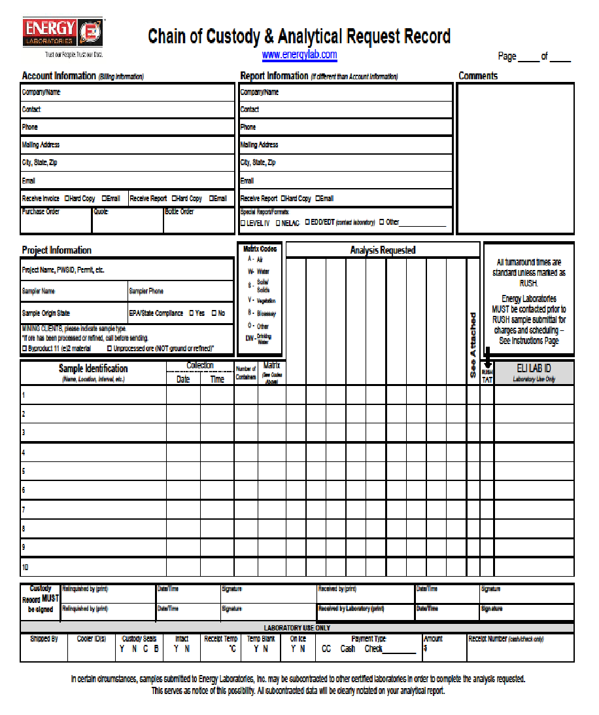

# Appendix C – EQUIPMENT AND SUPPLIES

* Sample bottles, preservatives, and cooler provided by Energy Lab
* Ice
* Chain of Custody Forms
* Recording devices for temperature, pH, time and location
* Camera
* Flow meter
* YSI Sonde
* Wading gear in cool weather

# Appendix D - QA/QC Terms and Definitions

**Accuracy**. A data quality indicator, accuracy is the extent of agreement between an observed value (sampling result) and the accepted, or true, value of the parameter being measured. High accuracy can be defined as a combination of high precision and low bias.

**Analyte**. Within a medium, such as water, an analyte is a property or substance to be measured. Examples of analytes would include pH, dissolved oxygen, bacteria, and heavy metals.

**Bias**. Often used as a data quality indicator, bias is the degree of systematic error present in the assessment or analysis process. When bias is present, the sampling result value will differ from the accepted, or true, value of the parameter being assessed.

**Blind sample**. A type of sample used for quality control purposes, a blind sample is a sample submitted to an analyst without their knowledge of its identity or composition. Blind samples are used to test the analyst’s or laboratory’s expertise in performing the sample analysis.

**Comparability**. A data quality indicator, comparability is the degree to which different methods, data sets, and/or decisions agree or are similar.

**Completeness**. A data quality indicator that is generally expressed as a percentage, completeness is the amount of valid data obtained compared to the amount of data planned.

**Data users**. The group(s) that will be applying the data results for some purpose. Data users can include the monitors themselves as well as government agencies, schools, universities, businesses, watershed organizations, and community groups.

**Data quality indicators (DQIs)**. DQIs are attributes of samples that allow for assessment of data quality. These include precision, accuracy, bias, sensitivity, comparability, representativeness and completeness.

**Data quality objectives (DQOs)**. Data quality objectives are quantitative and qualitative statements describing the degree of the data’s acceptability or utility to the data user(s). They include data quality indicators (DQIs) such as accuracy, precision, representativeness, comparability, and completeness. DQOs specify the quality of the data needed to meet the monitoring project's goals. The planning process for ensuring environmental data are of the type, quality, and quantity needed for decision making is called the DQO process. Madison Stream Team Sampling and Analysis Plan Page 23

**Detection limit**. Applied to both methods and equipment, detection limits are the lowest concentration of a target analyte that a given method or piece of equipment can reliably ascertain and report as greater than zero.

**Duplicate sample**. Used for quality control purposes, duplicate samples are an additional sample taken at the same time from, and representative of, the same site that are carried through all assessment and analytical procedures in an identical manner. Duplicate samples are used to measure natural variability as well as the precision of a method, monitor, and/or analyst. More than two duplicate samples are referred to as replicate samples.

**Environmental sample**. An environmental sample is a specimen of any material collected from an environmental source, such as water or macroinvertebrates collected from a stream, lake, or estuary.

**Field blank**. Used for quality control purposes, a field blank is a “clean” sample (e.g., distilled water) that is otherwise treated the same as other samples taken from the field. Field blanks are submitted to the analyst along with all other samples and are used to detect any contaminants that may be introduced during sample collection, storage, analysis, and transport.

**Instrument detection limit**. The instrument detection limit is the lowest concentration of a given substance or analyte that can be reliably detected by analytical equipment or instruments (see detection limit).

**Matrix**. A matrix is a specific type of medium, such as surface water or sediment, in which the analyte of interest may be contained.

**Measurement Range**. The measurement range is the extent of reliable readings of an instrument or measuring device, as specified by the manufacturer.

**Method detection limit (MDL)**. The MDL is the lowest concentration of a given substance or analyte that can be reliably detected by an analytical procedure (see detection limit).

**Precision**. A data quality indicator, precision measures the level of agreement or variability among a set of repeated measurements, obtained under similar conditions. Relative percent difference (RPD) is an example of a way to calculate precision by looking at the difference between results for two duplicate samples.

**Protocols**. Protocols are detailed, written, standardized procedures for field and/or laboratory operations.

**Quality assurance (QA)**. QA is the process of ensuring quality in data collection including developing a plan, using established procedures, documenting field activities, implementing planned activities, assessing and improving the data collection process and assessing data quality by evaluating field and lab quality control (QC) samples.

**Quality assurance project plan (QAPP)**. A QAPP is a formal written document describing the detailed quality control procedures that will be used to achieve a specific project’s data quality requirements. This is an overarching document that might cover several smaller projects a group is working on. A QAPP may have several sample analysis plans (SAPs) that operate underneath it.

**Quality control (QC)**. QC samples are the blank, duplicate and spike samples that are collected in the field and/or created in the lab for analysis to ensure the integrity of samples and the quality of the data produced by the lab.

**Relative percent difference (RPD)**. RPD is an alternative to standard deviation, expressed as a percentage and used to determine precision when only two measurement values are available. Calculated with the following formula: RPD as % = ((D1 – D2)/ ((D1 + D2)/2)) x 100 Where: D1 is first replicate result D2 is second replicate result

**Replicate samples**. See duplicate samples.

**Representativeness**. A data quality indicator, representativeness is the degree to which data accurately and precisely portray the actual or true environmental condition measured.

**Sampling and Analysis Plan (SAP)**. An SAP is a document outlining objectives, data collection schedule, methods and data quality assurance measures for a project.

**Sensitivity**. Related to detection limits, sensitivity refers to the capability of a method or instrument to discriminate between measurement responses representing different levels of a variable of interest. The more sensitive a method is, the better able it is to detect lower concentrations of a variable.

**Spiked samples**. Used for quality control purposes, a spiked sample is a sample to which a known concentration of the target analyte has been added. When analyzed, the difference between an environmental sample and the analyte’s concentration in a spiked sample should be equivalent to the amount added to the spiked sample.

**Standard operating procedures (SOPs)**. An SOP is a written document detailing the prescribed and established methods used for performing project operations, analyses, or actions.