

**Bitterroot River Protection Association**

**2022 Sapphire Front Project**

**Sampling and Analysis Plan**

May 16, 2022

**Prepared by:**

Michael Howell, Exec. Director

Bitterroot River Protection Association

P. O. Box 8, Stevensville, MT 59870

**Approved by:**

/s/ Abbie Ebert____________________________________________ 5/16/2022___________

Abbie Ebert (Montana DEQ VM Lab Analysis Program Manager) Date

/s/ Katie Makarowski_______________________________________ 5/16/2022___________

Katie Makarowski (Quality Assurance Officer) Date

# Table of Contents

Table of Contents 1

1.0 INTRODUCTION 1

1.1 Project Overview 1

1.2 Project Area Overview 1

1.3 Project Team and Responsibilities 3

2.0 Objectives and Sampling Design 4

2.1 Project Goals and Objectives 4

2.2 Monitoring Locations 5

2.3 Monitoring Schedule 7

2.4 Water Quality Parameters 7

3.0 Field Procedures 8

3.1 Order of Operations 8

3.2 Field Forms 9

3.3 Data Collection Standard Operating Procedures 9

4.0 Laboratory Analytical Requirements 9

5.0 Quality Assurance/Quality Control (QA/QC) 10

5.1 Overview 10

5.2 Training 11

5.3 QC Samples: Field Duplicates 11

5.4 QC Samples: Field Blanks 12

5.5 Instrument Calibration and Maintenance 12

5.6 Data Quality Indicators 12

5.7 Field Health and Safety 14

6.0 Data Management, Record Keeping & Reporting 14

6.1 DEQ’s MT-eWQX database and Data Quality Review 15

6.2 Other Data Management Approaches 15

7.0 Data Analysis and Reporting 15

7.1 Data Analysis 15

7.2 Reporting 16

8.0 References 16

Appendix A - Project Budget 18

Appendix B – NUTRIENT PROJECTS IN THE BITTERROOT 20

Appendix c – YSI PRODSS SENSOR SPECIFICATION 21

APPENDIX D – FLOWTRACKER2 SPECIFICATIONS 23

Appendix E – Field FOrms 24

Appendix F – QA/QC Terms and Definitions 30

Appendix G – Quality Control Checklist 33

# 1.0 INTRODUCTION

## 1.1 Project Overview

Bitterroot River Protection Association’s (BRPA) mission is to protect, preserve and enhance the water quality and quantity in the entire Bitterroot River Watershed. As part of that, we are the lead organization in a community-based water quality monitoring cooperative, called the Bitterroot River Health Check (BRHC), which includes Bitterroot Trout Unlimited, Bitterrooters for Planning, and other organizations, local businesses, and individuals. We operate under a Memorandum of Understanding (MOU) out of the Bitterroot College University of Montana, in Hamilton.

In 2017, BRHC adopted the stated goal of establishing a system of water quality monitoring sites on the Bitterroot River and its major tributaries to be maintained in perpetuity. It will serve as a grid for assessing the watershed’s health by providing baseline data from across the watershed and can be used in assessing impacts of the landscape management projects currently under way in the watershed and the ones planned. The effort to establish this network of sampling sites has been proceeding in phases.

**PHASE 1**: The Bitterroot River Mainstem project has led to the establishment of six sites on the river, five of which are now included in Montana Department of Environmental Quality (DEQ) 20 year plan for long term monitoring in the Bitterroot.

**PHASE 2**: The Sapphire Front Project was initiated in 2018 as a logical extension of the mainstem monitoring, especially in relation to nutrients (see **Appendix A**). Data has been collected annually since that time and last year (2021) we were awarded two grants covering laboratory analysis costs. We are hoping to do so again this season with potential financial support from DEQ lab analysis funding and potential funding from the Flathead Lake Biological Station (FLBS) Monitoring Montana Waters fund or other funding sources.

**PHASE 3**: The Bitterroot Front Project is a landscape scale project proposed by the Bitterroot National Forest covering the entire westside of the valley from Darby to Lolo. BRPA has recently signed an MOU with the Bitterroot National Forest to help establish a set of long-term water quality monitoring sites in the project area. This is all in the pre-planning stages but is also moving towards some defined projects within the area which may be conducted under the National Environmental Policy Act (NEPA) in the near future. We plan on working closely with DEQ on the water quality sampling protocols we employ and with the Department of Natural Resources and Conservation (DNRC) on the protocols for collecting flow measurements. We are also partnering with Dr. Payton Gardner, Assistant Professor of Hydrogeology at the University of Montana whose team (1 postdoc and two graduate students), helped in installation of gages and pressure transducers at sampling sites on three streams on the Bitterroot Front in 2021.

A budget table for laboratory analytical costs on the Sapphire Front Project is included in **Appendix B**.

## 1.2 Project Area Overview

The 2022 Sapphire Front Project involves collecting water quality samples and taking flow measurements on six streams that flow into the Bitterroot River from out of the Sapphire Mountains. This includes Rye Creek, North Rye Creek, Skalkaho Creek, Willow Creek, North Burnt Fork Creek, and Three Mile Creek. Each of these streams flows out of Bitterroot National Forest land and passes through private land with mixed agricultural and residential development before discharging into the Bitterroot River. These sites were all sampled in 2021 and will be sampled again in 2022.

All of these streams have been listed for some type of impairment or multiple impairments in the 2014 Bitterroot Total Maximum Daily Loads (TMDL). Impairments vary for individual streams but include sedimentation, nutrients, temperature, low flow alterations, and alteration in stream-side or littoral vegetation (see **Table 1**).

**Table 1. List of streams and documented impairments from the Clean Water Act Information Center (CWAIC).**

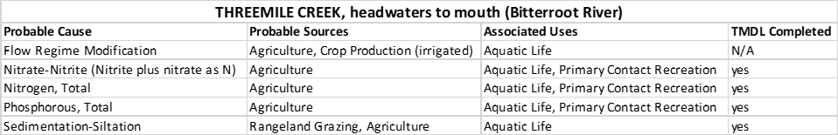

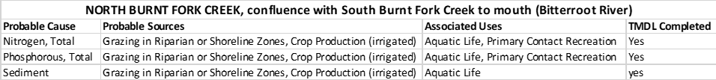

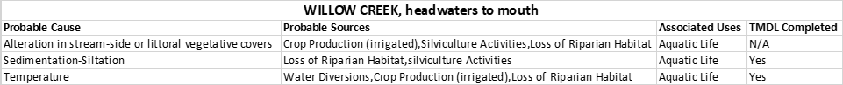



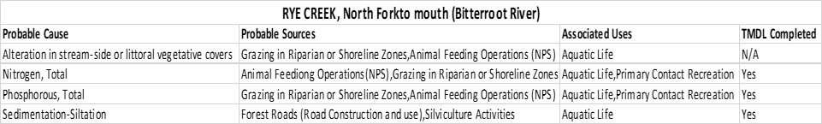

All these streams were monitored in the past by Will McDowell as part of the Tri-State Water Quality Council’s (TSWQC) work in the Bitterroot. They were also sampled by DEQ for TMDL purposes (MT DEQ & USEPA 2014). Three of them, Rye Creek, Skalkaho Creek, and Burnt Fork Creek are identified as priorities in the Bitterroot Water Forum’s 2020 Bitterroot Watershed Restoration Plan on the list for potential restoration projects.

An assessment of available water quality data on nutrients in the Bitterroot was done prior to initiating the project (see **Appendix C** and **Appendix D**).

**Figure 1. Map of sample locations for the Sapphire Front Project in the Bitterroot watershed**

## 1.3 Project Team and Responsibilities

Although the Project Leader has ultimate responsibility for the following roles initially, once the volunteers are assembled and committed for the season some roles and responsibilities may be delegated to other individuals, such as lab coordination, shipping and delivering, etc. It is possible that the uploading of data may be contracted out.

Project Leader Michael Howell (bitterrootriverprotection@gmail.com) is responsible for the following tasks:

1. Developing a Sampling and Analysis Plan (SAP)
2. Overseeing monitoring personnel
3. Training monitoring personnel
4. Reviewing field forms
5. Lab coordination (e.g, bottle orders, shipping, notifications, lab EDDS)
6. Shipping samples to lab
7. Reviewing data quality
8. Uploading data into MT-eWQX database
9. Writing final report

**Table 2. Project Team Roles and Responsibilities**

|  |  |  |  |
| --- | --- | --- | --- |
| **Person** | **Role** | **Contact Information** | **Responsibilities** |
| Michael Howell | Project Leader | [bitterrootriverprotection@gmail.com](mailto:bitterrootriverprotection@gmail.com) | Calibrate instruments; supervise and participate in sampling at each site |
| Chris Clancy | Sampler | [REDACTED] | Grabbing water samples, collecting YSI field parameters, flow measurements |
| Doug Soehren | Sampler | [REDACTED] | Grabbing water samples, collecting YSI field parameters |
| Mike Hoyt | Sampler | [REDACTED] | Grabbing water samples, collecting YSI field parameters |
| Janice Ling | Sampler | [REDACTED] | Grabbing water samples, collecting YSI field parameters |
| Craig Odegard | Sampler | [REDACTED] | Grabbing water samples, collecting YSI field parameters |

# 2.0 Objectives and Sampling Design

## 2.1 Project Goals and Objectives

The goals for the Sapphire Front Project are manifold. The study design includes water quality monitoring with distributed spatial coverage for evaluating basin wide similarities and differences on the east side of the Bitterroot River. The data collected will be used to determine the present condition of the streams with respect to the recommended ranges of nitrogen and phosphorus that protect beneficial uses, help establish a baseline for future comparisons and determine long term trends within each stream. By doing both nutrient sampling and flow measurements at the mouth of the streams we will be able to calculate the total nutrient load being delivered by each stream. Locating and calculating the loads being contributed from tributaries will be a significant addition to the information on trends being gathered in the mainstem under DEQ’s 20-year plan.

By gathering identical data at the forest service boundary, we will be able to make a distinction between the contributions coming off the forest land, which are subject to large scale forest management activities, from the contributions off private land in agricultural production and residential development. This information would be valuable in guiding and focusing ongoing restoration projects related to the Bitterroot Watershed Restoration Plan and the largescale land management activities being conducted by the USFS.

As these sites are intended to be monitored in perpetuity, the value of the data will increase over time and establish a baseline for drainage specific trends.

The specific objectives for this SAP are as follows:

1. Measure physical field parameters (barometric pressure, air temperature(˚C), water temperature (˚C), dissolved oxygen (mg/l), pH (standard units), specific conductance (μs/cm), total dissolved solids (mg/l), turbidity (NTU), and flows (cfs) in situ on all sites and during this time capture pre-irrigation baseline, irrigation and post irrigation baseline data.
2. Collect nutrient samples: total phosphorus (TP), total persulfate nitrogen (TPN), dissolved nitrate + nitrite nitrogen (NO2+NO3-N), dissolved ammonia nitrogen (NH3+NH4-N), and soluble reactive phosphorous (SRP) on all sites (see Table 5).
3. Take flow measurements

**Table 3. Project Goals, Objectives and Analyses**

|  |  |  |
| --- | --- | --- |
| **Goal** | **Objective** | **Data Analysis** |
| Goal # 1 is to assess current conditions of nutrients and in situ field measurements from May to October on 6 tributaries along the Sapphire Front. | To assess current conditions for nutrients relative to nutrient thresholds and to characterize field parameters as supporting  information. | Compare nutrient concentrations to the recommended ranges of nitrogen and phosphorus that protect beneficial uses. |
| Document the general condition of each location by taking photographs upstream, across and downstream during each sampling | Photos taken over time can be compared to identify any significant alteration to the environment in the area of the sampling |
| Goal # 2 is to distinguish the load being contributed from land primarily influenced by large scale forest management practices from loads contributed from land primarily influenced by agricultural and residential development. | Characterize tributary nutrient loads by collecting water samples for nutrient analysis and measuring discharge at two locations on each tributary. | Combined nutrient concentration data with flow data to determine the total nutrient load being delivered to the river by each stream.  The data can be used in subsequent years to evaluate how nutrient loads differ from year to year. |

## 2.2 Monitoring Locations

One monitoring station has been located on each creek near the mouth. A second station has been positioned near the Forest Service boundary. Many of the selected sites correspond to historic sampling projects with some available historic data. Each site is publicly accessible to ensure that it can be visited in the future, or a signed agreement with the landowner allowing access has been obtained.

The precise location of each site was determined based on considerations detailed in the Montana Watercourse Volunteer Water Monitoring Guidebook and the “Pollution Source Assessment” section of Monitoring Methods Selection Guide (MMSG).

BRPA policy is to have two people at every sampling event. Each of the creeks has a different volunteer dedicated to sampling both sites and trained in monitoring protocols. The second monitor, the Project Manager, calibrates the equipment at the College lab and delivers the equipment and sampling supplies to each site engaging with the local volunteer in the actual sampling process.

**Table 4. Monitoring Locations\***

**Table 4. Monitoring Locations\***

| **Site name** | **Station**  **ID** | **Latitude** | **Longitude** | **Parameters**  **to Collect** | **Rationale for**  **Decision** |
| --- | --- | --- | --- | --- | --- |
| Threemile Creek A | SF-ThreemileCr-A | 46.566433 | -114.061229 | Nutrients*, YSI**, Algae, Flow, Invasive Species*** | near Mouth of stream |
| Threemile Creek C | SF-ThreemileCr-C | 46.621497° | -113.898419 | Nutrients, YSI, Algae, Flow, Invasive Species | near Forest boundary |
| N. Burnt Fork Creek AA | SF-NBurntFk-AA | 46.533834 | -114.097733 | Nutrients, YSI, Algae, Flow, Invasive Species | near Mouth of stream |
| N. Burnt Fork Creek C | SF-NBurntFk-C | 46.404055 | -113.904142 | Nutrients, YSI, Algae, Flow, Invasive Species | near Forest boundary |
| Willow AA | SF-WillowCr-AA | 46.293488 | -114.965380 | Nutrients, YSI, Algae, Flow, Invasive Species | near Mouth of stream |
| Willow B | SF-WillowCr-B | 46.173845 | -114.0478 | Nutrients, YSI, Algae, Flow, Invasive Species | near Forest boundary |
| Skalkaho A | SF-SkalkahoCr-A | 46.214281 | -114.155135 | Nutrients, YSI, Algae, Flow, Invasive Species | near Mouth of stream |
| Skalkaho C | SF-SkalkahoCr-C | 46.169333 | -113.911171 | Nutrients, YSI, Algae, Flow, Invasive Species | near Forest boundary |
| Rye Creek AA | SF-RyeCr-AA | 45.575893 | -114.8805 | Nutrients, YSI, Algae, Flow, Invasive Species | near Mouth of stream |
| Rye Creek B | SF-RyeCr-B | 45.979160 | -114.028091 | Nutrients, YSI, Algae, Flow, Invasive Species | near Forest boundary |
| NF Rye Creek B | SF-NR-B | 45.996346 | -114.031623 | Nutrients, YSI, Algae, Flow, Invasive Species | near Forest boundary |

These are proposed sampling locations which may change due to unforeseen access or other issues.

* Nutrient parameters total phosphorus (TP), total persulfate nitrogen (TPN), dissolved nitrate + nitrite nitrogen (NO2+NO3-N), dissolved ammonia nitrogen (NH3+NH4-N), and soluble reactive phosphorous (SRP)

** YSI parameters include barometric pressure, air temperature, water temperature, conductivity, pH, DO, total dissolved solids and turbidity

*** Invasive species assessment includes both aquatic and terrestrial vegetative species.

## 2.3 Monitoring Schedule

Sampling will occur between June 1 and December 31. The specific dates will be selected so as not to conflict with our ongoing sampling project on the Bitterroot Mainstem. Samples will be collected on two (occasionally 3) consecutive days due to the limited equipment and travel distances involved. The testing schedule for nutrients, flows and YSI parameters is designed to capture the growing season from June through August, the late irrigation season September through October and an early winter baseline reading in December. Nutrient and flow data will be collected at least 14 days apart at each site.

**Table 5. Monitoring Schedule**

|  |  |  |  |  |
| --- | --- | --- | --- | --- |
| **Data** | **Parameters** | **Reason for date** | **QA/QC** | **Sampler** |
| Late May/early June | Nutrients, YSI, and Flow | Pre-high water  Baseline | FB, FD at North Burnt Fork | Michael Howell & volunteers |
| July | Nutrients, YSI, and Flow | During irrigation season | FB, FD at Willow | Michael Howell & volunteers |
| August | Nutrients, YSI, Flow, Algae, and Invasive Species | During irrigation season, low flows | FB, FD at Skalkaho | Michael Howell & volunteers |
| September | Nutrients, YSI, Algae, Flow, and Invasive Species | Late irrigation, low flows | FB, FD at North Rye | Michael Howell & volunteers |
| October | Nutrients, YSI, and Flow | Late irrigation, low flows | FB, FD at Three Mile | Michael Howell & volunteers |
| November | Nutrients, YSI and Flow | Winter Baseline | FB, FD at Rye | Michael Howell & volunteers |

## 2.4 Water Quality Parameters

Bitterroot River Protection Association volunteers will collect water (grab) samples at each site in labeled bottles that are covered with clear plastic tape. Sample duplicates and field blanks will also be collected.

During each sampling event at each sampling site, Bitterroot River Protection Association volunteers:

1. Collect parameter data using a YSI ProDSS (Appendix E). The instrument is equipped with a quatro cable and sensors to collect in situ measurements of water temperature (˚C), dissolved oxygen (mg/l), pH (standard units), specific conductance (μs/cm), total dissolved solids (mg/l), and turbidity (NTU). Results are recorded on BRPA site visit form (Appendix H)
2. Collect flow measurements with a FlowTracker2 flow meter (Appendix F) and correlate it to a height gauge in order to establish a rating curve for future readings. Volunteers will follow the DEQ protocols using the appropriate form for recording results.
3. Grab samples will be taken for nutrient analysis.

The water quality parameters being collected are listed in **Table 6**.

**Table 6. Water Quality Parameters**

|  |  |  |
| --- | --- | --- |
| **Parameter or Data Type** | **Collection Approach** | **Justification for Collecting** |
| Total Nitrogen (TN) | Parameters measured via grab water samples analyzed by an analytical lab | Existing nutrient impairments. |
| Total Phosphorus (TP) |
| Nitrite plus Nitrate (NO2+3) |
| Ammonia as N |
| SRP |
| Water Temperature | Parameters measured *in situ* with YSI field meter | Common descriptive water quality parameter |
| Specific conductance (SC) |
| pH |
| Dissolved oxygen (DO) |
| Total Disolved Solids (TDS) |
| Turbidity |
| Discharge (flow) | Measured with Flowtracker2 flow meter. | Necessary to pair concentrations with flow data to calculate loads. |
| Photos | Taken with digital camera | Tracking riparian conditions, benthic algae conditions, and other site conditions; low-cost. |

# 3.0 Field Procedures

## 3.1 Order of Operations

The Project Manager will prepare the appropriate sampling kits including all materials and equipment necessary and convey the equipment, coolers, and sampling supplies, etc. to each site and work with the appointed Volunteer at each site to do the sampling. All sites are mapped and marked in situ with a colored ribbon. Volunteers are familiarized with the location in training. The following Section references are to the BRPA Field Manual (see **Appendix G**).

At the site the order of operations is:

1. Arrive at site and identify a “safe and good” location to perform sampling (**Section 1**)
2. Turn on YSI meter, place in shade for 15 minutes (**Section 4**)
3. Fill out Site Visit Form with initial site information (name of site, ID, date, time of arrival and names of samplers (**Section 2**).
4. While the YSI is warming up other tasks may be performed serially or simultaneously (depending on how many volunteers are working at the site), as we move through the process of (a) photographing site (b) collecting nutrient samples (c) taking YSI readings (d) taking flow measurements (d) Invasive Species survey and (e) Algae assessment.
5. Once all the above activities are completed, volunteers pack up all equipment and proceed to remaining sites (if applicable)
6. Any time samples are transferred from one person to another, indicate that they were relinquished and received by signing the COC form with date and time (**Section 5**)
7. Return samples to storage location (Bitterroot College) and store samples in refrigerator or freezer according to sample preservation specifications (**Section 4**)
8. Ship samples to analytical laboratory within specified holding times (**Section 4**)

After collecting data at one site, the Project Manager will maintain custody of the samples and relay everything to the next creek where he will meet the local volunteer and follow the same procedures at those two sites. At the end of the day the Project Manager returns all the samples and equipment to the laboratory at the Bitterroot College and places all samples in either the refrigerator or the freezer whichever is appropriate. Equipment is cleaned and stored at the lab.

We are also following DEQ COVID-19 guidelines (Bell and Butts 2020).

## 3.2 Field Forms

Field forms to be used include:

* BRPA’s Site Visit Form
* Chain of Custody Forms
* YSI Calibration Form
* Total Discharge Form

Copies of field forms are included in **Appendix H**.

## 3.3 Data Collection Standard Operating Procedures

Step by step, detailed instructions of our procedures and protocols for collecting data are found in our Filed Manual which is included in the sampling kit taken to all sampling events (**Appendix G**).

# 4.0 Laboratory Analytical Requirements

**Table 7. Flathead Lake Biological Station Lab Monitoring Parameter Suite, Sample Handling, Analysis & Preservation**

| **Parameter** | **Preferred Method** | **Required Report Limit (µg/L)** | **Holding**  **Time (days)** | **Required Bottles** | **Preservative** |
| --- | --- | --- | --- | --- | --- |
| Total Nitrogen as N | A4500-N C | 25 | 28 | 60ml | Freeze or 0.2% H2SO4 (v/v) |
| Dissolved Orthophosphate as P | EPA 365.1 | 0.8 |
| Total Phosphorus as P | USGS 03‐4174, | 1.5 |
| Nitrate-Nitrite as N | EPA 353.2 | 1.5 |
| Total Ammonia as N | EPA 350.1 | 1.5 |

**Table 8. Energy Labs Monitoring Parameter Suite, Sample Handling, Analysis & Preservation**

| **Parameter** | **Preferred Method** | **Required Report Limit (µg/L)** | **Holding**  **Time (days)** | **Required Bottles** | **Preservative** |
| --- | --- | --- | --- | --- | --- |
| Total Persulfate  Nitrogen (TPN) | A4500-N C | 40 | 28 | 250 ml HDPE | ≤6oC on ice |
| Dissolved Orthophosphate as P | EPA 365.1 | 1 | 45 | 120 ml HDPE | Field filter 0.45 µm, freeze |
| Total Phosphorus as P | EPA 365.1 | 3 | 28 | 250 ml HDPE | H2SO4; ≤6oC on ice |
| Nitrate-Nitrite as N | EPA 353.2 | 10 |
| Total Ammonia as N | EPA 350.1 | 50 |

# 5.0 Quality Assurance/Quality Control (QA/QC)

## 5.1 Overview

Projects require adequate documentation, proper sample collection, handling, and analysis, and other measured to produce high quality, credible data that accurately represent conditions in the watershed and can be used to answer scientific questions or guide resource management decisions.

Quality Assurance (QA) is the overall system used to ensure a monitoring project produces data of the desired level of quality necessary to meet project goals and objectives. For example, QA activities include developing a sampling and analysis plan, properly training volunteers, communicating analytical requirements to the lab, and adhering to standard operating procedures.

Quality control (QC) are technical activities used to detect and control errors. For example, QC activities include collecting field duplicates, preparing field blanks, reviewing field forms for accuracy, and calibrating equipment. Good QC will help to identify problems with the data if they arise and help identify what the cause of the problem likely is.

A list of QA/QC terms and definitions is included in **Appendix I**. A Quality Control Check list is found in **Appendix J**.

## 5.2 Training

All program participants will attend a monitoring training/refresher course in which protocols are reviewed by the program leader and/or water quality professionals. In the past DEQ has provided training. Each participant will be provided with and asked to review this sampling and analysis plan, the BRPA Field Manual and field forms before sampling commences. Volunteers will receive training/refresher course planned to occur within the first two weeks in May, the date has not been set.

The training session will be held at the Bitterroot College lab and include a field trip to the river. Volunteers will demonstrate understanding of and proficiency in field methods prior to sampling. Volunteers have in their possession in the field a copy of the Project Field Manual which includes a step-by-step description of the procedures and protocols they are to follow. A program leader or alternate experienced volunteer will accompany each volunteer during sampling events at least until they demonstrate proficiency.

## 5.3 QC Samples: Field Duplicates

Field duplicate samples are multiple samples collected by the same person, at the same time and place, following the same method. Field duplicates help to test precision of samples and helps check that samplers are following approved protocols.

Generally, the number of field duplicates constitutes approximately 10% of the total number collected throughout the sampling season. During each sampling event (day), a set of field duplicates will be collected for each type of routine water chemistry parameter at one random or predetermined site (**Table 5**).

Field duplicates are used to determine field precision to ensure that proper procedures are followed consistently. For each field duplicate set collected, the relative percent difference will be calculated:

Relative Percent Different (RPD) = ((D1 – D2) / ((D1 + D2)/2)) x 100

where: D1 = routine sample result value

D2 = duplicate sample result value

Precision will be assessed by ensuring that relative percent difference (RPD) between duplicates is less than 25%. If the RPD of field duplicates is greater than 25% and the parent and duplicate result values are greater than five times the lower reporting limit, the result values will be flagged with a “J”.

When collecting field duplicate samples, a sampling location will be chosen that allows for two samples to be taken side-by-side upstream from any previous disturbances. All procedures performed in labeling, rinsing, collecting, preserving, storing, and handling the routine sample will be followed exactly the same as for the duplicate samples so that two identical samples have been collected at the same site. The same syringe that was used to collect routine filtered grab samples at a site can be used when collecting field duplicates, although a separate, new set of filters should be used.

Field duplicate samples will be labeled with “-FD” following the site ID (e.g., Skalkaho A-FD) on sample labels and field forms. Duplicate samples will be recorded on the Chain-of-Custody (COC) form and submitted to the analytical laboratory along with routine samples.

## 5.4 QC Samples: Field Blanks

Field blank samples are samples that are collected in the field on the day of sampling and prepared with laboratory-grade distilled or deionized water rather than ambient stream water. Field blanks help to test for contamination in equipment and throughout the sampling process, ensuring samplers and the lab followed approved protocols.

Generally, one set of field blanks is prepared during a sampling event (day) and these blanks are sent to the laboratory with each “batch” of routine samples. During each sampling event (day), a set of field blanks will be collected for each type of routine water chemistry parameter at one random or predetermined site (see **Table 5**).

When collecting field blank samples, all procedures performed in labeling, rinsing, collecting, preserving, storing, and handling the routine sample will be followed exactly the same as for the routine samples. A new syringe and filters should be used when preparing field blanks.

Field blank samples will be labeled with “-FB” following the site ID (e.g., SKALKAHO A-FB) on sample labels and field forms. Duplicate samples will be recorded on the Chain-of-Custody (COC) Form (Appendix H) and submitted to the analytical laboratory along with routine samples.

## 5.5 Instrument Calibration and Maintenance

YSI meter calibration will take place monthly for each parameter, or sooner if required. pH is pre-checked each time and calibrated if indicated. DO is calibrated prior to each use by turning the meter on fifteen minutes before placing it in the stream. Field meter specifications for the YSI ProDSS are found in **Appendix E**.

## 5.6 Data Quality Indicators

Data quality indicators (DQIs) are attributes of samples that allow data users to assess data quality. Because there are large sources of variability in streams and rivers, DQIs are used to evaluate the sources of variability and error and thereby increasing confidence in our data.

This section describes how the sampling and analysis plan, and study design aims to achieve data quality for each data quality indicator (representativeness, comparability, completeness, sensitivity, precision, and accuracy).

**Representativeness**

Representativeness refers to the extent to which measurements represent an environmental condition in time and space. This project follows a judgmental sampling design in which spatial and temporal considerations were used to help ensure representativeness.

**Spatial representation**

The sampling plan was designed to include a fair selection of impaired streams ranging from south to north on the east side of the river. The project area includes major tributaries covering the north, center and south ends of the valley to provide a good assessment of the whole area. The two sites on each stream were chosen to provide data on the nutrient load being delivered to the river and distinguish the load coming off the forest from the loads produced on the private lands. They were also chosen to provide a stable hydro-geomorphic contour making flow readings more accurate and dependable. The sites were also located in locations that have public access to ensure accessibility now and in the future.

**Temporal representation**

Samples collected from the same site on different days will be collected at approximately the same time of day. Sampling on the same waterbody on the same day will be conducted from downstream to upstream to ensure that the same water is not being sampled twice and so field crews are not disturbing the sampling location. Sufficient time will be allowed to pass between sampling events at the same site (e.g., 14 days for nutrients). Flow monitoring will occur in conjunction with chemistry sampling to help ensure comparable conditions.

**Comparability**

Comparability is the degree to which methods, data, or decisions are similar. Comparability expresses the confidence with which one data set can be compared to another. To achieve a comparable result, both the field collection method and the analytical method must be comparable. BRPA intends to assure comparability of results by following standard operating procedures, collecting the same data as is being collected in DEQ’s long term monitoring on the river, collecting the same analytes used by DEQ to assess water quality, and using similar laboratory detection limits.

**Completeness**

Completeness is a measure, expressed as a percentage, of the amount of data planned for collection compared to the amount actually collected. Prior to leaving a sampling site the Bitterroot River Health Check volunteers will be required to fill out a data sheet, which will be reviewed and signed by the field leader on site; this will reduce the occurrence of empty data fields. The project calls for a total of 96 samples to be taken over the course of the season. The overall project goal is 90% completeness.

Due to limited funding for laboratory analysis, collection of additional samples in the event of breakage of sample bottles en route to the laboratory are not planned. All field forms will be reviewed for completeness prior to departure from the site; any sampling events that must be cancelled for any reason will be rescheduled; lab reports will be reviewed upon receipt to ensure that results for each sample submitted are received.

**Sensitivity**

Sensitivity refers to the limit of a measurement to reliably detect a characteristic of a sample. Related to detection limits, the more sensitive a method is, the better able it is to detect lower concentrations of a variable; for analytical methods, sensitivity is expressed as the method detection limit (MDL).

Detection and reporting limits are specified for this project which are adequately low enough to enable comparison to the recommended ranges of nitrogen and phosphorus that protect beneficial uses. The laboratory routinely checks sensitivity (e.g., method blanks, continuing calibration blanks, and laboratory reagent blanks) per their quality management plan.

**Precision, Bias, and Accuracy**

Bias is the degree of systematic error in an assessment or analysis process; when bias is present, the sampling result value will differ from the accepted, or true, value of the parameter. Adhering to standard operating procedures during sampling will reduce sampling bias.

Precision measures the level of agreement or variability among a set of repeated measurements obtained under similar conditions. Field duplicates (Section 5.3) will be collected during this project and used to determine field precision. If problems are linked to field crew sampling error, supplemental training will be provided prior to the next sampling event.

Accuracy is the extent of agreement between an observed value (sampling result) and the accepted, or true, value of the parameter being measured. Field blanks (Section 5.4) will be prepared during this project and used to evaluate accuracy for field activities. The laboratory uses EPA approved and validated methods and performs precision and accuracy performance evaluations per their quality management plan.

**Holding Time**

All samples will be checked to verify that they were processed within their specified holding times. Sample results whose holding time was exceeded prior to being processed will be qualified with an “H” flag.

## 5.7 Field Health and Safety

Field personnel commonly encounter hazards while performing monitoring activities. All participants are advised to take adequate precautions to avoid injury or loss of life due to hazards including, but not limited to, driving, wading and other activities in and around water, weather conditions, wildlife interactions, people interactions, use of chemical preservatives, etc.

On every sampling trip, field personnel should carry with them a communication device (e.g., cell phone), first aid kit, bear spray, adequate drinking water, clothing appropriate for a range of weather conditions, personal protective equipment including waders, adequate footwear, and gloves to be worn while handling preservatives, and any other necessary safety-related items.

Each volunteer will be required to sign a waiver acknowledging risk and these waivers will be kept on file by the project coordinator. If, for any reason, field personnel feel unsafe while navigating to or from monitoring sites or while collecting data, they should error on the side of caution and not collect the data. Any delays or changes should be reported to the project coordinator as soon as possible so sampling can be rescheduled if possible.

Special protocols have been adopted to deal with the risks brought on by the COVID-19 pandemic (Bell and Butts, 2020).

# 6.0 Data Management, Record Keeping & Reporting

The person(s) responsible for data management, record keeping, data quality review and data upload will perform the following activities:

* Review field forms for completeness and accuracy, especially Site Visit and Chain of Custody forms.
* Draft a brief synopsis of any SAP derivations that occurred.
* Store and backup all data generated during this project, including field forms, laboratory reports obtained from the laboratories, electronic copies of field photographs, and written field notes.
* Review data quality and flag result values, as needed, prior to uploading into the database(s). Upload all laboratory data into MT e-WQX database (if DEQ funding or support is provided).
* Maintain records of volunteer hours, travel and other budget tracking, as needed.

## 6.1 DEQ’s MT-eWQX database and Data Quality Review

Analytical laboratories will prepare and analyze the samples in accordance with the chain-of-custody forms (**Appendix H**) and analytical methods specified in **Table 6**. The lab will then supply the project coordinator with laboratory analytical reports and Electronic Data Deliverable (EDD) spreadsheets. Two labs will be involved in the project.

If DEQ funding is received in support of the monitoring project (e.g., through DEQ’s Volunteer Monitoring

Lab Analysis Support Program), Energy Labs will analyze the first three sampling events at all sites.

If the Flathead Lake Biological Station funding is received in support of the monitoring project (e.g., through the Monitoring Montana Watersheds fund) the FLBS Lab will analyze the last three sampling events at all sites.

All data collected will be entered by the project coordinator into DEQ’s MT-eWQX database (also known as EQuIS). Instructions for preparing, validating, and submitting the EDD to MT-eWQX must be followed (available at https://deq.mt.gov/water/Programs/sw). If both laboratories are used in the project all information will be shared amongst all parties.

Steps include:

* Compiling data (including site information, field measurements and lab results),
* Transforming the data into the required format,
* Performing a thorough quality control check of the data to correct errors, qualify problematic sample result values with data flags, etc.,
* Validating the data, and
* Submitting EDDs to MT-eWQX.

## 6.2 Other Data Management Approaches

Quantitative data from YSI and Flowtracker2 instrument software will be transferred to computers and stored on external hard drive and in the cloud. Hard copies of all field forms including Site Visit Forms and Chain of Custody forms will be scanned and saved digitally on computer and in the cloud. Original hard copies are also saved in real filing cabinets. Photo records will be properly labeled and saved on computer hard drive and backed up in the cloud.

# 7.0 Data Analysis and Reporting

## 7.1 Data Analysis

The data on physical parameters obtained in the sampling project as well as the nutrient data obtained from the laboratory will be compared to the recommended ranges of nitrogen and phosphorus that protect beneficial uses. The flow measurements and paired nutrient concentration data at the mouth of the tributary will be used to calculate the total nutrient load being discharged into the river. Past data on each of the tributaries will be analyzed to see if any trend is indicated or established in terms of flows and or nutrients.

The same calculation will be made to determine the nutrient load at the forest boundary and mouth site. Data on nutrient loads from the top site and bottom site on each stream will then be compared to determine the difference between contributions from the national forest land and the private land through which the streams flow.

## 7.2 Reporting

Summaries and analysis of the data will be placed on the BRPA website bitterrootriver.org. Information will also be made available to the Montana Watershed Coordination Council, and the general public through social media and the press.

# 8.0 References

Montana DEQ and U.S. EPA Region 8. 2014. Bitterroot Watershed Total Maximum Daily Loads and Water Quality Improvement Plan. C05-TMDL-04aF. Helena, MT: Montana Dept. of Environmental Quality

Montana DEQ Bitterroot Mainstem Long-term Nutrient Trends Monitoring Quality Assurance Project Plan 2019-2039. Document number BRMMASQAPP-19. Helena, MT: Montana Dept. of Environmental Quality

Bitter Root Water Forum. 2020. Bitterroot Watershed Restoration Plan: https://deq.mt.gov/Portals/112/Water/WPB/Nonpoint/Publications/WRPs/Bitterroot_WRP_FINAL_01132 020.pdf

Volunteer Water Monitoring Guidebook; Montana Watercourse; 2015; https://static1.squarespace.com/static/5498382ce4b015fce7f847a2/t/57c723849f7456b915e3418f/14726 68678707/VWM.Handbook2015.pdf

Algae Identification Field Guide published by Agriculture and Agri-Food Canada Agri-Environment Services Branch can be found at this link: https://www.npss.sk.ca/docs/2_pdf/Algae_Identification_Field_Guide.pdf

Bell, Chace, and Gregory Butts. 2020. Standard Operating Procedure for COVID-19 Inspection and Fieldwork Health and Safety. WQDWQDSOP-01, Version 1.0. Helena, MT: Montana Department of Environmental Quality, Water Quality Planning Bureau.

A Guide to Montana’s Freshwater Aquatic Plants, published by the Montana Department of Agriculture and the Montana Noxious Weed Education Campaign, 2013

Montana Noxious Weed Field Guide, published by the Montana Weed Control Association, 2018 https://www.mtweed.org/weeds/weed-id/

McWilliams, Elizabeth. 2020. Standard Operating Procedure for Instantaneous Water Quality Field Meters. WQDWQPBFM-06, Version 1.0. Helena, MT: Montana Department of Environmental Quality, Water Quality Planning Bureau.

Makarowski, Kathryn. 2019. Standard Operating Procedure for Sample Collection for Chemistry Analysis: Water, Sediment, and Biological Tissue. WQDWQPBFM-02, Version 1.0. Helena, MT: Montana Department of Environmental Quality, Water Quality Planning Bureau.

McWilliams, Elizabeth. 2020. Standard Operating Procedure for Total Discharge. WQDWQPBFM-03, Version 1.0. Helena, MT: Montana Department of Environmental Quality, Water Quality Planning Bureau.

Suplee, Michael and Rosie Sada. 2021. Sample Collection and Laboratory Analysis of Chlorophyll-a Standard Operation Procedure. WQPBWQM-011, Version 8.0. Helena, MT: Montana Department of Environmental Quality, Water Quality Planning Bureau.

DEQ. 2021. Sampling and Analysis Plan Bitterroot Mainstem Long-term Nutrient Trends Monitoring. Helena, MT: Montana Department of Environmental Quality, Water Quality Planning Bureau.

# Appendix A - Project Budget

Projected Budget for Laboratory Analysis and Shipping

If the grants from DEQ and FLBS are awarded these two entities would each pay the cost for 3 sampling events at all 11 sites for the total project.

|  |  |  |  |  |  |  |  |  |
| --- | --- | --- | --- | --- | --- | --- | --- | --- |
| **BRPA Funding Request from DEQ** | | | | | | | | |
| **Analyte** | **Price per Analyte** | **Number of Sites** | **Number of visits per site** | **Number of routine samples** | **Number of field blanks** | **Number of field duplicates** | **Total number of samples** | **Total Cost** |
| Total Nitrogen as N | $22.40 | 11 | 3 | 33 | 3 | 33 | 39 | $873.60 |
| Total Phosphorus as P | $17.60 | 11 | 3 | 33 | 3 | 3 | 39 | $686.40 |
| Nitrate‐Nitrite as N | $20.00 | 11 | 3 | 33 |  | 3 | 39 | $780.00 |
| Ammonia as N | $16.00 | 11 | 3 | 33 | 3 | 3 | 39 | $624.00 |
| Soluble Reactive Phosphorus | $17.60 | 11 | 3 | 33 | 3 |  | 39 | $686.40 |
| SHIPPING | 34 | 3 | 3 | 9 |  |  |  | $306 |
| Sample Management Fee | 2 | 11 | 3 | 33 | 3 | 3 | 39 | $78 |
| **Total cost of all samples** | | | | | | | | $4034.40 |

|  |  |  |  |  |  |  |  |  |
| --- | --- | --- | --- | --- | --- | --- | --- | --- |
| **BRPA Funding Request from FLBS MMW Program** | | | | | | | | |
| **Analyte** | **Price per Analyte** | **Number of Sites** | **Number of visits per site** | **Number of routine samples** | **Number of field blanks** | **Number of field duplicates** | **Total number of samples** | **Total Cost** |
| Total Nitrogen as N | $31 | 11 | 3 | 33 | 3 | 3 | 39 | $1,209 |
| Total Phosphorus as P | 11 | 3 | 33 | 3 | 3 | 39 |
| Ammonia as N | $14 | 11 | 3 | 33 | 3 | 3 | 39 | $546 |
| Nitrate‐Nitrite as N |  | 11 | 3 | 33 | 3 | 3 | 39 |  |
| Soluble Reactive Phosphorus | $23 | 11 | 3 | 33 | 3 | 3 | 39 | $897 |
| SHIPPING |  |  |  |  |  |  |  | $90 |
| Consumables * |  |  |  |  |  |  |  | $57.85 |
| **Total cost of all samples** | | | | | | | | $2,799.85 |
| **\* cost of syringes and filters** | | | | | | | |  |

# Appendix B – NUTRIENT PROJECTS IN THE BITTERROOT

Bitterroot Nutrient Projects, and their sites , years, parameters (a summary of data provided by J McQuillan, DEQ)

Missoula Waste Water Treatment Plant has the longest record 1988 to present (altho this data set stops in 11-2013)

2005-2013 Buckhouse & Maclay bridges -- twice a month

1988-2004 Maclay Bridge -- 2-4 times a month Parameters: NH3, NO3-NO2, TN, Ortho P, TP

Tristate Water Quality Council has two long term projects

CFRPO (Clark Fork River Monitoring) from 6-98 to 12-05 (monthly at one site—46.852,-114.1 Maclay Br)

There are some gaps: 2002 only Jan to Sept; no samples in 2004.

Parameters: NH3, NO3-NO2, TN, Ortho P, TP

BITT Trib (Bitterroot Mainstem Tributaries) from 12-01 to 6-09 (monthly at 8 sites)

Darby Br, Hamilton Main St, Vet Br & Silver Br in Hamilton, Bell Crossing, Poker Joe RR Br, Florence Br, Buckhouse Br

Parameters: NO3-NO2, TN, ortho P, TP plus NH3 from 6-2007 to 6-2009

Note: this appears to be Doug Nation’s data, but his name is not included in DEQ’s database.

Montana Department of Environmental Quality

Project 61 (Clark Fork Basin monitoring project) 1977-9, 1984-96, just one site (46.854, -114.099 Maclay Br)

Project BITT-TPA (Bitterroot River Tribs) just 2 dates ( 8-2012 & 9-2012) at 12 sites (Note – some sites were sampled on only one of these two sampling events)

below Rye Cr @ USGS station, Darby, HWY 93 crossing above Hamilton (Angler’s Rest or

Roost?), Woodside Br (E. of Corvallis), Bell Crossing, Poker Joe Fish Access, Chief Looking Glass, Lolo Park, above Mill Cr, Buckhouse Br, upstream of Maclay Br (about halfway to Buckhouse), Bridge on North Ave (Maclay)

Parameters: NO3-NO2, TN, TP, chl a (mg/m2) and AFDW (g/m2)

Most of the Bitterroot algae data in the DEQ database comes from this project.

In addition, these short term projects (mainly DEQ) were not summarized

18 Ammonia Toxicity study a few samples in 79,83,86 69 Bitterroot Recovery program some samples in 83 55 Five Valleys monitoring program, 11-83, 4-93

90 Bitterroot Study program 11-83, 4-93, 12-93

Ambient monitoring program 4-93, 12-93

# Appendix c – YSI PRODSS SENSOR SPECIFICATION

| **Parameter (units)** | **Sensor Type** | **Range** | **Accuracy** | **Resolution** | **Calibration** | **Maximum**  **Depth** |
| --- | --- | --- | --- | --- | --- | --- |
| **Dissolved Oxygen (% saturation)** | Optical Luminescence - Lifetime Method | 0 to 500% | 0 to 200% (±1% of reading or 1% air saturation, whichever is greater) 200% to  500% (±8% of  reading) | 0.1% or 1%  air saturation (user selectable) | 1 or 2 points | 100 m |
| **Dissolved**  **Oxygen** (mg/L, ppm) temp comp range -5 to 50°C | Optical Luminescence - Lifetime Method | 0 to 50 mg/L | 0 to 20 mg/L  (±0.1 mg/L or 1% of reading, whichever is greater) 20 – 50  mg/L (±8% of  reading) | 0.1 or 0.01  mg/L (user selectable) | 1 or 2 points (user selectable) | 100 m |
| **Temperature (°C,**  **°F, K)** | Thermistor; Combination Sensor with  Conductivity | -5 to 70°C (23 to 158°F) | ±0.2°C | 0.1°C or 0.1°F  (user selectable) | None | 100 m |
| **Turbidity (FNU, NTU)** | Nephelometric - Optical, 90° Scatter | 0 to 4000 FNU | 0 to 999 (0.3 or ±2%  of reading, whichever is greater) 1000 to  4000 (±5% of  reading) | 0.1 FNU | 1, 2, or 3  points (user selectable) | - |
| **Specific Conductance (µS, mS)** | Calculated from Conductivity and  Temperature | 0 to 200 mS/cm | ±0.5% of reading or  0.001 mS/cm, whichever is greater | 0.001, 0.01,  0.1 mS/cm | 1 point | - |
| **pH (mV, pH units)** | Glass Bulb Combination Electrode; Ag/AgCl  Reference Gel | 0 to 14 units | ±0.2 units | 0.01 units | 1, 2, or 3  points (user selectable) | 100 m |
| **ORP (mV)** | Platinum Button; Ag/AgCl  Reference | --1999 to  +1999 mV | ±20 mV | 0.1 mV | 1 point | 100 m |
| **Ammonium**\*\* (NH4-N mg/L, NH4-  N mV) ammonia  with pH sensor | Ion Selective Electrode | 0 to 200 mg/L NH4-N | ±10% of reading or 2 mg/L, whichever is greater | 0.01 mg/L | 1, 2, or 3  point (user selectable) | 20 m |
| **Ammonia**\*\*\* (NH3-N mg/L) | Calculated from Ammonium, Temperature,  Salinity and pH | 0 to 200 mg/L NH4-N | - | 0.01 mg/L | - | - |
| **Nitrate**\*\* (NO3-N mg/L, NO3-N mV) | Ion Selective Electrode | 0 to 200 mg/L NO3-N | ±10% of reading or  2 mg/L, whichever is greater | 0.01 mg/L | 1, 2, or 3  point (user selectable) | 20 m |
| **Total Dissolved Solids (TDS) (mg/L, kg/L, g/L)** | Calculated from Conductivity and  Temperature | 0 to 100 g/L | User-Selectable TDS Multiplier (0.30 to  1.00; 0.65 default) | 0.001, 0.01,  0.1g/L | - | - |
| **Total Suspended Solids (TSS) (mg/L)** | Correlated from Turbidity Field Measurements and Lab TSS Measurements from Grab Samples | 0 to 30000  mg/L | Calculated from Turbidity and User- Entered Correlation Points | 0.01, 0.1  mg/L | - | - |
| **Barometer**  **(mmHg, inHg, mbar, psi, kPa, ATM)** | Piezoresistive | 375 to 825  mmHg | ±1.5 mmHg from 0 to 50°C | 0.1 mmHg | 1 point | - |

* Derived parameters can include specific conductance, and total dissolved solids

**ISE sensors for freshwater only; 20-meter maximum depth

*** Ammonia calculated from ammonium, temp, salinity, and pH

# APPENDIX D – FLOWTRACKER2 SPECIFICATIONS

# Appendix E – Field FOrms

BITTERROOT RIVER HEALTH CHECK

Sapphire Front

Site Visit FORM

SITE NAME _____________________

SITE ID: ________________________ DATE: ________________ arrival time: ________

SAMPLERS-

Name(s) PRINTED: ______________________________________________________________­­­­_____________

***Signatures*** ____________________________________________________________________________

Others_______________________________________________________________________

1. Turn on the YSI meter and put it in a shady place for 10-15 minutes to acclimatize to the site and equilibrate.
2. Inventory: Right sample bag for site? With all the right bottles, syringe, filters, preservatives? Thermometer, bug repellent, First Aid kit?
3. Sample bottle labels may be filled out EXCEPT FOR THE TIME at the vehicle in inclement weather. No ink is to be used. A #9 mechanical pen is required and supplied. The label should include the initials of the sampler as well as the standard information: Site ID and date. Carry sample bag, tape, meter and small cooler to the site. Once at the site and sampling begins the label is filled out or completed by adding the time and covering it with two strips of clear tape to ensure that the label is protected. Grab the samples.
4. Record the air temperature and take the YSI readings. Record the YSI parameters on the site form and log them into the meter. Turn off YSI and place in shade or in carrying case and then grab water samples.

**YSI Pro DSS parameters**

|  |  |
| --- | --- |
| (Air temperature) °C | Spec. Conductance µS/cm |
| Water temperature °C | Total dissolved solids (TDS). mg/L |
| Barometric Pressure mmHg | pH (standard) |
| Dissolved Oxygen DO mg/l | NTU NTU |

**YSI ProPlus parameters**

|  |  |
| --- | --- |
| (Air temperature) °C | Spec. Conductance µS/cm |
| Water temperature °C | pH (standard) |
| Barometric Pressure mmHg | Turbidity: #1 ______ #2 ______ #3 ______ |
| Dissolved Oxygen. DO mg/l | Average: ______cm. _______NTU |

**ENERGY LAB**’s CHECK LIST

Sample duplicate blank

1. 1 Liter bottle – White cap

Rinsed three times in ambient river water and then filled? ______ ______ ______

Firmly capped and placed in cooler? ______ ______ ______

1. 250 ml bottle – White cap

Rinsed three times in ambient river water and then filled? ______ ______ ______

Firmly capped and placed in cooler? ______ ______ ______

1. 500 ml bottle – Yellow cap

Rinsed three times in ambient river water and then filled? ______ ______ ______

Preservatives added, wearing gloves? ______ ______ ______

Firmly capped and placed in cooler? ______ ______ ______

1. 120 ml bottle – White cap - FILTERED

Syringe rinsed 3 times in ambient river water and then filled? _____ ______ ______

Bottle rinsed 3 times with FILTERED water and filled with

FILTERED water (leaving room for expansion)? _____ _____ ______

Firmly capped and placed in cooler? _____ ______ ­______­­

**Flathead Lake Biological Lab** CHECK LIST

1. 60 ml bottle – Blue Label

Rinsed three times in ambient river water and then filled? ______ ______ ______

Firmly capped and placed in cooler? ______ ______ ______

1. 60 ml bottle – Red Label (filtered)

Syringe rinsed 3 times in ambient river water and then filled? ______ ______ ______

Bottle rinsed 3 times with FILTERED water and filled with

FILTERED water (leaving room for expansion)? _____ ______ ______

Firmly capped and placed in cooler? ______ ______ ­­______

DEPARTURE TIME: _____________ am pm

NOTES:

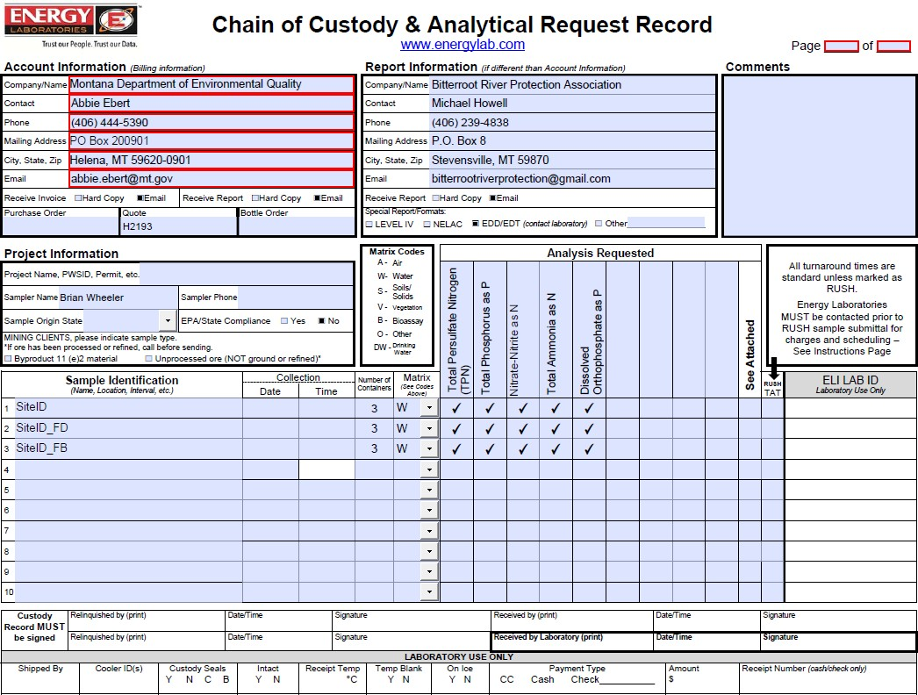

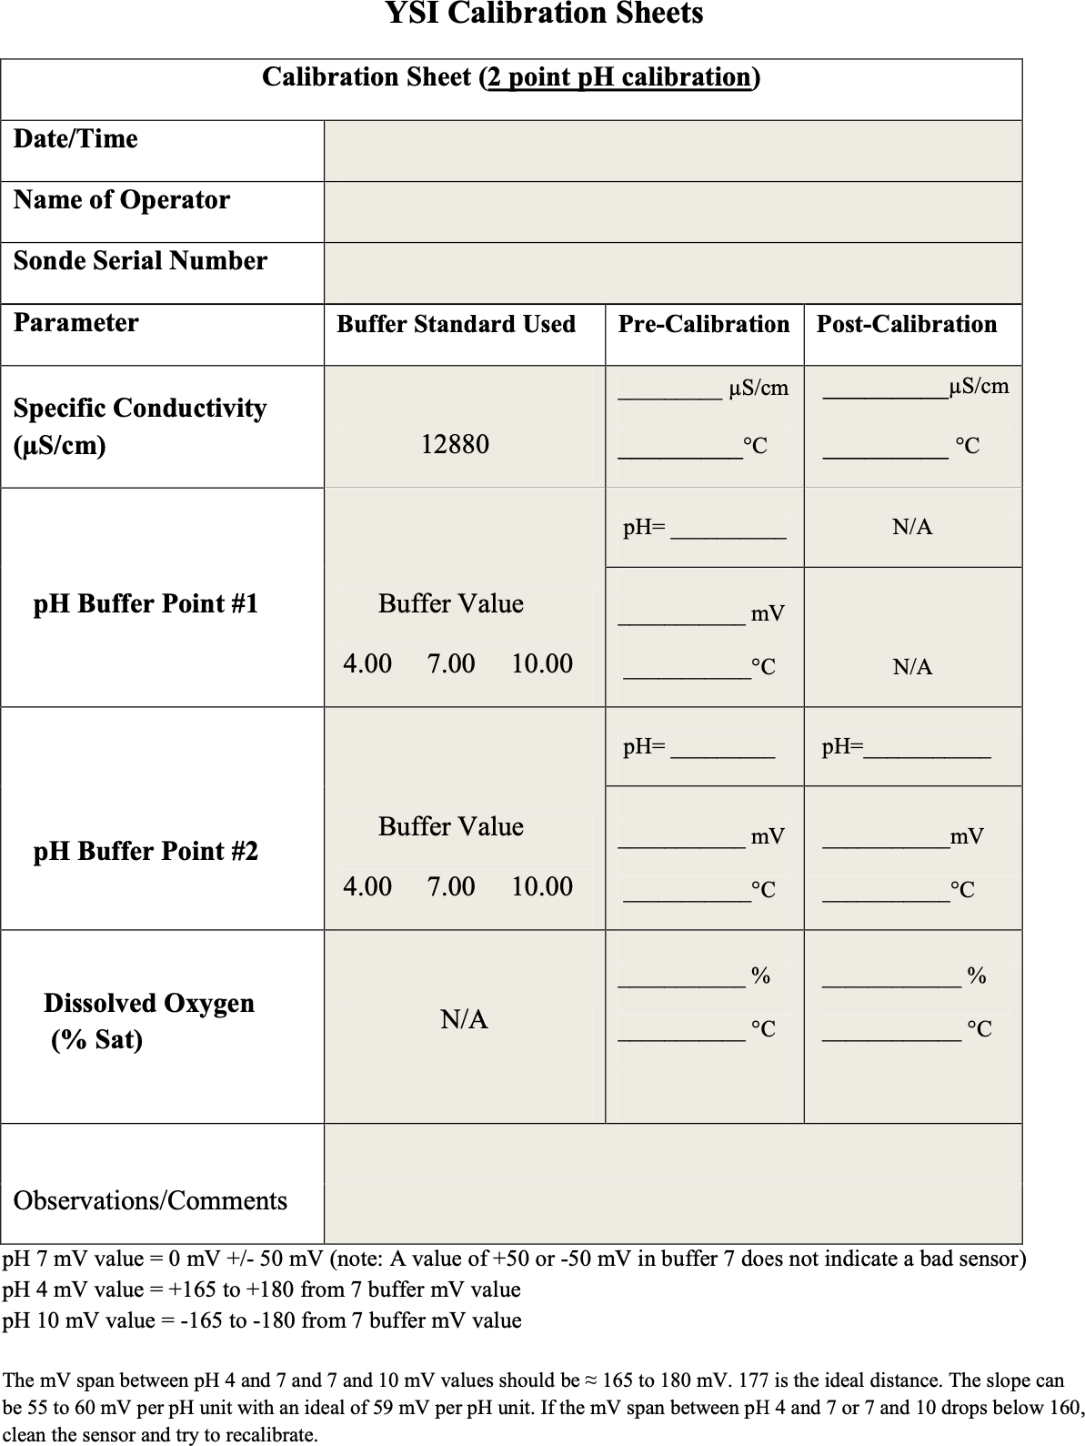



# Appendix F – QA/QC Terms and Definitions

**Accuracy**. A data quality indicator, accuracy is the extent of agreement between an observed value (sampling result) and the accepted, or true, value of the parameter being measured. High accuracy can be defined as a combination of high precision and low bias.

**Analyte**. Within a medium, such as water, an analyte is a property or substance to be measured. Examples of analytes would include pH, dissolved oxygen, bacteria, and heavy metals.

**Bias**. Often used as a data quality indicator, bias is the degree of systematic error present in the assessment or analysis process. When bias is present, the sampling result value will differ from the accepted, or true, value of the parameter being assessed.

**Blind sample**. A type of sample used for quality control purposes, a blind sample is a sample submitted to an analyst without their knowledge of its identity or composition. Blind samples are used to test the analyst’s or laboratory’s expertise in performing the sample analysis.

**Comparability**. A data quality indicator, comparability is the degree to which different methods, data sets, and/or decisions agree or are similar.

**Completeness**. A data quality indicator that is generally expressed as a percentage, completeness is the amount of valid data obtained compared to the amount of data planned.

**Data users**. The group(s) that will be applying the data results for some purpose. Data users can include the monitors themselves as well as government agencies, schools, universities, businesses, watershed organizations, and community groups.

**Data quality indicators (DQIs)**. DQIs are attributes of samples that allow for assessment of data quality. These include precision, accuracy, bias, sensitivity, comparability, representativeness and completeness.

**Data quality objectives (DQOs)**. Data quality objectives are quantitative and qualitative statements describing the degree of the data’s acceptability or utility to the data user(s). They include data quality indicators (DQIs) such as accuracy, precision, representativeness, comparability, and completeness. DQOs specify the quality of the data needed in order to meet the monitoring project's goals. The planning process for ensuring environmental data are of the type, quality, and quantity needed for decision making is called the DQO process. Madison Stream Team Sampling and Analysis Plan Page 23

**Detection limit**. Applied to both methods and equipment, detection limits are the lowest concentration of a target analyte that a given method or piece of equipment can reliably ascertain and report as greater than zero.

**Duplicate sample**. Used for quality control purposes, duplicate samples are an additional sample taken at the same time from, and representative of, the same site that are carried through all assessment and analytical procedures in an identical manner. Duplicate samples are used to measure natural variability as well as the precision of a method, monitor, and/or analyst. More than two duplicate samples are referred to as replicate samples.

**Environmental sample**. An environmental sample is a specimen of any material collected from an environmental source, such as water or macroinvertebrates collected from a stream, lake, or estuary.

**Field blank**. Used for quality control purposes, a field blank is a “clean” sample (e.g., distilled water) that is otherwise treated the same as other samples taken from the field. Field blanks are submitted to the analyst along with all other samples and are used to detect any contaminants that may be introduced during sample collection, storage, analysis, and transport.

**Instrument detection limit**. The instrument detection limit is the lowest concentration of a given substance or analyte that can be reliably detected by analytical equipment or instruments (see detection limit).

**Matrix**. A matrix is a specific type of medium, such as surface water or sediment, in which the analyte of interest may be contained.

**Measurement Range**. The measurement range is the extent of reliable readings of an instrument or measuring device, as specified by the manufacturer.

**Method detection limit (MDL)**. The MDL is the lowest concentration of a given substance or analyte that can be reliably detected by an analytical procedure (see detection limit).

**Precision**. A data quality indicator, precision measures the level of agreement or variability among a set of repeated measurements, obtained under similar conditions. Relative percent difference (RPD) is an example of a way to calculate precision by looking at the difference between results for two duplicate samples.

**Protocols**. Protocols are detailed, written, standardized procedures for field and/or laboratory operations.

**Quality assurance (QA)**. QA is the process of ensuring quality in data collection including: developing a plan, using established procedures, documenting field activities, implementing planned activities, assessing and improving the data collection process and assessing data quality by evaluating field and lab quality control (QC) samples.

**Quality assurance project plan (QAPP)**. A QAPP is a formal written document describing the detailed quality control procedures that will be used to achieve a specific project’s data quality requirements. This is an overarching document that might cover a number of smaller projects a group is working on. A QAPP may have a number of sample analysis plans (SAPs) that operate underneath it.

**Quality control (QC)**. QC samples are the blank, duplicate and spike samples that are collected in the field and/or created in the lab for analysis to ensure the integrity of samples and the quality of the data produced by the lab.

**Relative percent difference (RPD)**. RPD is an alternative to standard deviation, expressed as a percentage and used to determine precision when only two measurement values are available. Calculated with the following formula: RPD as % = ((D1 – D2)/((D1 + D2)/2)) x 100 Where: D1 is first replicate result D2 is second replicate result

**Replicate samples**. See duplicate samples.

**Representativeness**. A data quality indicator, representativeness is the degree to which data accurately and precisely portray the actual or true environmental condition measured.

**Sampling and Analysis Plan (SAP)**. A SAP is a document outlining objectives, data collection schedule, methods and data quality assurance measures for a project.

**Sensitivity**. Related to detection limits, sensitivity refers to the capability of a method or instrument to discriminate between measurement responses representing different levels of a variable of interest. The more sensitive a method is, the better able it is to detect lower concentrations of a variable.

**Spiked samples**. Used for quality control purposes, a spiked sample is a sample to which a known concentration of the target analyte has been added. When analyzed, the difference between an environmental sample and the analyte’s concentration in a spiked sample should be equivalent to the amount added to the spiked sample.

**Standard operating procedures (SOPs)**. An SOP is a written document detailing the prescribed and established methods used for performing project operations, analyses, or actions.

# Appendix G – Quality Control Checklist

**Laboratory QC**

Condition of samples upon receipt

Cooler/sample temperature within required range

Proper collection containers

All containers intact

Sufficient sample volume for analysis

Sample pH of acidified samples <2

All field documentation complete. If incomplete areas cannot be completed, document the issue.

Holding times met

Field duplicates collected at the proper frequency (specified in SAP)

Field blanks collected at the proper frequency (specified in SAP)

All sample IDs match those provided in the SAP. Field duplicates are clearly noted as such in lab results.

Analyses carried out as described in the SAP (e.g., analytical methods, photo documentation, field protocols)

Reporting detection limits met the project-required detection limit

All blanks were less than the project-required detection limit.

If any blanks exceeded the project-required detection limit, associated data is flagged.

Laboratory blanks/duplicates/matrix spikes/lab control samples were all within the required control limits defined within the SAP

Project DQOs and DQIs were met (as described in SAP)

Summary of results of OC analysis, issues encountered, and how issues were resolved addressed (corrective action)

Completed QC checklist before upload into DEQ’s EQuIS (or other) database.