**Missoula Valley Water Quality District**

**Missoula Valley Tributary Baseline Nutrient Monitoring**

**Sampling and Analysis Plan**

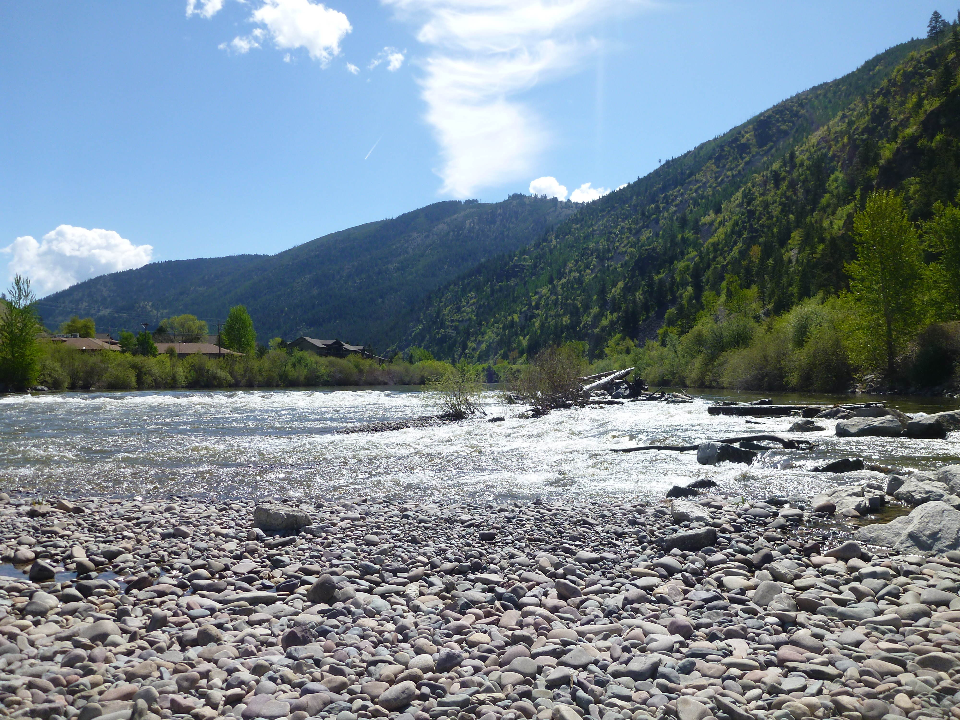

Date: May 9th, 2022

**Prepared by:**

Kerri Mueller

Elena Evans

Missoula Valley Water Quality District

301 W. Alder St.

Missoula, MT 59802

**Approved by:**

/s/ Abbie Ebert____________________________________________ 5/16/2022___________

Abbie Ebert (Montana DEQ VM Lab Analysis Program Manager) Date

/s/ Katie Makarowski_______________________________________ 5/16/2022___________

Katie Makarowski (Quality Assurance Officer) Date

# Table of Contents

Table of Contents 1

1.0 INTRODUCTION 1

1.1 Project Overview 1

1.2 Project Area Overview 1

1.3 Project Team and Responsibilities 7

2.0 Objectives and Sampling Design 8

2.1 Project Goals and Objectives 8

2.2 Monitoring Locations 9

2.3 Monitoring Schedule 12

2.4 Water Quality Parameters 12

3.0 Field Procedures 13

3.1 Order of Operations 13

3.2 Field Forms 13

3.3 Data Collection Standard Operating Procedures 13

4.0 Laboratory Analytical Requirements 16

5.0 Quality Assurance/Quality Control (QA/QC) 17

5.1 Overview 17

5.2 Training 17

5.3 QC Samples: Field Duplicates 18

5.4 QC Samples: Field Blanks 18

5.6 Data Quality Indicators 19

5.7 Field Health and Safety 21

6.0 Data Management, Record Keeping & Reporting 21

6.1 DEQ’s MT-eWQX database and Data Quality Review 21

6.1.1 Project ID 22

6.2 Other Data Management Approaches 22

7.0 Data Analysis and Reporting 22

7.1 Data Analysis 22

7.2 Reporting 22

8.0 References 23

Appendix A - Project Budget 24

Appendix B – Field Forms 26

Appendix c – Equipment and supplies 31

Appendix D – QA/QC Terms and Definitions 31

# 1.0 INTRODUCTION

## 1.1 Project Overview

The Missoula Valley Water Quality District (MVMQD) is charged with protecting and improving the quality of surface water and groundwater within the Missoula Valley. In addition to extensive monitoring of groundwater and the Clark Fork River since the 1990’s, surface water monitoring of the key tributaries to the Clark Fork River is essential in order to understand the sub-basin pollutant contributions to the Clark Fork, identify baseline conditions in the tributaries as development increases and land subdivisions are requested, and focus restoration efforts.

In 2019, the MVWQD initiated a volunteer monitoring program to engage the Missoula Valley community including its highly skilled water professionals with the process of protecting and monitoring the tributaries of the Clark Fork River; this baseline study allows the MVWQD and the community to track the impact that development, climate change, recreation, and historic uses have on the quality of Missoula’s water. To identify how management and land use changes impact water quality, it is necessary to build a quantitative dataset consisting of background nutrient, chloride, and total suspended solids (TSS) distributions in the valley. This tributary study is a crucial step in order to meet the water quality improvement goals for the Clark Fork River by focusing on how changes in the sub-basins influence the Clark Fork River.

With the support of Montana Department of Environmental Quality (DEQ), the MVWQD has monitored six tributaries' streams to the Clark Fork River since 2019; this included Grant Creek, Miller Creek, O’Brien Creek, O’Keefe Creek, Pattee Creek, and Rattlesnake Creek. Beginning in 2021, MVWQD monitored an additional ten tributary streams with the support of Monitoring Montana Waters (MMW), which included Marshall Creek, Donovan Creek, Houle Creek, Mill Creek, Deer Creek, Butler Creek, La Valle Creek, Hayes Creek, Lolo Creek, and Roman Creek. For 2022, MVWQD plans to continue monitoring the original six tributaries funded by DEQ and continue monitoring nine of the original ten tributaries funded by MMW.

The volunteers participating in the monitoring program will collect grab samples of the tributary streams to the Clark Fork River that will be sent to Energy Labs through DEQ Volunteer Monitoring Lab Analysis Support Program (VMLASP) OR to the Freshwater Research Lab (FRL) at the Flathead Lake Biological Station through the Monitoring Montana Waters Volunteer Monitoring program. MVWQD staff will measure stream discharge within the same week as volunteer sample collection on Grant, Miller, O’Brien, O’Keefe, Pattee, Mill, Deer, Butler, La Valle, and Hayes Creeks; this data will be used to create discharge rating curves to compliment the water quality baseline data for a more comprehensive analysis of the tributaries. Staff gauge measurements will be collected on the streams that have staff gauges installed; this includes on Grant, Miller, O’Brien, O’Keefe, and Pattee Creeks.

A budget table for laboratory analytical costs is included in **Appendix A**.

## 1.2 Project Area Overview

The Missoula Valley is located in Missoula County in Western Montana in the Middle Rockies ecoregion. The Missoula Valley is home to a quickly growing population of approximately 120,000 people. The Clark Fork River flows east to west across the valley; its’ largest tributary is the Bitterroot River, which flows northwest into the valley and joins the Clark Fork west of the City of Missoula. Missoula’s valley bottom is largely developed with forested land predominating headwaters. The people of the valley rely heavily upon its sole-source aquifer which both receives and feeds surface water from the Clark Fork River and its’ tributaries, depending upon the reach and season.

With increasing development and impact, it is important to collect and understand the baseline water quality data of the tributaries in the valley. Although Grant Creek and Miller Creek are the only tributaries currently listed as impaired, many of their identified probable sources of impairment, such as streambank modifications/destabilization and site clearance associated with land development, are likely widespread throughout the valley. In order to identify if the MVWQD should focus restoration efforts, work with DEQ to list other streams, or provide specific comments for subdivisions in different basins, a baseline water quality assessment and understanding of probable pollution sources throughout other key tributaries is necessary.

The data from all 15 tributaries will be used in conjunction with groundwater sampling and land use information to begin to evaluate surface-groundwater interaction and the impact of policy on water quality. Ideally, streams will be monitored upstream, mid-stream, and downstream, but monitoring sites are dependent on access and funding. Further, this monitoring program will serve as an important outreach tool to interest and incorporate individuals in areas that have not traditionally participated in water quality efforts with the MVWQD.

The six tributaries monitored in the study that are funded by the DEQ include Grant, Miller, O’Brien, O’Keefe, Pattee, and Rattlesnake Creeks. Monitoring locations are outlined in **Table 3**. Below are descriptions of the six DEQ funded tributaries:

1. **Grant Creek** – North Valley Clark Fork River Tributary

Grant Creek is an impaired stream for sediment, nutrients (specifically total nitrogen (TN)), and temperature. The TMDL identified Grant Creek as being significantly altered in the lower portion of the watershed. The Central Clark Fork Tributaries TMDLs and Water Quality Improvement Plan identified issues in Grant Creek that include alteration in streamside or littoral vegetation covers, excess algal growth, low flow alterations, nutrient, sediment, and temperature issues (<http://deq.mt.gov/Portals/112/Water/WQPB/CWAIC/TMDL/COL-TMDL-01a.pdf>). After flooding in the 1990s, the County used pre-disaster mitigation funding on the reach between West Broadway and the Clark Fork River floodplain. The three sampling locations were selected in areas similar to those used for the TMDL study on public right of way in order to ensure access.

1. **Miller Creek** – Bitterroot River Tributary

Miller Creek is listed for temperature and sediment impairments. The MVWQD recently completed a Watershed Restoration Plan for Miller Creek (<http://deq.mt.gov/Portals/112/Water/WPB/Nonpoint/Publications/WRPs/Miller_Creek_WRP-Final.pdf>). Recent informal field surveys identified that the stream loses volume at approximately the middle sampling point (MIL_LOS). In order to identify how this impacts water quality, we will sample three key locations within representative land uses to compare water quality data with septic and well permits, as well as further refine restoration focus. There have been significant restoration efforts in the waterway and volunteer monitoring may provide an opportunity to assess resulting load reductions.

1. **O’Brien Creek** – South Valley Bitterroot River Tributary

O’Brien Creek is not listed as impaired on the 303(d) list. It is a key tributary to the Bitterroot River with larger parcel development, such as 40 acre lots instead of 0.5 acre lots. Monitoring O’Brien Creek will provide insight on how valley orientation may impact water quality because it is in a north facing valley while Grant, O’Keefe, and Rattlesnake Creeks are in a south facing valley. Watershed orientation can alter runoff patterns which impacts the transport of road chlorides and the overall hydrograph. The data collected from the two sampling locations on O’Brien Creek will be important to gaining a fuller understanding of factors controlling water quality in the Missoula Valley.

1. **O’Keefe Creek** – North Valley Clark Fork River Tributary

O’Keefe Creek is currently not listed as an impaired stream. From its headwaters in the Evaro area to the confluence with the Clark Fork, O’Keefe Creek is channelized by the Highway 93 corridor and then flows through large parcel subdivisions before being rerouted around the former Smurfit-Stone Mill. The three sampling locations were selected to capture land use and longitudinal changes. MWVQD identified O’Keefe Creek as a stream of concern due to increasing development pressure and some of the highest contaminant concentrations in previous years of sampling.

1. **Pattee Creek** – Bitterroot River Tributary

Pattee Creek headwaters are in the Lolo National Forest in a recreational area, flowing downstream through more developed areas. Shortly after entering the valley, Pattee Creek enters a desilting pond and is thereafter treated as stormwater. Our upstream sampling location is located at the Barmeyer Trailhead where conditions should be representative of less developed conditions. The downstream sampling location on Hillcrest Loop is in a hilly, residential area. Both sampling locations are before the desilting pond and any strong stormwater influences.

1. **Rattlesnake Creek** – North Valley Clark Fork River Tributary

Rattlesnake Creek is not listed as impaired, but the watershed has experienced considerable development over the past twenty years. With Trout Unlimited removing the Rattlesnake Dam the summer of 2019, more attention is focused on the river. Trout Unlimited is conducting geomorphic monitoring to assess planform and longitudinal changes as a result of the dam removal; water quality data from the two sampling locations will nicely complement this work. Further, nutrient sampling will enable the MVWQD to compare current data with previous MVWQD studies involving nutrients and areas of the Rattlesnake with and without sewer service. This could help in directing efforts to increase sewer connectivity or help the cohort of groups working in the Rattlesnake area to identify high impact restoration projects.

In 2021, MVWQD monitored ten streams funded by MMW; nine streams will be monitored in 2022. The nine tributaries that are funded by MMW include Marshall, Donovan, Houle, Mill, Deer, Butler Creek, La Valle, Hayes, and Roman Creeks. Monitoring locations are outlined in section 2.2 Monitoring Locations in Table 3. Monitoring Locations. Below are descriptions of the nine MMW funded tributaries:

1. **Marshall Creek** – Clark Fork River Tributary

Marshall Creek runs through Marshall Mountain which was an old ski resort that was purchased by the city in late 2021 to open as a recreational park. With monitoring starting the year it was purchased by the city, impacts from recreation may be evident in 2022’s data and will be crucial when looking into whether restoration efforts are necessary. Marshall Creek runs through an area prime for future development and will be sampled upstream and downstream to monitor impacts to water quality.

1. **Donovan Creek** – Clark Fork River Tributary

Donovan Creek is located east of and outside of the Water Quality District Boundary but is a contributor to the Clark Fork River and interacts with the groundwater heavily. The sampling site is downstream near I-90. Donovan Creek interacts with a lot of roads and houses that are encroaching on the riparian area of the stream. Data may reflect any upstream non-point source pollution or groundwater contributions.

1. **Houle Creek** – Clark Fork River Tributary

Houle Creek is located on the northwest side of the Missoula Valley in clay heavy soil. It runs through a USFS management area and development is increasing in the area; monitoring data from the one upstream sampling site may reflect any recreational or human impacts on water quality over time.

1. **Mill Creek** – Clark Fork River Tributary

Mill Creek is located on the northwest side of the Missoula Valley in clay heavy soil and flows through USFS management land with approximately 85% of the area being covered by forest. Mill Creek flows through Frenchtown once it reaches the valley and past I-90. The upstream sampling site should reflect true headwaters conditions and the downstream site should reflect impacts from development especially regarding TSS and chlorides.

1. **Deer Creek** – Clark Fork River Tributary

Deer Creek runs through Pattee Canyon and flows northeast on a north facing basin, opposite of Pattee Creek which flows west. The upstream location should reflect less developed conditions, and the downstream site should reflect any impacts from recreation, forest management in Pattee Canyon, increased alterations to roads, and inholdings.

1. **Butler Creek** – Clark Fork River Tributary

Butler Creek’s headwaters start above the Snowbowl Ski Area on the north side of the valley in an area with the potential for more development. The upstream sampling site is located downstream of the Snowbowl Ski Area and may show any impacts from recreation in the area; it is also adjacent to changing land use patterns. The downstream site may identify any cumulative impacts of recreation and development upstream. The confluences with the Clark Fork River for La Valle Creek and Butler Creek are near each other, but both streams flow out of different valleys in the mountains. The proximity of these creeks will help in comparing how different land uses impact water quality.

1. **La Valle Creek** – Clark Fork River Tributary

La Valle Creek is located in the north side of the valley in an area with potential for development. The upstream sampling site is located below the USFS boundary, and the downstream site may identify any cumulative impacts of recreation and development upstream. The confluences for La Valle and Butler are close in proximity, but both streams flow out of different valleys in the mountains. The proximity of these creeks will help in comparing how different land uses impact water quality.

1. **Hayes Creek** – Bitterroot River Tributary

The headwaters of Hayes Creek are predominately on USFS land; the DNRC designated the drainage as a controlled groundwater area. It is part of a smaller drainage with greater bedrock drainage; fractured bedrock may increase the interaction between the creek and septic systems. Hayes Creek is monitored at one site to capture downstream conditions.

1. **Roman Creek** – Clark Fork River Tributary

Roman Creek is located west of the City of Missoula in an area with clay soils and rapidly increasing development. The area has high groundwater; the irrigation ditch that runs along the northern edge of the valley influences the creek and groundwater.

From the previous three years of sampling on the six tributaries funded by the DEQ, MWVQD identified O’Keefe Creek as a stream of concern. MVWQD is following up with a more intensive study this year to monitor water levels of private wells in the area. Many other tributary streams are similar to O’Keefe Creek in terms of increasing development pressure and limited knowledge to date. With funds from MMW, MVWQD can continue to expand the scope of the analyses and identify where the MVWQD should focus restoration efforts, work with DEQ to list other streams, or provide specific comments for subdivisions in different basins. A baseline water quality assessment and understanding of probable sources throughout other key tributaries is necessary. **Figure 1** depicts the Missoula Valley and the streams and rivers of interest for volunteer monitoring.

**Figure 1. 2022 MVWQD Volunteer Monitoring Project Area**

## 1.3 Project Team and Responsibilities

One volunteer will be designated the team lead. The team lead will be someone who has experience in water sampling either through their profession or as a student. The team lead will ensure all the data are entered into Survey123, the data are recorded in a field notebook, and the samples are delivered to Kerri Mueller. The team lead will oversee picking up the sample bottles or designating where and with whom the sample bottles will be dropped off prior to sampling (i.e., a workplace, with another volunteer etc.).

**Table 1. Project Team Roles and Responsibilities**

| **Role** | **Person(s)** | **Contact phone, email** |
| --- | --- | --- |
| VM Program Manager | Elena Evans | (406) 258-3495  eevans@missoulacounty.us |
| Develop Sampling and Analysis Plan (SAP) | Elena Evans  Kerri Mueller | (406) 258-3495  eevans@missoulacounty.us |
| Training monitoring personnel | [REDACTED]  kmueller@missoulacounty.us |
| Primary monitoring personnel | Kerri Mueller  Volunteers | [REDACTED]  kmueller@missoulacounty.us |
| Oversee monitoring personnel | Kerri Mueller | [REDACTED]  kmueller@missoulacounty.us |
| Review field forms |
| Lab coordination (e.g., bottle orders, shipping notifications, lab EDDs) |
| Ship or deliver samples to lab |
| Review data quality |
| Upload data into MT-eWQX database |
| Write final report |

# 2.0 Objectives and Sampling Design

## 2.1 Project Goals and Objectives

**Table 2. Project Goals, Objectives, and Analyses**

| **Goal** | **Question** | **Objective** | **Data Analysis** |
| --- | --- | --- | --- |
| **GOAL 1:** To investigate nutrient loading on tributary streams to the Clark Fork River in the MVWQD and prioritize water quality improvement projects aimed at reducing nutrients. | What are the current nutrient concentrations in the stream and how do they vary from upstream to downstream? | Collect nutrient samples (TPN, TP, and NO2+3) once prior to peak runoff, once during summertime and once in October to bracket summer runoff and identify septic inputs. | Graph nutrient concentrations and evaluate differences from site to site. |
| Compare nutrient concentrations to Montana's protective ranges of nutrients. |
| Where are opportunities to pursue voluntary best management practices to reduce nutrient loads? | Evaluate land uses between sites where the data indicates increasing nutrient concentrations to identify potential nutrient-reduction project areas. |
| Compare nutrients to septic density and assumed septic age. |
| Is there a relationship between the density of septics and nutrient loading? Is there a relationship between age of development/age of septic and nutrient loading? | Compare stream nutrient data with groundwater data to further identify impact of septics and/or surface-groundwater exchange. |
| **GOAL 2:** To evaluate chloride and TSS loads and timing as it relates to septic or road salt inputs. | Where are TSS and Chloride loads high? Is there a relationship between high loading and land uses/road proximity/lack of riparian vegetation? | Collect TSS and chloride samples once prior to peak runoff, once during summertime and once after October 1 to bracket summer runoff and year-round inputs such as those from septics. | Use GIS to identify road density, land use, and approximate timing of inputs. |
| Are there trends between upstream and downstream sites or trends over time? |
| **GOAL 3:** To collect baseline data. | What does water quality look like in Missoula Valley tributary sub-basins? | Collect nutrients, TSS and chloride samples once prior to peak runoff, once during summertime and once after October 1 capture the rising limb, falling limb, and baseflow water quality characteristics of the sub-basins. | Compare “headwaters” to “confluence” as a whole dataset and then as individual basins. |
| Are there any perturbations unique to this year that may make this data not ideal as baseline? How does it compare to any previous data? Across sub-basins? | Identify circumstances (such as dam removal on Rattlesnake) to caveat that data and identify if a valley wide baseline can be identified. |

## 2.2 Monitoring Locations

There is a total of 29 MVWQD Volunteer Monitoring Sites. 15 are funded by the DEQ and 14 are funded by MMW.

**Table 3. Monitoring Locations\***

| **Site Name** | **Station ID** | **Latitude, Longitude** | **Site Description** | **Rationale for Site Selection** |
| --- | --- | --- | --- | --- |
| **Funded by DEQ** | | | | |
| Grant Creek – Mullan Rd | GRA_MUL | 46.885768, -114.085061 | Close to confluence with Clark Fork River | Determine contribution** to Clark Fork from Grant sub-basin |
| Grant Creek – Highlander | GRA_HIG | 46.904487, -114.045168 | Downstream of residential area | Assess contributions from larger developed area |
| Grant Creek – Old Grant Creek Rd Bridge | GRA_OLD | 46.947375, -114.014831 | Headwaters | Baseline water quality parameters upstream from development and agriculture |
| Miller Creek – Wise River Rd | MIL_WIS | 46.790227, -114.051675 | Close to confluence with Bitterroot River | Downstream of residential development, determine contribution** to Bitterroot from Miller sub-basin |
| Miller Creek – Singletree Ln Bridge | MIL_LOS | 46.781115, -114.003185 | Downstream of agricultural lands and adjacent to previous restoration work | Assess contributions** from agricultural area |
| Miller Creek – Gibson Residence | MIL_GIB | 46.765687, -113.943077 | Headwaters | Baseline water quality parameters upstream from development |
| O’Brien Creek – Blue Mountain Rd | OBR_BLU | 46.849874, -114.109469 | Close to confluence with Clark Fork River | Determine contribution to Clark Fork from Rattlesnake sub-basin |
| O’Brien Creek – O’Brien Creek Rd Trlhd. | OBR_TRA | 46.8485595, -114.223383 | Headwaters sample on USFS land at the trailhead | Determine impacts and contributions of fire upstream |
| O’Keefe Creek – Waldo Rd | OKE_WAL | 46.965377, -114.144676 | Lower gradient reach downstream of residential area | Assess contributions from larger developed area and proximal to groundwater monitoring well |
| O’Keefe Creek – O’Keefe Creek Blvd | OKE_OKE | 46.987048, -114.126119 | Downstream of more development | Isolate impacts from development |
| O’Keefe Creek – 93N | OKE_93N | 47.005632, -114.125258 | Proximal to 93N | Understand highway impacts |
| Pattee Creek – Hillcrest Loop | PAT_HIL | 46.840887, -113.991942 | Just before entering valley floor | Assess contributions from upstream residential area |
| Pattee Creek – Barmeyer Trlhd. | PAT_BAR | 46.82936, -113.978755 | Headwaters | Baseline water quality parameters upstream from development |
| Rattlesnake Creek – Greenough Park | RAT_GRE | 46.879531, -113.974461 | Lower gradient reach downstream of residential area | Assess contributions from larger developed area and proximal to groundwater monitoring well |
| Rattlesnake Creek – Sawmill Gulch Bridge | RAT_SAW | 46.923038, -113.961038 | Headwaters | Baseline water quality parameters upstream from development |
| **Funded by MMW** | | | | |
| Marshall Creek – Marshall Creek Rd Culvert | MAR_CUL | 46.906345, -113.926104 | Headwaters | Marshall Creek is adjacent to areas with increasing recreation use and prime for future development. This is the upstream site. |
| Marshall Creek – Hwy 200 | MAR_200 | 46.888584, -113.925663 | Confluence with Clark Fork | Marshall Creek is adjacent to areas with increasing recreation use and prime for future development. This is the downstream site. |
| Donovan Creek – E Mullan Road | DON_EMU | 46.802814, -113.7758854 | Downstream | Reflects impacts of upstream non-point source and groundwater contributions |
| Hayes Creek – Highway 93S | HAY_93S | 46.813711, -114.094114 | Downstream | Reflects cumulative impacts from upstream non-point sources |
| Houle Creek – Lackman Loop | HOU_LAC | 47.061767, -114.276527 | Headwaters | Upstream site so reflective of USFS management and recreation impacts |
| Mill Creek – Beckwith St | MIL_BEC | 47.014365, -114.228465 | Downstream | Downstream, cumulative impacts |
| Mill Creek – Mill Creek Trl | MIL_FOR | 47.022445, -114.206001 | Upstream | Upstream site reflective of USFS management conditions |
| Deer Creek – Deer Creek Rd | DEE_DEE | 46.856425, -113.882955 | Downstream | Downstream site that can identify cumulative impacts from recreation and management actions |
| Deer Creek – Pattee Canyon Rd | DEE_PAT | 46.819584, -113.908581 | Headwaters | Upstream site reflective of intensive recreation in the area |
| Butler Creek – Interstate Pl | BUT_INT | 46.933205, -114.097495 | Downstream | Downstream site to identify cumulative impacts |
| Butler Creek – Butler Creek Rd | BUT_BUT | 46.970065, -114.03717 | Upstream | Upstream site adjacent to changing land use patterns |
| La Valle Creek – Expressway | LAV_EXP | 46.935893, -114.102026 | Downstream | Downstream site for LaValle but above the superfund site |
| La Valle Creek – La Valle Creek Rd | LAV_LAV | 46.973856, -114.07114 | Upstream | Upstream site on LaValle below USFS boundary |
| Roman Creek – Morgan Lane | ROM_FOR | 47.053174, -114.250421 | Only public access available | Reflects rapid development and irrigation influences |

*These are proposed sampling locations which may change due to unforeseen access or other issues. See attached GIS layer for longitude/latitude. All sites will collect the parameters outlined in Table 5. **Contribution is used in lieu of load due to uncertainty in calculating load as a result of limited discharge and water quality samples. Our sampling efforts do not currently meet DEQ nutrient sampling protocols.

**Figure 2. 2022 Proposed Volunteer Monitoring Locations.** Sampling locations for the 2022 volunteer monitoring field seasons. Monitoring locations funded by the DEQ are indicated by a pink cross; DEQ funded samples will be sent to Energy Labs in Helena for analysis. Monitoring locations funded by MMW are indicated by a green diamond; MMW funded samples will be sent to the Flathead Lake Bio Station for analysis.

## 2.3 Monitoring Schedule

Monitoring will occur at one to three sites along each tributary three times between May 1st and October 31st. The following parameters will be collected during each visit to each site:  total persulfate nitrogen (TPN), total phosphorus (TP), nitrite plus nitrate (NO2+3), total suspended solids (TSS), and chloride. The sites will be sampled in Mid-May to early June to capture high flow and contributions from winter accumulation, in Mid-July to capture baseflow and a flushed system, and in late September to early October to capture baseflow and fall contributions.

**Table 4. Monitoring Schedule**

|  |  |  |
| --- | --- | --- |
| **Expected Date** | **Parameters** | **Rationale for Timing** |
| May 20th – 23rd | TN, TP, NO2+3, Chloride, TSS | High flow expected, contributions from winter development (i.e., salt) |
| July 15th – 18th | TN, TP, NO2+3, Chloride, TSS, stage | Baseflow, flushed system |
| September 30th – October 3rd | TN, TP, NO2+3, Chloride, TSS, stage | Baseflow; fall contributions |

## 2.4 Water Quality Parameters

The water quality parameters important to this project include total nitrogen (TN), total phosphorous (TP), nitrite plus nitrate (NO2+3), total suspended solids (TSS), and chlorides. Discharge (flow) and photos will also be collected. These parameters are crucial to track nutrient impairments and to assess human impacts on the water quality.

**Table 5. Water Quality Parameters**

|  |  |  |
| --- | --- | --- |
| **Water Quality Parameters** | | |
| **Parameter or Data Type** | **Collection Approach** | **Justification for Collecting** |
| Total Nitrogen (TN) | Grab samples will be collected by volunteers and shipped to Energy Labs (DEQ) OR Flathead Lake Bio Station (MMW) for laboratory analyses of parameters. | Collect baseline nutrient data on Clark Fork tributaries to see existing nutrient impairments and to evaluate nutrient patterns, using Chloride as an additional parameter to assess human impacts. |
| Total Phosphorus (TP) |
| Nitrite plus Nitrate (NO2+3) |
| Total Suspended Solids (TSS) |
| Chloride |
| Discharge (flow)* | Measured with OTT flow meter. | Necessary to pair concentrations with flow data to calculate loads. |
| Photos | Taken with phone or digital camera. | To document seasonal changes in riparian vegetation, land uses, stream flora, and flow conditions. |

*Staff oversee creating stage-discharge rating curves and conducting discharge measurements. Where staff gauges are installed, volunteers will collect stage information. Discharge measurements and calculations will not necessarily be collected at the same time as volunteer monitoring efforts and are not a deliverable specifically for the volunteer monitoring program.

# 3.0 Field Procedures

## 3.1 Order of Operations

The order of operations for volunteer monitoring will be as follows:

1. Check the weather for date and time of sampling to ensure safe sampling. Read the **MVWQD Volunteer Monitoring Program Field Sampling Standard Operating Procedures (SOP)** for more detailed descriptions on operating procedures. Watch videos of how to take a grab sample (videos are sent to volunteers).
2. Volunteers pick up sampling bottles the week of sampling. Kerri Mueller will prepare the sets of bottles for each volunteer and coordinate bottle pick up.
3. Gather and pack necessary equipment listed in **Appendix C**.
4. At the sampling site, make observations of the stream to ensure it is safe to sample at that time. Prepare for sampling and collect grab samples according to the Field Instructions including labeling bottles, taking photos, filling out Survey123 and field forms, sampling, adding preservative, and confirming all notes and observations are written and submitted.
5. Deliver samples to Kerri Mueller at the Water Quality District.
6. Freeze TPN, TN, NO2+3 samples and refrigerate TSS and chloride samples.
7. Confirm all necessary samples are collected. Fill out the Chain of Custody for the respective lab and ship the samples.

## 3.2 Field Forms

* ArcGIS Survey123
* Field Notebook
* Energy Lab Chain of Custody
* Flathead Lake Bio Station Chain of Custody

Copies of field forms are included in **Appendix B**.

## 3.3 Data Collection Standard Operating Procedures

Water quality samples will be conducted following the cautions, sampling methods, and other guidance detailed in the **MVWQD Volunteer Monitoring Program Field Sampling SOP** below.Volunteers will receive this SOPwhen picking up the sample bottles for each sampling event. Kerri Mueller will ensure each volunteer has the correct bottles and SOPs that are specific to each sampling site depending on the lab the sample will be analyzed at.

**MVWQD Volunteer Monitoring Program Field Sampling SOP**

1. **Safety First:** Check the weather in the area and of sampling locations. Do not go out in inclement weather and do not sample streams that are too deep or moving too quickly.
2. **Training:** Watch instructional videos of how to collect a grab sample
   1. [How to Collect a Grab Sample](https://www.youtube.com/watch?v=dbCE4R3AD90) (<https://www.youtube.com/watch?v=dbCE4R3AD90>)
   2. [How to Collect Water Samples](https://www.youtube.com/watch?v=NZeb8bA4ze4) (<https://www.youtube.com/watch?v=NZeb8bA4ze4>)
3. **Before leaving for site:** Gather the gear necessary for sampling. Coordinate bottle pick up with Kerri Mueller. Kerri will prepare a cooler of the correct bottles for each site and volunteer.
   1. Gear Checklist:
      1. Sample bottles
      2. Smartphone with Survey123 app installed
      3. Cooler filled with ice
      4. Waterproof boots or waders
      5. Field notebook
      6. Labels or tape
      7. Permanent marker, pen, and pencil
      8. Camera or a phone with a camera
      9. SAP and SOP
4. **Travel to site**
   1. Upon arrival, take a few minutes to acquaint yourself with the dynamics of the site. Look upstream and downstream to see if there is something that may impact the mixing of the flow or if there are areas that may not accurately represent the reach such as side channels or back eddies. Grab samples are representative of a single point in time and we want to compare upstream samples to downstream samples and then samples from each location to each other through time.
   2. Returning volunteers will navigate to the site they sampled in previous years and new volunteers will be shown where to sample by staff members.
   3. A list of monitoring locations in located in the SAP, Section 3.0 Monitoring Locations, Table 3. Monitoring Locations.
5. **Label bottles**
   1. If the bottles are not prelabeled, use the tape to add a label.
   2. Use the first three letters of the stream, the first three letters of the site and then the month, day, and year as the sample ID.
      1. e.g.) For a sample on Rattlesnake -Greenough Park on May 30th, 2022 use RAT_GRE_05302022.
   3. If you have been asked to do a duplicate or blank append that label
      1. e.g.) RAT_GRE_05302022_Dup
      2. e.g.) RAT_GRE_05302022_Blank
   4. Date Collected:
   5. Time Collected: please use military time (1:00 pm being 13:00)
   6. Filtered or Unfiltered: depends on the parameter (and lab associated with site)
6. **Fill out Survey123 and Field Notebook**
   1. Open the Survey123 app, select “Volunteer Water Monitoring,” and press the Collect button at the bottom of the screen. Fill out the following fields at time of sampling:
      1. Volunteer Name
      2. Date and Time of Sampling
      3. Site Drainage (Stream Name)
      4. GPS Location (this will auto populate to the position you are standing when you press collect)
      5. Photos: take photos in the same location every sampling trip. Please take additional photos if necessary to document changes in riparian vegetation condition, land uses, stream flora, flow conditions, water clarity, etc. Photos can be a combination of close-ups of water and substrate conditions as well as stream panoramas.
         1. Photo Upstream
         2. Photo Downstream
         3. Photo of Stream Staff Gauge
      6. Stream Staff Gauge Height (if present)
      7. Grab Sample Gathered? (Y/N)
      8. Notes or observations about the site (weather, water color or smell, etc.)
   2. In the Field Notebook, record all information entered into Survey123.
7. **Collect grab samples (DEQ Sites– Energy Labs Procedure)**
   1. Locate a place in the stream that is representative of the whole stream.
   2. Rinse the 1000 mL TSS sample bottle and lid three times by collecting a small amount of stream water, shaking the bottle with the cap on, and then disposing of the water behind you. Collect TSS first to ensure other grab samples are not disturbing extra sediment.
   3. Collect the TSS sample according to the instructional videos in Step 2. Submerge the bottle upside down until the mouth is about halfway between the surface and the bottom then fill. Fill the bottle above the shoulder of the bottle.
   4. Repeat b and c with the other bottles provided for TN, TP, NO2+3, Chloride, and duplicates.
   5. For the bottle with the yellow cap and “SULFURIC ACID PRESERVED” label, add the small vial of sulfuric acid after taking the sample.
   6. Place all samples immediately on ice in the cooler.
8. **Collect grab samples (MMW Sites – FLBS Procedure)**
   1. Locate a place in the stream that is representative of the whole stream
   2. For unfiltered samples (bottles with blue tape: TN/TP, Chloride, TSS)
      1. Rinse the 1000 mL TSS sample bottle and lid three times by collecting a small amount of stream water, shaking the bottle with the cap on, and then disposing of the water behind you. Collect TSS first to ensure other grab samples are not disturbing extra sediment.
      2. Collect the TSS sample according to the instructional videos in Step 2. Submerge the bottle upside down until the mouth is about halfway between the surface and the bottom then fill. Fill the bottle above the shoulder of the bottle.
      3. Repeat b and c with the other bottles provided for TN/TP, Chloride, and duplicates.
   3. For filtered samples (bottles with red tape: NO2+3)
      1. Open a new 60 cc syringe package. Triple-rinse the syringe three times with ambient stream water.
      2. Fill the syringe with stream water then screw a new 0.45 µm filter onto the syringe. Pass a small about of water through the syringe and filter to “prime” the filter.
      3. Triple-rinse the sample bottle and lid with a small amount of filtered water. Discard the filter used for rinsing, fill the syringe, attach a new filter, and prime the filter.
      4. Collect the sample: fill the bottle with filtered water. Often, to fill the bottle will require multiple refills of the syringe; when the syringe is empty, grip the filter’s edge, unscrew the filter, and refill the syringe, taking care not to contaminate the filter. If the filter is not clogged, screw the filter back onto the syringe and continue filtering until the bottle is sufficiently full. If the filter clogs mid-way throughout filtering, unscrew and discard the clogged filter, refill the syringe, screw on a new filter, pass a small amount of water through the new filter, and continue filtering. Repeat this process until the sample bottle is full.
      5. Leave appropriate headspace:
         1. For most samples, fill the bottle to the shoulder line in order to leave a small amount of head space if preservative is necessary.
         2. If samples are to be frozen, leave sufficient head space to allow the sample to expand when it freezes without the bottle breaking.
      6. If preservative is required to be added to the sample, put on gloves, carefully unscrew the lid, pour the entire contents of the preservative vial into the sample bottle, replace the lid, and gently invert the sample bottle three times to mix the preservative into the sample. Discard the empty preservative vial.
      7. Store samples upright according to sample preservation and storage requirements (e.g., in a cooler on regular ice at ≤6oC)
9. **Complete field activity checklist**
   1. Filled out and submitted Survery123
   2. Filled out the field notebook
   3. Labeled sample bottles
   4. Collected samples and put in cooler on ice
10. Coordinate sample drop off with Kerri Mueller
11. Once samples from all sites are dropped off with MVWQD, MVWQD will complete the following steps:
12. Fill out the Chain of Custody for samples for the respective lab: Energy Labs or Flathead Lake Bio Station Research Lab.
13. Package the samples properly and send as soon as possible keeping in mind the 7-day holding time for TSS.

## 4.0 Laboratory Analytical Requirements

**Table 6. Monitoring Parameter Suite, Sample Handling, Analysis & Preservation**

| **Parameter** | **Preferred Method** | **Required Reporting Limit (µg/L)** | **Holding Time (days)** | **Sample Container (size and material)** | **Preservative** |
| --- | --- | --- | --- | --- | --- |
| **Energy Labs** | | | | | |
| Total Suspended Solids (TSS) | A2540 D | 4000 | 7 | 1000 mL or 500 mL HDPE | Place on ice (≤6°C) |
| Chloride | EPA 300.00 | 50 | 28 | 250 mL HDPE | Place on ice (≤6°C) |
| Total Persulfate Nitrogen (TN) | A4500-N C | 40 | 28 | 250 mL HDPE | Place on ice (≤6°C) |
| Total Phosphorous as P | EPA 365.1 | 3 | 28 | 250 mL HDPE | Add provided H2SO4, then place on ice (≤6°C) |
| Nitrate-Nitrite as N | EPA 353.2 | 10 |
| **FLBS Freshwater Research Laboratory** | | | | | |
| Total Suspended Solids (TSS) | SM 2540-D | 0.2 | 7 | 1000 mL HDPE | Place on ice (4°C) |
| Chloride | EPA 300.1 | 0.25 | 28 | 60 mL HDPE | Filter, then freeze |
| Total Nitrogen as N | USGS 03-4174, EPA 363.2 | 25.0 | 45 | 60 mL HDPE | Freeze |
| Total Phosphorous as P | USGS 03-4174, EPA 365.1 | 1.5 | 45 | 60 mL HDPE | Freeze |
| Nitrate-Nitrite as N | EPA 353.2 |  | 45 | 60 mL HDPE | Filter, then freeze |

# 5.0 Quality Assurance/Quality Control (QA/QC)

## 5.1 Overview

Projects require adequate documentation, proper sample collection, handling, and analysis, and other measured to produce high quality, credible data that accurately represent conditions in the watershed and can be used to answer scientific questions or guide resource management decisions.

Quality Assurance (QA) is the overall system used to ensure a monitoring project produces data of the desired level of quality necessary to meet project goals and objectives. For example, QA activities include developing a sampling and analysis plan, properly training volunteers, communicating analytical requirements to the lab, and adhering to standard operating procedures.

Quality control (QC) are technical activities used to detect and control errors. For example, QC activities include collecting field duplicates, preparing field blanks, reviewing field forms for accuracy, and calibrating equipment. Good QC will help to identify problems with the data if they arise and help identify what the cause of the problem likely is.

A list of QA/QC terms and definitions is included in **Appendix C**.

## 5.2 Training

All volunteers will be trained in all field methods, including field meters, sample collection and handling, prior to the initial sampling event. Volunteers will demonstrate understanding of and proficiency in field methods to volunteer monitoring program manager(s) prior to sampling. Volunteers will be required to bring a copy of this SAP as well as any supplemental documentation of detailed field methods and/or standard operating procedures.

In addition to Missoula Valley Water Quality District employees, the Missoula Water Quality Advisory Council will be asked to bring their expertise to assist in the training. UM staff will also be encouraged to support student participation in water focused classes in order to broaden student experience with hands on learning. Trainings will be scheduled at locations likely to draw interest and broaden awareness of the program (i.e., Highlander Brewery, Clark Fork Market etc.).

MVWQD staff will be available during sample days and accompany those teams with the least experience in sampling. MVWQD staff will collect all samples from field teams within 24 hours of collection.

## 5.3 QC Samples: Field Duplicates

Field duplicates are two samples (i.e., a routine sample and a duplicate sample) of ambient water collected from a waterbody as close as possible to the same time and place by the same person and carried through identical sampling and analytical procedures. Field duplicate samples are labeled, collected, handled, and stored in the same way as the routine samples and are sent to the laboratory at the same time.

Field duplicates are typically collected at a rate of approximately 10% of the total number of routine samples collected. Therefore, to achieve this, one set of field duplicates will be collected during each sampling event. Duplicates may be collected at any of the monitoring locations shown in **Section 2.2**. See **Section 3.4** for information about duplicate sample labelling, and **Section 4.0** for analytical requirements.

Field duplicates are used to determine field precision to ensure that proper procedures are followed consistently. For each field duplicate set collected, the relative percent difference will be calculated:

Relative Percent Different (RPD) = ((D1 – D2) / ((D1 + D2)/2)) x 100

where: D1 = routine sample result value

D2 = duplicate sample result value

Precision will be assessed by ensuring that relative percent difference (RPD) between duplicates is less than 25%. If the RPD of field duplicates is greater than 25% and the parent and duplicate result values are greater than five times the lower reporting limit, the result values will be flagged with a “J”.

## 5.4 QC Samples: Field Blanks

Field blanks are samples of analyte-free, laboratory-grade deionized water poured into a sample container in the field using the same method, container, and preservation as routine samples, and shipped to the lab along with other field (i.e., routine and duplicate) samples. All labeling, rinsing, preservation, and storage requirements applied for routine and duplicate samples are applied to field blanks; the only difference is that the water is deionized water rather than ambient stream water. Field blanks must be prepared while in the field.

One set of field blanks is submitted to the laboratory with each batch of samples delivered to the laboratory. Therefore, one set of field blanks will be prepared at or near the end of each monthly sampling event and submitted to the laboratory alongside the other routine and duplicate samples from that trip. See **Section 3.4** for information about field blank sample labelling, and **Section 4.0** for analytical requirements.

Field blanks are used to determine the integrity of the field personnel’s handling of samples, the condition of the sample containers supplied by the laboratory, and the accuracy of the laboratory methods. Accuracy will be assessed by ensuring that field blanks return values less than the lower reporting limit (i.e., non-detects) (shown in **Section 4.0**). If an analyte is detected in a field blank, all result values for that analyte from that batch of samples associated with the field blank will be qualified with a “B” flag. The exception is that data with a value greater than 10 times the detected value in the blank does not need to be qualified.

## 5.5 Data Quality Indicators

Data quality indicators (DQIs) are attributes of samples that allow data users to assess data quality. Because there are large sources of variability in streams and rivers, DQIs are used to evaluate the sources of variability and error and thereby increasing confidence in our data.

This section describes how the sampling and analysis plan and study design aims to achieve data quality for each data quality indicator (representativeness, comparability, completeness, sensitivity, precision, and accuracy).

**Representativeness**

Representativeness refers to the extent to which measurements represent an environmental condition in time and space.

**Spatial representation**

Sampling locations were designed to collect data representative of the likely issues of within the watershed. Generally, a headwaters or less impacted site was selected to identify variability in background water quality by watershed. A site was also selected close to the confluence in order to assess basin contributions to either the Clark Fork or Bitterroot Rivers. On some streams, additional sampling locations were selected to identify whether subdivisions or changes in surface/ground water interaction (i.e., gaining to losing) impacted water quality. Sample locations were limited to publicly accessible parcels or right of way.

**Temporal representation**

Sampling on each waterbody will be conducted from downstream to upstream and repeated three times over the calendar year. Samples for each stream will be collected on the same day but samples for every stream may not be collected in the same day. Ideally, all samples will be collected during one weekend but will at least be collected within an eight-day span. MVWQD will install staff gauges and will create a staff gauge-discharge rating curve for each site to determine discharge. Volunteers will identify staff gauge height at the time of sample collection.

**Comparability**

Comparability is the degree to which methods, data, or decisions are similar. Comparability expresses the confidence with which one data set can be compared to another. To achieve a comparable result, both the field collection method and the analytical method must be comparable.

Comparability allows data users to determine the applicability of data to certain projects or decisions. For example, Montana DEQ may incorporate water chemistry data collected by volunteers if the analytes, analytical methods, and required reporting limits are comparable to those that DEQ uses.

This is the fourth year of sampling, and we hope to establish these stations and continue to collect data for the next five years. We will follow the sampling design detailed in this SAP. Depending upon the results, we may change some of the analytes to investigate different questions, however, we will continue to collect TSS.

**Completeness**

Completeness is a measure, expressed as a percentage, of the amount of data that you *planned to collect* compared to the amount of data that you *actually collected*.

The overall project goal is 90% completeness. Because of the limited funding for laboratory analysis, collection of additional samples in the event of breakage of sample bottles en route to the laboratory is not planned.

Prior to leaving a sampling site the volunteers will fill out data in the ArcGIS Survey123 app, which will be reviewed by all volunteers on site; this will reduce the occurrence of empty data fields. When intaking samples, MVWQD staff will review ArcGIS Survey123 info and determine if information is complete. If information is not complete, copies of field notebooks will be completed and scanned into ArcGIS Survey123 to complete record and identify why additional data was added after the fact. Samples will be shipped by MVWQD staff which will present an opportunity to check the samples against the COC and against data in ArcGIS Survey123.

**Sensitivity**

Sensitivity refers to the limit of a measurement to reliably detect a characteristic of a sample. Related to detection limits, the more sensitive a method is, the better able it is to detect lower concentrations of a variable; for analytical methods, sensitivity is expressed as the method detection limit (MDL).

Detection and reporting limits are specified for this project which are adequately low enough to enable comparison to the thresholds of interest (e.g., numeric nutrient standards). The laboratory routinely checks sensitivity (e.g., method blanks, continuing calibration blanks, and laboratory reagent blanks) per their quality management plan.

**Precision, Bias, and Accuracy**

Bias is the degree of systematic error in an assessment or analysis process; when bias is present, the sampling result value will differ from the accepted, or true, value of the parameter. Adhering to standard operating procedures during sampling will reduce sampling bias.

Precision measures the level of agreement or variability among a set of repeated measurements obtained under similar conditions. Field duplicates (**Section 5.3**) will be collected during this project and used to determine field precision. If problems are linked to field crew sampling error, supplemental training will be provided prior to the next sampling event.

Accuracy is the extent of agreement between an observed value (sampling result) and the accepted, or true, value of the parameter being measured. Field blanks (**Section 5.4**) will be prepared during this project and used to evaluate accuracy for field activities. The laboratory uses EPA approved and validated methods and performs precision and accuracy performance evaluations per their quality management plan.

**Holding Time**

All samples will be checked to verify that they were processed within their specified holding times. Sample results whose holding time was exceeded prior to being processed will be qualified with an “H” flag.

## 5.6 Field Health and Safety

Field personnel commonly encounter hazards while performing monitoring activities. All participants are advised to take adequate precautions to avoid injury or loss of life due to hazards including, but not limited to, driving, wading and other activities in and around water, weather conditions, wildlife interactions, people interactions, use of chemical preservatives, etc.

On every sampling trip, field personnel should carry with them a communication device (e.g., cell phone), first aid kit, bear spray, adequate drinking water, clothing appropriate for a range of weather conditions, personal protective equipment including waders, adequate footwear, and gloves to be worn while handling preservatives, and any other necessary safety-related items.

Each volunteer will be required to sign a waiver acknowledging risk and these waivers will be kept on file by the project coordinator. If, for any reason, field personnel feel unsafe while navigating to or from monitoring sites or while collecting data, they should err on the side of caution and not collect the data. Any delays or changes should be reported to the project coordinator as soon as possible so sampling can be rescheduled if possible.

# 6.0 Data Management, Record Keeping & Reporting

The person(s) responsible for data management, record keeping, data quality review and data upload will perform the following activities:

* Review field forms for completeness and accuracy, especially Site Visit and Chain of Custody forms.
* Draft a brief synopsis of any SAP derivations that occurred.
* Store and backup all data generated during this project, including field forms, laboratory reports obtained from the laboratories, electronic copies of field photographs, and written field notes.
* Review data quality and flag result values, as needed, prior to uploading into the database(s). Upload all laboratory data into MT e-WQX database (if DEQ funding or support is provided).
* Maintain records of volunteer hours, travel, and other budget tracking, as needed.

## 6.1 DEQ’s MT-eWQX database and Data Quality Review

Analytical laboratories will prepare and analyze the samples in accordance with the chain-of-custody forms and analytical methods specified in **Table 6**. The lab will then supply the project coordinator with laboratory analytical reports and Electronic Data Deliverable (EDD) spreadsheets.

If DEQ or MMW funding is received in support of the monitoring project (e.g., through DEQ’s VMLASP or other funding mechanism), all data collected must be entered by the project coordinator into DEQ’s MT-eWQX database (also known as EQuIS). Instructions for preparing, validating, and submitting the EDD to MT-eWQX must be followed (available at https://deq.mt.gov/water/Programs/sw). For example, steps include:

* Compiling data (including site information, field measurements and lab results),
* Transforming the data into the required format,
* Performing a thorough quality control check of the data to correct errors, qualify problematic sample result values with data flags, etc.,
* Validating the data, and
* Submitting EDDs to MT-eWQX.

## 6.1.1 Project ID

Project ID: MVWQD_VM2022

Project Name: MVWQD Volunteer Monitoring

Project Description: Missoula Valley Water Quality District Volunteer Monitoring 2022

## 6.2 Other Data Management Approaches

ArcGIS Survey123 will import the data into our online GIS system. Data will be reviewed within 48 hours of sampling events for completeness. If questions arise, MVWQD staff will ask volunteers to scan their monitoring field notebooks. Photographs are stored automatically through the app interface.

# 7.0 Data Analysis and Reporting

## 7.1 Data Analysis

Each of the bullets below will result in a graph and statistical analysis if applicable. Furthermore, these data will be added to our GIS database to reference in comparison to groundwater monitoring data and as a baseline for future collection.

Nutrients

* Compare to recommended ranges of nitrogen and phosphorus that protect beneficial uses for the Middle Rockies. Sites above thresholds may drive increased sampling in future years.
* Compare nutrient loading upstream to downstream.
* Compare nutrient data across “headwaters” sites and “confluence” sites.
* Compare nutrient data against septic densities and other pertinent land use data in GIS.

Chloride and TSS

* Identify if there is a relationship between TSS and Chloride.
* Compare rising limb samples to falling limb samples? Compare chloride values to road density and proximity.
* Identify land use upstream of high chloride samples.
* Identify whether loading increases longitudinally, using estimated stream flow and concentrations to determine loading.
* Investigate changes in TSS and chloride concentrations in relation to season and stream flow.
* Compare TSS to Chloride and Nutrients.
* Determine TSS load by sub-basin.

## 7.2 Reporting

Data will be uploaded into MT-eWQX database following QA/QC. Sampling information will be uploaded to our website, compiled into an annual report for distribution at public outreach events, to partners, and presented at our end of season outreach party. The results will also be presented to the Missoula Water Quality Advisory Council in October, a noticed, public meeting.

# 8.0 References

Heart of the Clark Fork Watershed Restoration Plan: <https://clarkfork.org/our-work/what-we-do/monitor-watershed-health/central-clark-fork-wrp/>

Montana DEQ. 2014. Final Central Clark Fork Basin Tributaries TMDLs and Water Quality Improvement Plan. Helena, MT: Montana Dept. of Environmental Quality

Missoula Valley Water Quality District. 2016. Miller Creek Watershed Restoration Plan. Missoula, MT: Missoula Valley Water Quality District

Missoula Valley Water Quality District. 2022. MVWQD Volunteer Monitoring Program Field Sampling Standard Operating Procedures. Missoula, MT: Missoula Valley Water Quality District

Montana DEQ, 2016. Volunteer Monitoring SAP Template. Helena, MT: Montana Dept. of Environmental Quality.

# Appendix A - Project Budget

**Projected Budget for Laboratory Analysis and Shipping\***

|  |  |  |  |  |  |  |  |  |
| --- | --- | --- | --- | --- | --- | --- | --- | --- |
| **Parameter** | **Price per Parameter** | **Number of Sites** | **Number of visits per site** | **Number of routine samples** (number of sites x number of visits per site) | **Number of field blanks** (often one per sampling event) | **Number of field duplicates** (often ~10% of the total number of routine samples) | **Total number of samples** (routine + duplicates + blanks) | **Total Cost** (Total number of samples x cost per parameter) |
| **DEQ April – June Budget** | | | | | | | | |
| TSS | 12 | 15 | 1 | 15 | 1 | 2 | 18 | 216 |
| Chloride | 8 | 15 | 1 | 15 | 1 | 2 | 18 | 144 |
| Total Nitrogen (TN) | 20 | 15 | 1 | 15 | 1 | 2 | 18 | 360 |
| Total Phosphorous (TP) | 16 | 15 | 1 | 15 | 1 | 2 | 18 | 288 |
| N-N | 20 | 15 | 1 | 15 | 1 | 2 | 18 | 360 |
| Shipping | 34 | 4 | 1 | 4 |  |  | 3 | 136 |
| Sample Management Fee | 2 | 15 | 1 | 15 | 1 | 2 | 18 | 36 |
| April-June Total: | | | | | | | | 1540 |
| **DEQ July – End of Monitoring Budget** | | | | | | | | |
| TSS | 14.4 | 15 | 2 | 30 | 2 | 3 | 35 | 504 |
| Chloride | 9.6 | 15 | 2 | 30 | 2 | 3 | 35 | 336 |
| Total Nitrogen (TN) | 22.4 | 15 | 2 | 30 | 2 | 3 | 35 | 784 |
| Total Phosphorous (TP) | 17.6 | 15 | 2 | 30 | 2 | 3 | 35 | 616 |
| N-N | 20 | 15 | 2 | 30 | 2 | 3 | 35 | 700 |
| Shipping | 34 | 4 | 2 | 8 |  |  | 8 | 272 |
| Sample Management Fee | 2 | 15 | 2 | 30 | 2 | **3** | 35 | 70 |
| July – End Total: | | | | | | | | 3282 |
| **Total DEQ Cost Request:** | | | | | | | | **4822** |
| **Total MMW Monitoring Budget** | | | | | | | | |
| TSS | 16 | 14 | 3 | 42 | 3 | 6 | 51 | 816 |
| Chloride | 17 | 14 | 3 | 42 | 3 | 6 | 51 | 867 |
| TP/TN | 31 | 14 | 3 | 42 | 3 | 6 | 51 | 1581 |
| N-N | 15 | 14 | 3 | 42 | 3 | 6 | 51 | 765 |
| Shipping | 15 | 6 | 1 | 6 |  |  | 6 | 90 |
| **Total MMW Cost Request:** | | | | | | | | **4119** |
| **Total DEQ and MMW Monitoring Budget** | | | | | | | | |
| **DEQ April - June** | | | | | | | | |
| TSS | 12 | 15 | 1 | 15 | 1 | 2 | 18 | 216 |
| Chloride | 8 | 15 | 1 | 15 | 1 | 2 | 18 | 144 |
| Total Nitrogen (TN) | 20 | 15 | 1 | 15 | 1 | 2 | 18 | 360 |
| Total Phosphorous (TP) | 16 | 15 | 1 | 15 | 1 | 2 | 18 | 288 |
| N-N | 20 | 15 | 1 | 15 | 1 | 2 | 18 | 360 |
| Shipping | 34 | 4 | 1 | 4 |  |  | 3 | 136 |
| Sample Management Fee | 2 | 15 | 1 | 15 | 1 | 2 | 18 | 36 |
| **DEQ July - End of Monitoring** | | | | | | | | |
| TSS | 14.4 | 15 | 2 | 30 | 2 | 3 | 35 | 504 |
| Chloride | 9.6 | 15 | 2 | 30 | 2 | 3 | 35 | 336 |
| Total Nitrogen (TN) | 22.4 | 15 | 2 | 30 | 2 | 3 | 35 | 784 |
| Total Phosphorous (TP) | 17.6 | 15 | 2 | 30 | 2 | 3 | 35 | 616 |
| N-N | 20 | 15 | 2 | 30 | 2 | 3 | 35 | 700 |
| Shipping | 34 | 4 | 2 | 8 |  |  | 8 | 272 |
| Sample Management Fee | 2 | 15 | 2 | 30 | 2 | **3** | 35 | 70 |
| Total DEQ Request: | | | | | | | | 4822 |
| **MMW Monitoring Season** | | | | | | | | |
| TSS | 16 | 14 | 3 | 42 | 3 | 6 | 51 | 816 |
| Chloride | 17 | 14 | 3 | 42 | 3 | 6 | 51 | 867 |
| TP/TN | 31 | 14 | 3 | 42 | 3 | 6 | 51 | 1581 |
| N-N | 15 | 14 | 3 | 42 | 3 | 6 | 51 | 765 |
| Shipping | 15 | 6 | 1 | 6 | 0 | 0 | 6 | 90 |
| Total MMW Request: | | | | | | | | 4119 |
| **Total DEQ and MMW Cost Request:** | | | | | | | | **8941** |

*Please reference Table 3. Monitoring Locations for site description, locations, and funder. An Excel Spreadsheet of the budget is available.

# Appendix B – Field Forms

ArcGIS Survey123: <https://survey123.arcgis.com/surveys>

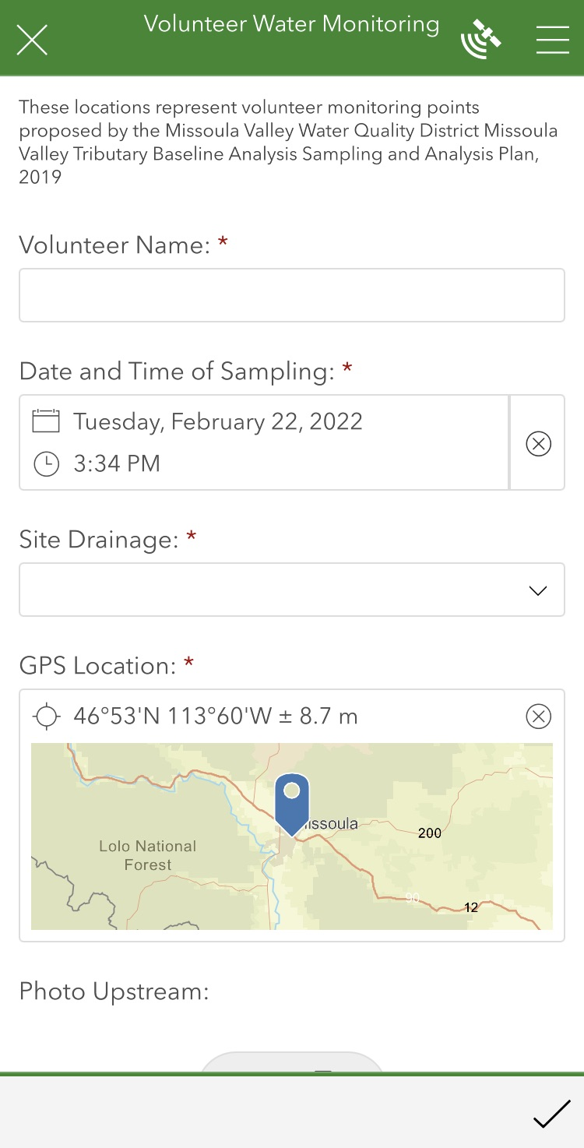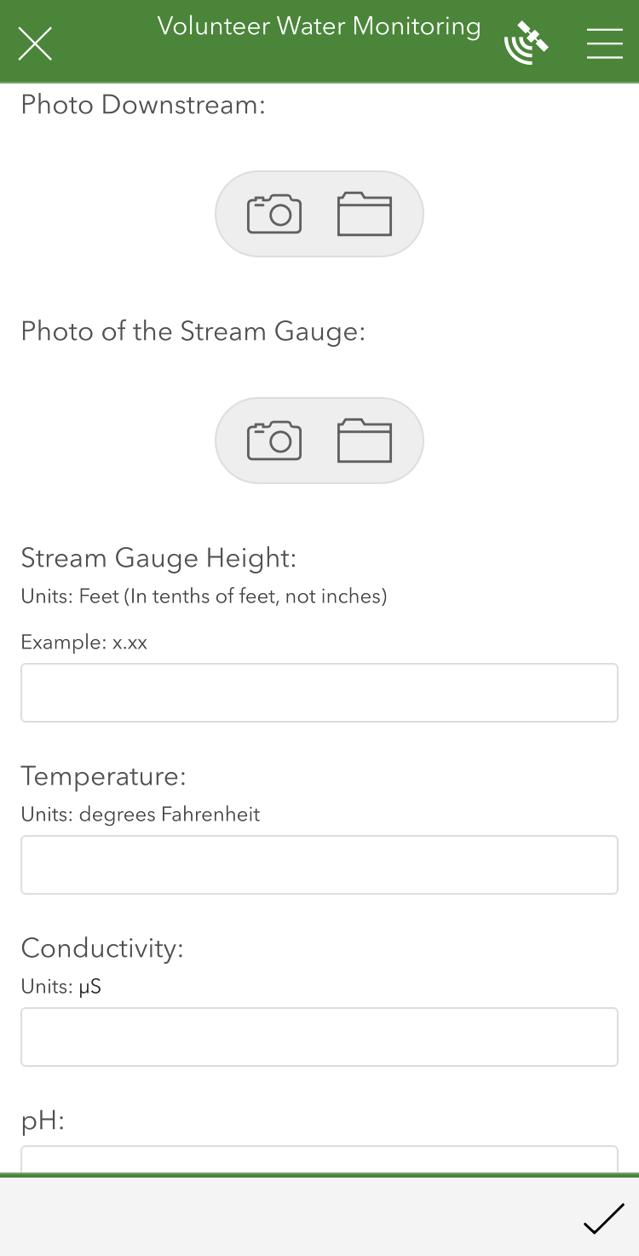

Field Notebook

Date:

Time:

Site:

Parameters Collecting:

Staff Gauge Height:

People onsite:

Energy Lab Chain of Command:

Flathead Bio Station Chain of Command:

Big Sky Watershed Corps Volunteer Agreement, Release, and Acknowledgement of Risk Form:

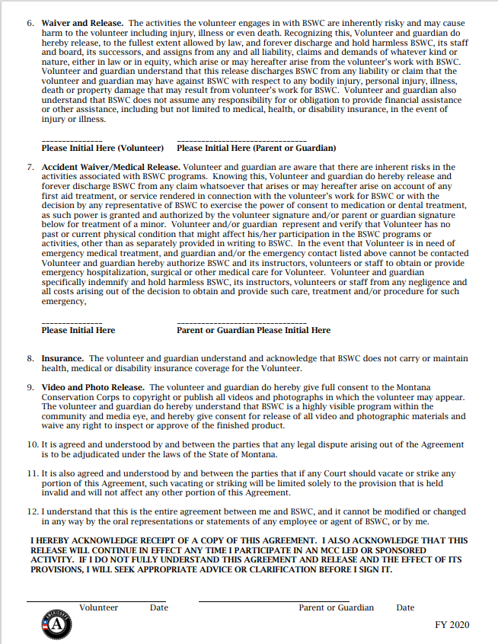

# Appendix c – Equipment and supplies

1. Sample bottles (number and type depends on sampling site and lab)
2. Smartphone with Survey123 app installed
3. Cooler filled with ice
4. Waterproof boots or waders
5. Field notebook and pencils or pens
6. Permanent marker
7. Tape
8. Camera or a phone with a camera
9. SAP and SOP

# Appendix D – QA/QC Terms and Definitions

**Accuracy**. A data quality indicator, accuracy is the extent of agreement between an observed value (sampling result) and the accepted, or true, value of the parameter being measured. High accuracy can be defined as a combination of high precision and low bias.

**Analyte**. Within a medium, such as water, an analyte is a property or substance to be measured. Examples of analytes would include pH, dissolved oxygen, bacteria, and heavy metals.

**Bias**. Often used as a data quality indicator, bias is the degree of systematic error present in the assessment or analysis process. When bias is present, the sampling result value will differ from the accepted, or true, value of the parameter being assessed.

**Blind sample**. A type of sample used for quality control purposes, a blind sample is a sample submitted to an analyst without their knowledge of its identity or composition. Blind samples are used to test the analyst’s or laboratory’s expertise in performing the sample analysis.

**Comparability**. A data quality indicator, comparability is the degree to which different methods, data sets, and/or decisions agree or are similar.

**Completeness**. A data quality indicator that is generally expressed as a percentage, completeness is the amount of valid data obtained compared to the amount of data planned.

**Data users**. The group(s) that will be applying the data results for some purpose. Data users can include the monitors themselves as well as government agencies, schools, universities, businesses, watershed organizations, and community groups.

**Data quality indicators (DQIs)**. DQIs are attributes of samples that allow for assessment of data quality. These include precision, accuracy, bias, sensitivity, comparability, representativeness, and completeness.

**Data quality objectives (DQOs)**. Data quality objectives are quantitative and qualitative statements describing the degree of the data’s acceptability or utility to the data user(s). They include data quality indicators (DQIs) such as accuracy, precision, representativeness, comparability, and completeness. DQOs specify the quality of the data needed in order to meet the monitoring project's goals. The planning process for ensuring environmental data are of the type, quality, and quantity needed for decision making is called the DQO process. Madison Stream Team Sampling and Analysis Plan Page 23

**Detection limit**. Applied to both methods and equipment, detection limits are the lowest concentration of a target analyte that a given method or piece of equipment can reliably ascertain and report as greater than zero.

**Duplicate sample**. Used for quality control purposes, duplicate samples are an additional sample taken at the same time from, and representative of, the same site that are carried through all assessment and analytical procedures in an identical manner. Duplicate samples are used to measure natural variability as well as the precision of a method, monitor, and/or analyst. More than two duplicate samples are referred to as replicate samples.

**Environmental sample**. An environmental sample is a specimen of any material collected from an environmental source, such as water or macroinvertebrates collected from a stream, lake, or estuary.

**Field blank**. Used for quality control purposes, a field blank is a “clean” sample (e.g., distilled water) that is otherwise treated the same as other samples taken from the field. Field blanks are submitted to the analyst along with all other samples and are used to detect any contaminants that may be introduced during sample collection, storage, analysis, and transport.

**Instrument detection limit**. The instrument detection limit is the lowest concentration of a given substance or analyte that can be reliably detected by analytical equipment or instruments (see detection limit).

**Matrix**. A matrix is a specific type of medium, such as surface water or sediment, in which the analyte of interest may be contained.

**Measurement Range**. The measurement range is the extent of reliable readings of an instrument or measuring device, as specified by the manufacturer.

**Method detection limit (MDL)**. The MDL is the lowest concentration of a given substance or analyte that can be reliably detected by an analytical procedure (see detection limit).

**Precision**. A data quality indicator, precision measures the level of agreement or variability among a set of repeated measurements, obtained under similar conditions. Relative percent difference (RPD) is an example of a way to calculate precision by looking at the difference between results for two duplicate samples.

**Protocols**. Protocols are detailed, written, standardized procedures for field and/or laboratory operations.

**Quality assurance (QA)**. QA is the process of ensuring quality in data collection including developing a plan, using established procedures, documenting field activities, implementing planned activities, assessing and improving the data collection process and assessing data quality by evaluating field and lab quality control (QC) samples.

**Quality assurance project plan (QAPP)**. A QAPP is a formal written document describing the detailed quality control procedures that will be used to achieve a specific project’s data quality requirements. This is an overarching document that might cover a number of smaller projects a group is working on. A QAPP may have several sample analyses plans (SAPs) that operate underneath it.

**Quality control (QC)**. QC samples are the blank, duplicate and spike samples that are collected in the field and/or created in the lab for analysis to ensure the integrity of samples and the quality of the data produced by the lab.

**Relative percent difference (RPD)**. RPD is an alternative to standard deviation, expressed as a percentage and used to determine precision when only two measurement values are available. Calculated with the following formula: RPD as % = ((D1 – D2)/((D1 + D2)/2)) x 100 Where: D1 is first replicate result D2 is second replicate result

**Replicate samples**. See duplicate samples.

**Representativeness**. A data quality indicator, representativeness is the degree to which data accurately and precisely portray the actual or true environmental condition measured.

**Sampling and Analysis Plan (SAP)**. An SAP is a document outlining objectives, data collection schedule, methods, and data quality assurance measures for a project.

**Sensitivity**. Related to detection limits, sensitivity refers to the capability of a method or instrument to discriminate between measurement responses representing different levels of a variable of interest. The more sensitive a method is, the better able it is to detect lower concentrations of a variable.

**Spiked samples**. Used for quality control purposes, a spiked sample is a sample to which a known concentration of the target analyte has been added. When analyzed, the difference between an environmental sample and the analyte’s concentration in a spiked sample should be equivalent to the amount added to the spiked sample.

**Standard operating procedures (SOPs)**. An SOP is a written document detailing the prescribed and established methods used for performing project operations, analyses, or actions.