MADISON STREAM TEAM WATER QUALITY AND NUTRIENT MONITORING

SAMPLING AND ANALYSIS PLAN

Prepared for the Montana Department of Environmental Quality

November 8, 2012

Updated February 23, 2022

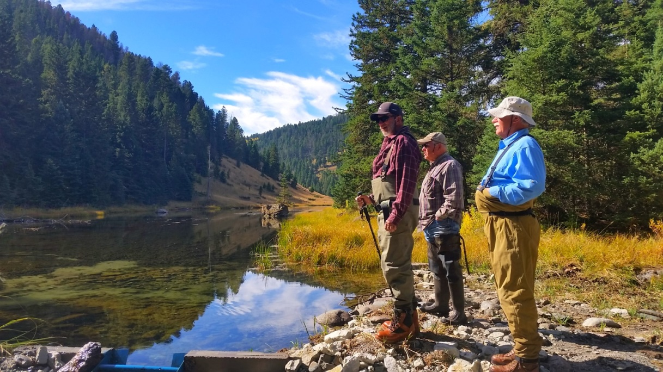

**Initially Prepared by: Updated by:**

Adam Sigler David Laufenberg

Year: 2012 Year: 2022

MSU Extension Water Quality Madison Conservation District

P. O. Box 173120 P. O. Box 606  
Bozeman, MT 59717-3120 Ennis, MT 59729

**Approvals:**

*/s/ Abbie Ebert 7/6/2022*

________________________________________________________ _____________

Abbie Ebert (Montana DEQ VM Support Program Manager) Date

*/s/ Katie Makarowski 7/7/2022*

________________________________________________________ _____________

Katie Makarowski (Montana DEQ Quality Assurance Officer) Date

*Page intentionally left blank*

Introduction 6

Project Objectives 6

Sampling Design 7

Project Team Responsibilities 11

Sampling Methods 11

Field methods 11

Flow (Discharge) Measurement 12

Photo Point Monitoring 12

Water Sample Collection and Handling for Laboratory Analysis 12

Quality Assurance and Quality Control Requirements 14

Data Quality Objectives 14

Data Quality Indicators 14

Quality Assurance for Field Quality Control Samples 14

Quality Assurance for Lab Quality Control Samples 15

Qualifying Data that fails data quality criteria 15

Training 16

Changes to the Field Sampling Plan 16

Field Health And Safety Procedures 16

Data Analysis, Record Keeping & Reporting Requirements 16

References 18

Quality Control Checklist 20

QA/QC Terms 22

Data qualifiers and descriptions 26

Summary of Lab Analysis Costs and Sampling Schedule 28

**List of Figures and Tables**

Figure 1: Map of Madison Stream Team – Tributary Blitz nutrient sampling sites 17

Figure 2: Map of Jack Creek (low flow/winter) nutrient sampling sites 18

Table 1: Project Goals, Objectives and Analyses 7

Table 2: Sample site IDs, names, coordinates and descriptions for Tributary Blitz 8

Table 3: Sample site IDs, names, coordinates and descriptions for Winter Sampling 8

Table 4: Sampling Schedule 9

Table 5: Project team members and responsibilities 10

Table 6: Field instruments and performance characteristics. 10

Table 7: Lab parameter analytical methods, reporting limits, hold times, and preservatives. 11

Table 8: Data quality indicator criteria for lab QC samples. 14

*Page intentionally left blank*

# 

# Introduction

This document constitutes the Sampling and Analysis Plan (SAP) for volunteer water quality sampling for sixteen creeks in the Upper Madison TMDL planning area in Madison County, Montana. Moores Creek, Jack Creek, North Meadow Creek, and South Meadow Creek have been monitored by the Madison Conservation District and Madison Stream Team since 2010. Additionally, monitoring began on Hot Springs Creek in 2016. The five previously monitored streams in addition to the 11 new waterbodies (all outlined in Table 1) were selected to better understand long-term water quality trends across the Madison Watershed. The Montana Department of Environmental Quality (DEQ) recently published Madison Stream Summaries (October 2020) and Madison TMDLs (Temperature and Sediment in September 2020, and Nutrients and Metals in February 2019), many of these streams have high potential for future water quality improvements. The high concentration of residential development, recreation, and agricultural production in the Madison Watershed allows for many opportunities for local conservation organizations to work with landowners and land managers to identify and implement conservation practices that improve or maintain the water quality conditions of these streams.

This effort was initiated to increase education and outreach opportunities specific to water quality in the Madison Watershed. The supporting organizations recognize the value of collecting water quality and quantity data on impaired waterways that will add to the information which has already been used by DEQ in making water quality assessment determinations, and in developing and finalizing TMDLs. Furthermore, this information will be used in trend analyses which will lead to identifying potential projects that will make improvements on impaired streams or those with deteriorating quality. Additionally, the proposed winter sampling is specific to a unique watershed that is experiencing rapid and increasing development in its headwaters (Jack Creek). This SAP outlines general field parameters and sampling for lab analysis that will take place in 2022.

# Project Goals and Objectives

The community-related goals are:

* To increase community engagement around water resources, and to collect data that enhances the understanding of conditions on local waterways.
* To create an awareness of non-point source pollution sources and inform citizens of improvement opportunities that exist through watershed restoration efforts.
* To increase communication between data collectors and land managers.

Additionally, through the collection of water quality data, the project will provide the following products or opportunities:

* Annual report containing data from current year with comparisons to data collected in previous years. Baseline conditions will be established by noting any extremes or incidences of exceedances of state thresholds. Annual report will be made available to the public at the Madison Conservation District website.
* Summary of preliminary findings of the Madison Stream Team project will be presented to the general public and other pertinent audiences following the field season.

**Table 1. Project Goals, Objectives and Analyses**

|  |  |  |
| --- | --- | --- |
| **Goal** | **Objective** | **Data Analysis** |
| Evaluate spatial and temporal trends of water quality throughout the Upper Madison Watershed | To collect nutrient samples (TN, Diss. Orthophosphate, TP and NO2+3) from 16 major tributaries of the Upper Madison Watershed on a single morning during late summer conditions (low flow) | Compare nutrient concentrations against the protective ranges of nutrients. |
| Graph nutrient concentrations and observe spatial patterns |
| Conduct trend analysis for nutrient concentrations |
| To collect multimeter, photo, and turbidity data from 16 major tributaries of the Upper Madison Watershed on a single morning during late summer conditions (low flow) | Graph variables and observe spatial patterns for multimeter, photo, and turbidity data |
| Conduct trend analysis for multimeter, photo, and turbidity data |
| Evaluate whether the development patterns of Jack Creek are impacting the stream | To collect nitrate samples in Jack Creek at three sites along an elevational gradient during baseflow conditions in January and/or February | Conduct trend analysis for nitrate concentrations |
| Monitor conditions at three streams of community interest (Jack, Moores, and South Meadow Creeks) | To collect water quality data throughout the growing season (May – September) | Conduct trend analysis for multimeter variables |
| Conduct trend analysis for turbidity |

# Sampling Design

Most of the major tributaries to the Upper Madison River are represented in this effort. These streams and sampling locations were chosen based on accessibility and community interest. We also wanted to select sites that were near the confluence with the mainstem of the Madison River as these sites would most likely reflect the overall condition of the tributary. Sample sites for 2022 were selected based on data collected in previous years in conjunction with the aforementioned DEQ reports. The watershed-wide sampling day occurs in late summer (first annual Tributary Blitz occurred on August 31, 2020 with 2 MCD staff and 5 MST volunteers), and the Jack Creek baseline or low flow nitrate sampling occurs in mid-winter (first winter sampling of nitrate on Jack Creek occurred on February 20, 2021 with David Laufenberg, Sunni Heikes-Knapton, and Adam Sigler; all current or prior authors of this SAP). The 2022 Jack Creek baseline low flow nitrate sampling occurred on February 18th and 25th with David Laufenberg and Raeya Gordon.

For the Tributary Blitz, lab analysis in 2022 will include; total persulfate nitrogen, total phosphorus, nitrate plus nitrite, and dissolved orthophosphate. For Jack Creek (low flow/dormant/winter) sampling, lab analysis will include nitrate plus nitrate as an indicator of upstream anthropogenic influence in the watershed (Gardner and McGlynn 2009). The tributaries being sampled have remained consistent, but some station IDs have been changed since the 2021 sampling plan was submitted in order to be in accordance with historic, long-term data submission and station IDs. Refer to Appendix E to see the new station IDs in reference to previously established sites.

Table 2: Sample site IDs, names, coordinates and descriptions for Tributary Blitz 2022.

|  |  |  |  |  |
| --- | --- | --- | --- | --- |
| **Stream Name** | **Existing/Proposed Site ID** | **Site Description** | **Latitude** | **Longitude** |
| Mile Creek | MILE-SHEEP | Sheep Mountain Rd off Highway 87 | 44.792040 | -111.463910 |
| West Fork Madison River | WFORK-CAMP | Access via campground off of Sundance Bench Road; 600m upstream of Madison River confluence | 44.883302 | -111.580413 |
| Papoose Creek | PAP-HWY | Immediately downstream of Hwy 287 crossing | 44.892916 | -111.582492 |
| Ruby Creek | RUBY-CAMP | Campground off of Ruby Creek Road; 140m upstream of Madison River confluence | 45.059425 | -111.665258 |
| Bear Creek | BEAR-BRRD | Immediately downstream of Bear Creek Loop | 45.168662 | -111.596552 |
| Wigwam Creek | WIG-GRRD | Immediately upstream of Gravelly Range Road crossing | 45.208414 | -111.761491 |
| Blain Springs Creek | BLAIN-VRD | Immediately downstream of the Varney Road (aka Route 249) | 45.232549 | -111.757164 |
| Eight Mile Creek | EIGHT-TBRD | Immediately downstream of Montana Way (eastern/downstream) crossing | 45.311911 | -111.771437 |
| Cherry Creek | CHRY-HWY | Immediately downstream of Hwy 84 crossing | 45.622150 | -111.548660 |
| Moores Creek | MC-HOME | Creek crossing in town, downstream of Main Street near picnic basket | 45.349382 | -111.729960 |
| Odell Creek | OD-VGR | Valley Gardens FAS (fishing access site) | 45.363965 | -111.706471 |
| Jack Creek | JCP-JCR | Jack Creek Ranch public road crossing north of Jeffers | 45.376213 | -111.694978 |
| South Meadow Creek | SM-LKRD | Last public road crossing prior to the Ennis res. | 45.443805 | -111.718767 |
| North Meadow Creek | NM-MLL | Last public road crossing prior to the Ennis res. | 45.444718 | -111.713513 |
| Hot Springs Creek | HS-CNF | FAS at the confluence with mainstem | 45.586320 | -111.596491 |
| Indian Creek | INDN-BRRD | Immediately upstream of Bear Creek Loop crossing | 45.106751 | -111.582044 |

Table 3: Sample site IDs, names, coordinates and descriptions for Jack Creek (low flow/winter) nutrient sampling sites.

| **Stream Name** | **Existing/Proposed Site ID** | **Site Description** | **Latitude** | **Longitude** |
| --- | --- | --- | --- | --- |
| Jack Creek | JCP-JCR | Jack Creek Ranch public road crossing north of Jeffers | 45.376213 | -111.694978 |
| Jack Creek | JCP-CY | Public road crossing at mouth of canyon | 45.355993 | -111.581415 |
| Jack Creek | JCP-SSR | Private bridge crossing accessed with permission from Jack Creek Preserve and Moonlight Basin, LLC | 45.330103 | -111.474708 |

Water quality sampling will also regularly occur on South Meadow Creek, Moores Creek, and Jack Creek. On each site visit for each stream, collection will include: data from YSI 556 multi-meter (air and water temperature, pH, specific conductance, and dissolved oxygen), discharge estimate, photo points, and turbidity.

Table 4: Sampling Schedule

| **Event/Stream** | **Number Sites / Stream** | **Sampling Frequency** | **Month** | **Variables of Interest** |
| --- | --- | --- | --- | --- |
| Tributary Blitz | 16 | One event each year | Late August or Early September | Dissolved Orthophosphate, TP, TPN, N02+3 |
| South Meadow Creek, Moores Creek, Jack Creek | 2 (South Meadow and Moores) and 3 (Jack) | One stream each week on a rotating cycle. Each stream will be sampled every three weeks. | Late May through Early October | Multi-meter variables, discharge estimates, photo points, turbidity |
| Jack Creek | 3 | Twice each year | January and/or February | N02+3 |

Instantaneous discharge (flow) will be measured at each site on each of the weekly visits, if conditions allow for the safe measurement (May – September). TruTrack capacitance rods that measure hourly water height (mm), water temperature (C), and air temperature (C), will be deployed at: SM-WEIR, SM-EDC, MC-MCR, MC-HOME, and JCP-JCR. Additionally, permanently mounted stream gaging stations at JCP-SSR and JCP-CY measure continuous water height, water and air temperature, and continuous specific conductivity. Discharge measurements at these sites will be paired with stage data to develop rating curves that produce daily streamflow values.

Measurement of field parameters is a basic operating procedure when other water quality data is collected and will provide context for interpreting basic stream conditions and other data. Samples collected for nutrients will be handled according to SOPs and shipped to the DEQ contracted laboratory (Energy Laboratories) for analysis. Nutrient concentration data will be compared to MT DEQ recommended ranges of nitrogen and phosphorus that protect beneficial uses. Additionally, bottles will be filled at each site for analysis with a Hach 2100Q Portable Turbidimeter in order to assist in locating possible sources of sediment into each stream.

# Project Team Responsibilities

The project manager will be the Director of Conservation, David Laufenberg and regular support will be provided by the Big Sky Water Corp Member, Raeya Gordon (Montana Conservation Corp). Responsibilities include a pre-season meeting, volunteer coordination, storage/maintenance of equipment, data management, data analysis, report composition, and reporting to project partners. The staff will also join the volunteers on each site visit to ensure monitoring protocols are followed properly and to capture photo and video of the volunteer efforts. The project administration will be completed by the Madison Conservation District, which will include the accounting and financial management of the project. The project team responsibilities are provided in Table 5.

Table 5: Project team members and responsibilities

| **Name/Title** | **Project Responsibilities** | **Contact information** |
| --- | --- | --- |
| David Laufenberg; Director of Conservation | Data Collection, coordination of educational events, equipment maintenance, volunteer recruitment and training, data analysis and reporting. | PO Box 606  Ennis, MT 59729  406.682.3181; david@madisoncd.org |
| Raeya Gordon; MCC Big Sky Water Corp | Regular leadership and support of MST activities as listed above | raeya@madisoncd.org |
| Rebecca Barney; Madison Conservation District Administrator | Financial Management | PO Box 606  Ennis, MT 59729  406.682.3181; rebecca@madisoncd.org |
| Adam Sigler; MSUEWQ Water Quality Specialist | Technical assistance as needed for equipment and data. | Sigler Lab, MSU, PO Box 173120, Bozeman, MT, 59717-3120  406.994.7381; asigler@montana.edu |

# Sampling Methods

Sampling will be conducted according to the standard operating procedures (SOP) outlined in the Madison Stream Team 2022 SOP. A Site Visit Form will be completed for each site visit and will include all field data collected and an inventory of samples collected for analysis at the DEQ contracted laboratory. Site locations will be corroborated using this document and/or a GPS and the method will be specified on the site visit form. The GPS coordinate system datum will be WGS84 (Google Earth), in decimal degrees to at least the fourth decimal. Photographs will be taken using a digital camera at each site to verify site location, and document site conditions.

## Field methods

Field parameter data will be collected with an YSI 556 meter, and turbidity samples will be analyzed with a Hach 2100Q Portable Turbidimeter. The meters will be calibrated according to manufacturer instructions on the same day prior to sampling, and calibration logs will be kept for each meter.

Table 6: Field instruments and performance characteristics.

| **Parameter** | **Meter** | **Measurement Range** | **Resolution** | **Accuracy** |
| --- | --- | --- | --- | --- |
| Temperature | YSI 556 | -5 to 45° C | 0.01° C | ±0.15° C |
| pH | YSI 556 | 1. to 14.00 units | 0.01 units | ±0.2 units |
| SC | YSI 556 | 0 to 200 mS/cm | 0.001 mS/cm to 0.1 mS/cm | ±0.5% of reading or 0.001 mS/cm |
| DO | YSI 556 | 0 to 50 mg/L | 0.01 mg/L | ±2% of the reading or 0.2 mg/L |
| Turbidity | Hach 2100Q | 0-1000 NTU | .01 NTU | ±2% of the reading |

## Flow (Discharge) Measurement

Stream discharge data will be collected at all water quality monitoring sites using the Marsh-McBirney Model 2000 Flo-Mate. The Flo-mate is a portable flow meter that uses an electromagnetic sensor to measure velocity. As conditions allow, TruTrack capacitance rods will be installed from April or May to October and programmed to record hourly water height (mm), water temperature (C), and air temperature (C). Upon each subsequent site visit, data will be downloaded to a laptop computer equipped with Omnilog Software and saved as a Microsoft Excel file with site name, date, and time of download. Measured flow and recorded height will be used to create a stage/discharge relationship for each year data is collected. As suggested by DEQ staff, stage data for periods with air temperatures below freezing will be evaluated and data may be qualified based on observations that stage data accuracy decreases within this temperature range.

## Photo Point Monitoring

The conditions of each site will be documented by capturing photos in a repeatable format. Photo points are taken from the same position and oriented in the same direction with the same vertical angle. This is done with a goal of recreating the same frame within the picture so that minor and major changes in riparian condition can be documented. Camera operators must take extra precaution when taking photo points to ensure they are in the correct location and orientation, and to record the necessary photograph metadata.

Upon arrival a monitoring site, samplers will refer to the Photo Point Instruction Guide for that site. This will provide instructions on the specific photo points that are to be taken, including helpful notes and reference photographs that can be used to ensure photo uniformity from visit to visit.

## Water Sample Collection and Handling for Laboratory Analysis

Grab samples will be collected for delivery to the DEQ contracted lab for chemistry analysis using acid washed, polyethylene bottles provided by the testing laboratory. Table 7 details the analytical methods and handling procedures for each parameter.

Bottles shall be rinsed three times with stream water prior to sampling. Samples will be collected in a well-mixed portion of each stream. During sampling, the sample bottle opening should face upstream and should be drawn through the water column once, carefully avoiding disturbance of bottom sediments. Notably, Dissolved Orthophosphate samples must be field filtered. A 60 mL syringe will be used to collect water, then a 0.45 µm filter will be placed on the syringe before using the collected water to rinse the sample bottle three times. After the bottle has been rinsed, the filter will be removed and a 100 mL (leaving 20mL in bottle for sample expansion when frozen) water sample will be collected with the syringe. A new filter will be placed on the syringe and the water sample will be filtered into the bottle. Samples will be preserved on ice in the field, and Dissolved Orthophosphate samples will be frozen once returned from the field and until shipment to the lab. Notably, Total Phosphorus and Nitrate-Nitrite will be analyzed out of the same sample bottle (three bottles will be collected per set of samples).

Table 7: Lab parameter analytical methods, reporting limits, hold times, and preservatives.

| **Parameter** | **Preferred Method** | **Req. Report Limit mg/L** | **Holding Time Days** | **Bottle** | **Preservative** |
| --- | --- | --- | --- | --- | --- |
| Total Persulfate Nitrogen (TPN) | A 4500-N C | 0.04 | 28 | 250 ml HDPE | ice ≤6oC |
| Nitrate-Nitrite as N | EPA 353.2 | 0.01 | 28 | 250 ml HDPE | H2SO4, ice ≤6oC |
| Total Phosphorus as P | EPA 365.1 | 0.003 |
| Dissolved Orthophosphate | EPA 365.1 | 0.001 | 45 if frozen | 120 ml HDPE | Field filter 0.45 µm, on ice in the field and freeze until shipment |

Sample labels should be filled out with the date, time, and sample ID. The sample ID is very important and includes the year, the month, the day, the site ID and a letter indicating the type of sample (regular, blank or duplicate).

Sample ID = YearMonthDay-SiteID-Parameter ID-Sample Type Letter

* Sample Type Letter

R = Regular sample

D = Duplicate sample

B = Blank sample

**Sample ID Examples:**

A **regular sample** collected at the Moore Creek Bricker site on August 15th, 2019 for Total Persulfate Nitrogen would be labeled:

* 20190815-MCBRK -R

A **duplicate** at the same place and time as above:

* 20190815-MCBRK- D

A **blank** at the same place and time as above:

* 20190815-MCBRK- B

Immediately following grab-sample collection, samples will be put on ice. The MT DEQ contract analytical lab chain of custody forms will be used to document and track all samples collected during the project. Chain of custody forms will be completed for each set of samples submitted to the laboratory.

# Quality Assurance and Quality Control Requirements

For water quality data to be useful, it needs to be an accurate representation of conditions in the water body at the time the samples were collected. This requires proper sample handling and processing and then assessment of data to ensure quality. Data quality objectives (DQOs) state the required quality of data for the intended use and data quality indicators (DQIs) are the specific criteria that data are assessed by to determine quality. Definitions and a list of DQIs are included in the glossary. These indicators are assessed by collecting quality control (QC) samples and then performing quality assurance (QA) checks on those samples.

QC samples are blank, duplicate and spike samples collected or created in the lab and/or the field for evaluation of quality indicators. Once the lab results are returned for the QC samples, QA is the process of assessing the data through use of indicators to determine data quality.

## Data Quality Objectives

Efforts will be made to collect streamflow in June to produce high flow data, but the monitoring schedule is constrained by the availability of the volunteers and safety of conditions. The bulk of monitoring will occur from July through September.

Provisions are in place to ensure sensitivity of data collected to differences in stream water quality and comparability of data collected to other datasets. These provisions include the collection of grab samples and field QC for submission to a certified laboratory and assessment of QC data relative to data quality indicators. Data that does not meet quality criteria will be qualified appropriately in the annual report and during the MT EQUIS submission process.

To ensure the highest degree of data completeness possible, the team leaders will fill out datasheets and review them before leaving a site. David Laufenberg will review datasheets for completeness and will follow-up with volunteers if fields are not completed. Volunteers and/or staff are expected to complete scheduled events as long as no complications arise from possible weather, access, and volunteer availability challenges.

## Data Quality Indicators

Quality assurance and quality control (QAQC) can be broken down into a field and a laboratory component. The field component consists of collection of blank and duplicate samples and comparison of data to criteria. The laboratory component consists of assessment of data for blanks as well as a variety of duplicate and spiked samples analyzed by the lab. Blank samples should ideally yield results indicating “no detection” of the analyte in question. Duplicate samples should ideally produce identical results and analysis of spiked samples should recover exactly the amount of analyte added. Methods are not perfect however, so the criteria outlined in the following two sections are used to assess if data is of acceptable quality.

## QC Samples: Field Duplicates

Field duplicates are two samples (i.e., a routine sample and a duplicate sample) of ambient water collected from a waterbody as close as possible to the same time and place by the same person and carried through identical sampling and analytical procedures. Field duplicate samples are labeled, collected, handled and stored in the same way as the routine samples and are sent to the laboratory at the same time.

Field duplicates are typically collected at a rate of approximately 10% of the total number of routine samples collected. Therefore, to achieve this, two sets of field duplicates will be collected during the Tributary Blitz and one set of duplicates will be collected with winter sampling events.

Field duplicates are used to determine field precision to ensure that proper procedures are followed consistently. For each field duplicate set collected, the relative percent difference will be calculated:

Relative Percent Different (RPD) = ((D1 – D2) / ((D1 + D2)/2)) x 100

where: D1 = routine sample result value

D2 = duplicate sample result value

Precision will be assessed by ensuring that relative percent difference (RPD) between duplicates is less than 25%. If the RPD of field duplicates is greater than 25% and the parent and duplicate result values are greater than five times the lower reporting limit, the result values will be flagged with a “J”.

## QC Samples: Field Blanks

Field blanks are samples of analyte-free, laboratory-grade deionized water poured into a sample container in the field using the same method, container, and preservation as routine samples, and shipped to the lab along with other field (i.e., routine and duplicate) samples. All labeling, rinsing, preservation, and storage requirements applied for routine and duplicate samples are applied to field blanks; the only difference is that the water is deionized water rather than ambient stream water. Field blanks must be prepared while in the field.

One set of field blanks is submitted to the laboratory with each batch of samples delivered to the laboratory. Therefore, one set of field blanks will be prepared at or near the end of the Tributary Blitz sampling event and submitted to the laboratory alongside the other routine and duplicate samples from that trip.

Field blanks are used to determine the integrity of the field personnel’s handling of samples, the condition of the sample containers supplied by the laboratory, and the accuracy of the laboratory methods. Accuracy will be assessed by ensuring that field blanks return values less than the lower reporting limit (i.e., non-detects). If an analyte is detected in a field blank, all result values for that analyte from that batch of samples associated with the field blank will be qualified with a “B” flag. The exception is that data with a value greater than 10 times the detected value in the blank does not need to be qualified.

Certified laboratories run QC samples for at least 10% of their sample volume. Integrity of laboratory data will be determined by comparing results for laboratory QC samples to the data quality indicator criteria in Table 9. Reports with lab QC results and data quality indicator calculations should be provided by the lab with each set of sample results. Each of the quality indicator criteria in Table 9 must be checked for each analyte for each batch of samples submitted to the lab. This process is easier if a matrix is used to systematically check the numbers. An example of a completed matrix is provided on page 24 of this document.

Table 8: Data quality indicator criteria for lab QC samples.

| Parameter | Method Blanks mg/L | Lab Duplicates (RPD) | Lab Control LCS/LFB (percent recovery) | Matrix Spike/ Matrix Spike Dup (percent recovery) |
| --- | --- | --- | --- | --- |
| Total Persulfate Nitrogen | 0.04 | < 10% RPD | 90%-110% | 90%-110% |
| Nitrate-Nitrite as N | 0.01 | < 10% RPD | 90%-110% | 90%-110% |
| Total Phosphorus as P | 0.003 | < 10% RPD | 90%-110% | 90%-110% |
| Dissolved Orthophosphate | 0.001 | < 10% RPD | 90%-110% | 90%-110% |

## Qualifying Data that fails data quality criteria

If any of the data quality objectives for field or laboratory QC samples fail the criteria above, all data for that analyte for that sample batch must be qualified accordingly. Note that a blank which exceeds the threshold does not automatically mean all data for that sample batch must be qualified. Sample results with values greater than 10 times the detected value in the blank do not need to be qualified. A narrative in the annual sampling report should outline what data was qualified and for what reason. The data will also need to be qualified during the process of uploading to MT EQUIS using the appropriate qualifier codes. A list of data qualifier codes is provided at the end of this document.

# Training

A volunteer training day for 2022 is planned for late May or early June. The classroom portion will cover watershed and water quality basics and a review of results from 2021. The classroom portion will also include information on aquatic invasive species and methods volunteers can adopt to reduce the risk of transport of these species during field work.

During the field portion of the training, volunteers will learn proper use of the YSI meter, measurement of discharge using the Marsh-McBirney FloMeter, photo documentation, collection of water quality samples for submission to a lab, collection of turbidity samples, and completion of field visit sheets.

# Changes to the Field Sampling Plan

As conditions in the field may vary, it may become necessary to implement minor modifications to sampling as presented in this plan. Modifications to the approved plan will be documented.

# Field Health and Safety Procedures

Field personnel commonly encounter hazards while performing monitoring activities. All participants are advised to take adequate precautions to avoid injury or loss of life due to hazards including, but not limited to, driving, wading and other activities in and around water, weather conditions, wildlife interactions, people interactions, use of chemical preservatives, etc.

On every sampling trip, field personnel should carry with them a communication device (e.g., cell phone), first aid kit, bear spray, adequate drinking water, clothing appropriate for a range of weather conditions, personal protective equipment including waders, adequate footwear, and gloves to be worn while handling preservatives, and any other necessary safety-related items.

Each volunteer will be required to sign a waiver acknowledging risk and these waivers will be kept on file by the project coordinator. If, for any reason, field personnel feel unsafe while navigating to or from monitoring sites or while collecting data, they should err on the side of caution and not collect the data. Any delays or changes should be reported to the project coordinator as soon as possible so sampling can be rescheduled if possible.

# Data Analysis, Record Keeping & Reporting Requirements

Analytical laboratories will prepare and analyze the samples in accordance with the chain-of-custody forms and analytical methods specified in **Table 7**. The lab will then supply the project coordinator with laboratory analytical reports and Electronic Data Deliverable (EDD) spreadsheets.

If DEQ funding is received in support of the monitoring project (e.g., through DEQ’s Volunteer Monitoring Lab Analysis Support Program or other funding mechanism), all data collected must be entered by the project coordinator into DEQ’s MT-eWQX database (also known as EQuIS). Instructions for preparing, validating and submitting the EDD to MT-eWQX must be followed (available at <https://deq.mt.gov/water/Programs/sw>**).** For example, steps include:

* Compiling data (including site information, field measurements and lab results),
* Transforming the data into the required format,
* Performing a thorough quality control check of the data to correct errors, qualify problematic sample result values with data flags, etc.,
* Validating the data, and
* Submitting EDDs to MT-eWQX.

Additionally, data collected during the 2022 season will be uploaded to the Montana State University Extension Water Quality Data Hub. Here, the information will be publicly available in a user-friendly format where members of the public can access data on streams in the Madison dating back to 2012.

Finally, we will interpret and share the data via a public event at the end of the season and/or in the spring of 2023 depending upon COVID-19 precautions. For instance, last year’s Tributary Blitz was initially shared via a virtual event in October and then an in-person event later that month.

# References

DEQ, 2005b. Quality Assurance Project Plan (QAPP) Sampling and Water Quality Assessment of Streams and Rivers in Montana, 2005. Available at http://www.deq.state.mt.us/wqinfo/QAProgram/WQPBQAP-02.pdf.

DEQ, 2019. Circular DEQ-7, Montana Numeric Water Quality Standards, 2006. Available at http://deq.mt.gov/water/resources/circulars

Gardner, K. K., and B. L. McGlynn (2009). Seasonality in spatial variability and influence of land use/land cover

and watershed characteristics on stream water nitrate concentrations in a developing watershed in the Rocky Mountain West. Water Resour. Res., 45, W08411. doi:10.1029/2008WR007029.

Makarowski, Kathryn. 2019. Standard Operating Procedure for Sample Collection for Chemistry Analysis: Water, Sediment, and Biological Tissue. WQDWQPBFM-02, Version 1.0. Helena, MT: Montana Department of Environmental Quality, Water Quality Planning Bureau.

MT DEQ. 2011. MT DEQ. Clean Water Act Information Center, Jack Creek Water Quality Assessment. http://cwaic.mt.gov/wqrep/2010/assmtrec/MT41F004_050.pdf

Madison Stream Team Nutrient Sampling Sites

Figure 1: Map of Madison Stream Team – Tributary Blitz nutrient sampling sites

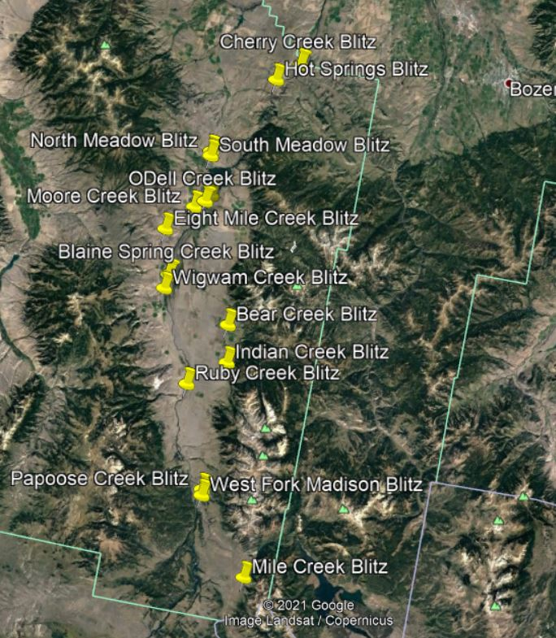

**Figure 2: Map of Jack Creek (low flow/winter) nutrient sampling sites**

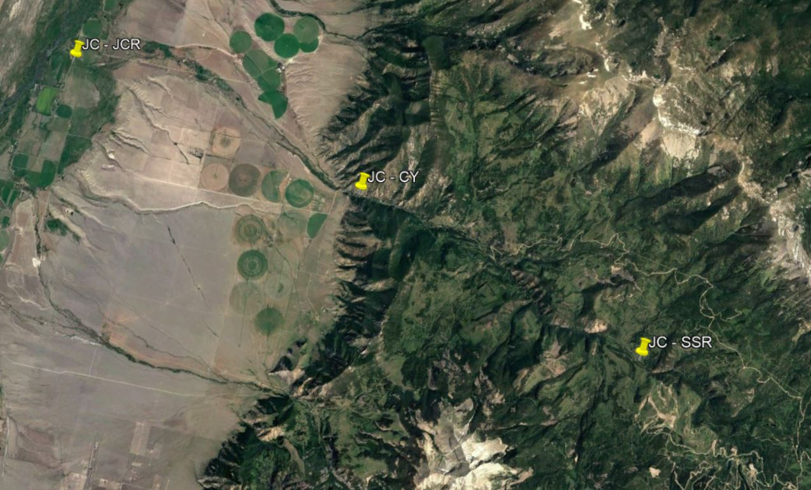

# 

# Quality Control Checklist

___Condition of samples upon receipt

___Cooler/sample temperature

___Proper collection containers

___All containers intact

___Sample pH of acidified samples <2

___All field documentation complete. If incomplete areas cannot be completed, document the issue.

___Holding times met

___Field duplicates collected at the proper frequency (specified in SAP)

___Field blanks collected at the proper frequency (specified in SAP)

___All sample IDs match those provided in the SAP. Field duplicates are clearly marked on samples and noted as such in lab results.

___Analyses carried out as described within the SAP (e.g. analytical methods, photo documentation, field protocols)

___Reporting detection limit met the project-required detection limit

___All blanks were less than the project-required detection limit

___If any blanks exceeded the project-required detection limit, associated data is flagged

___Laboratory blanks/duplicates/matrix spikes/lab control samples were analyzed at a minimum 10% frequency

___Laboratory blanks/duplicates/matrix spikes/lab control samples were all within the required control limits defined within the SAP

___Project DQOs and DQIs were met (as described in SAP)

___Summary of results of QC analysis, issues encountered, and how issues were addressed (corrective action)

___Completed QC checklist before MT-EQUIS upload

**Appendix A - Project Budgets**

**Tributary Blitz Event**

|  |  |  |  |  |  |  |  |  |
| --- | --- | --- | --- | --- | --- | --- | --- | --- |
| **Parameter** | **Cost per Analyte** | **# of Sites** | **# of visits per site** | **# of Routine Samples** | **# of Field Blanks** (one per sampling event) | **# of Field Duplicates** (10% of the total number of routine samples) | **Total # samples per parameter** | **Total Cost** |
| Dissolved Orthophosphate | $17.60 | 16 | 1 | 16 | 1 | 2 | 19 | $334.40 |
| TPN | $22.40 | 16 | 1 | 16 | 1 | 2 | 19 | $425.60 |
| TP | $17.60 | 16 | 1 | 16 | 1 | 2 | 19 | $334.40 |
| NO2+3 | $20.00 | 16 | 1 | 16 | 1 | 2 | 19 | $380 |
| Shipping | $34.00 | 3 | 1 | 3 |  |  |  | $102 |
| Sample Handling Fee | $2.00 | 16 | 1 | 16 | 1 | 2 | 19 | $38 |
|  |  |  |  |  |  |  | **Total** | **$1,614.40** |

**Jack Creek Winter/Low Flow Sampling**

|  |  |  |  |  |  |  |  |  |
| --- | --- | --- | --- | --- | --- | --- | --- | --- |
| **Parameter** | **Cost per Analyte** | **# of Sites** | **# of visits per site** | **# of Routine Samples** | **# of Field Blanks** (one per sampling event) | **# of Field Duplicates** (10% of the total number of routine samples) | **Total # samples per parameter** | **Total Cost** |
| NO2+3 | $20.00 | 3 | 2 | 6 | 2 | 1 | 9 | $180 |
| Shipping | $34.00 | 1 | 2 | 2 |  |  |  | $68 |
| Sample Handling Fee | $2.00 | 3 | 2 | 6 | 2 | 1 | 9 | $18 |
|  |  |  |  |  |  |  | **Total** | **$266** |

# Appendix B – Field Form

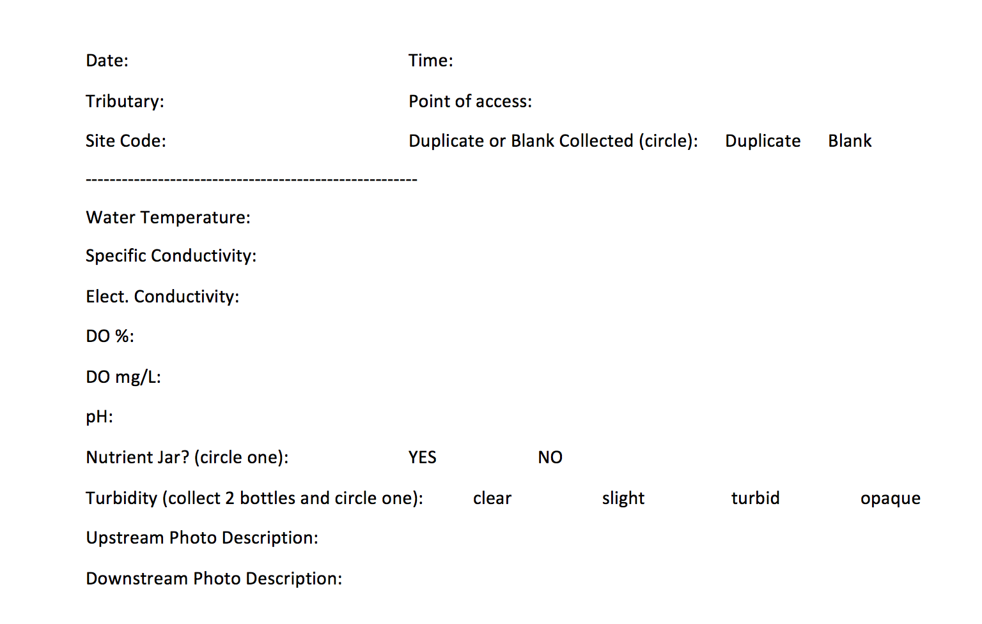

*Tributary Blitz Data Sheet

# Appendix C – QA/QC Terms and Definitions

***Accuracy.*** A data quality indicator, accuracy is the extent of agreement between an observed value (sampling result) and the accepted, or true, value of the parameter being measured. High accuracy can be defined as a combination of high precision and low bias.

***Analyte.*** Within a medium, such as water, an analyte is a property or substance to be measured. Examples of analytes would include pH, dissolved oxygen, bacteria, and heavy metals.

***Bias.*** Often used as a data quality indicator, bias is the degree of systematic error present in the assessment or analysis process. When bias is present, the sampling result value will differ from the accepted, or true, value of the parameter being assessed.

***Blind sample.*** A type of sample used for quality control purposes, a blind sample is a sample submitted to an analyst without their knowledge of its identity or composition. Blind samples are used to test the analyst’s or laboratory’s expertise in performing the sample analysis.

***Comparability.*** A data quality indicator, comparability is the degree to which different methods, data sets, and/or decisions agree or are similar.

***Completeness.*** A data quality indicator that is generally expressed as a percentage, completeness is the amount of valid data obtained compared to the amount of data planned.

***Data users.*** The group(s) that will be applying the data results for some purpose. Data users can include the monitors themselves as well as government agencies, schools, universities, businesses, watershed organizations, and community groups.

***Data quality indicators (DQIs).*** DQIs are attributes of samples that allow for assessment of data quality. These include precision, accuracy, bias, sensitivity, comparability, representativeness and completeness.

***Data quality objectives (DQOs).*** Data quality objectives are quantitative and qualitative statements describing the degree of the data’s acceptability or utility to the data user(s). They include data quality indicators (DQIs) such as accuracy, precision, representativeness, comparability, and completeness. DQOs specify the quality of the data needed in order to meet the monitoring project's goals. The planning process for ensuring environmental data are of the type, quality, and quantity needed for decision making is called the ***DQO process*.**

***Detection limit.*** Applied to both methods and equipment, detection limits are the lowest concentration of a target analyte that a given method or piece of equipment can reliably ascertain and report as greater than zero.

***Duplicate sample.*** Used for quality control purposes, duplicate samples are an additional sample taken at the same time from, and representative of, the same site that are carried through all assessment and analytical procedures in an identical manner. Duplicate samples are used to measure natural variability as well as the precision of a method, monitor, and/or analyst. More than two duplicate samples are referred to as *replicate samples*.

***Environmental sample.*** An environmental sample is a specimen of any material collected from an environmental source, such as water or macroinvertebrates collected from a stream, lake, or estuary.

***Field blank.*** Used for quality control purposes, a field blank is a “clean” sample (e.g., distilled water) that is otherwise treated the same as other samples taken from the field. Field blanks are submitted to the analyst along with all other samples and are used to detect any contaminants that may be introduced during sample collection, storage, analysis, and transport.

***Instrument detection limit.*** The instrument detection limit is the lowest concentration of a given substance or analyte that can be reliably detected by analytical equipment or instruments (see *detection limit*).

***Matrix.*** A matrix is a specific type of medium, such as surface water or sediment, in which the analyte of interest may be contained.

***Measurement Range.*** The measurement range is the extent of reliable readings of an instrument or measuring device, as specified by the manufacturer.

***Method detection limit (MDL).*** The MDL is the lowest concentration of a given substance or analyte that can be reliably detected by an analytical procedure (see *detection limit*).

***Precision.*** A data quality indicator, precision measures the level of agreement or variability among a set of repeated measurements, obtained under similar conditions. Relative percent difference (RPD) is an example of a way to calculate precision by looking at the difference between results for two duplicate samples.

***Protocols.*** Protocols are detailed, written, standardized procedures for field and/or laboratory operations.

***Quality assurance (QA).*** QA is the process of ensuring quality in data collection including: developing a plan, using established procedures, documenting field activities, implementing planned activities, assessing and improving the data collection process and assessing data quality by evaluating field and lab quality control (QC) samples.

***Quality assurance project plan (QAPP).*** A QAPP is a formal written document describing the detailed *quality control* procedures that will be used to achieve a specific project’s data quality requirements. This is an overarching document that might cover a number of smaller projects a group is working on. A QAPP may have a number of sample analysis plans (SAPs) that operate underneath it.

***Quality control (QC).*** QC samples are the blank, duplicate and spike samples that are collected in the field and/or created in the lab for analysis to ensure the integrity of samples and the quality of the data produced by the lab.

***Relative percent difference (RPD).*** RPD is an alternative to *standard deviation*, expressed as a percentage and used to determine precision when only two measurement values are available. Calculated with the following formula:

RPD as % = ((D1 – D2)/((D1 + D2)/2)) x 100

Where:

D1 is first replicate result

D2 is second replicate result

***Replicate samples.*** See duplicate samples.

***Representativeness.*** A data quality indicator, representativeness is the degree to which data accurately and precisely portray the actual or true environmental condition measured.

***Sample analysis plan (SAP).*** A SAP is a document outlining objectives, data collection schedule, methods and data quality assurance measures for a project.

***Sensitivity.*** Related to *detection limits*, sensitivity refers to the capability of a method or instrument to discriminate between measurement responses representing different levels of a variable of interest. The more sensitive a method is, the better able it is to detect lower concentrations of a variable.

***Spiked samples.*** Used for quality control purposes, a spiked sample is a sample to which a known concentration of the target analyte has been added. When analyzed, the difference between an environmental sample and the analyte’s concentration in a spiked sample should be equivalent to the amount added to the spiked sample.

***Standard operating procedures (SOPs).*** An SOP is a written document detailing the prescribed and established methods used for performing project operations, analyses, or actions.

# **Appendix D -** Data qualifiers and descriptions

|  |  |
| --- | --- |
| **Result Qualifier** | **Result Qualifier Description** |
| B | Detection in field and/or trip blank |
| D | Reporting limit (RL) increased due to sample matrix interference (sample dilution) |
| H | EPA Holding Time Exceeded |
| J | Estimated: The analyte was positively identified and the associated numerical value is the approximate concentration of the analyte in the sample. |
| R | Rejected: The sample results are unusable due to the quality of the data generated because certain criteria were not met. The analyte may or may not be present in the sample. |
| U | Not Detected: The analyte was analyzed for, but was not detected at a level greater than or equal to the level of the adjusted Contract Required Quantitation Limit (CRQL) for sample and method. |
| UJ | Not Detected/Estimated: The analyte was not detected at a level greater than or equal to the adjusted CRQL or the reported adjusted CRQL is approximate and may be inaccurate or imprecise. |

# Appendix E – Last Year and This Year Station IDs

**Tributary Blitz Sites**

|  |  |  |
| --- | --- | --- |
| **Stream Name** | **Last Year (2021)** | **This Year (2022)** |
| Mile Creek | MIC-DITCH | MILE-SHEEP |
| West Fork Madison River | WF-CAMP | WFORK-CAMP |
| Papoose Creek | PC-HWY | PAP-HWY |
| Ruby Creek | RC-CAMP | RUBY-CAMP |
| Bear Creek | BC-ROAD | BEAR-BRRD |
| Wigwam Creek | WC-ROAD | WIG-GRRD |
| Blain Springs Creek | BS-VARNEY | BLAIN-VRD |
| Eight Mile Creek | EM-MT | EIGHT-TBRD |
| Cherry Creek | CC-HWY | CHRY-HWY |
| Moores Creek | MC-HOME | MC-HOME |
| Odell Creek | OD-VGR | OD-VGR |
| Jack Creek | JC-JCR | JCP-JCR |
| South Meadow Creek | SM-LKRD | SM-LKRD |
| North Meadow Creek | NM-MLL | NM-MLL |
| Hot Springs Creek | HS-CNF | HS-CNF |
| Indian Creek | IC-ROAD | INDN-BRRD |

*Notably, although site names are different between recent annual SAPs, the site names associated with data uploaded to WQX in 2020 and 2021 are the same as listed for this year’s SAP (2022) per counsel and coordination with Dr. Adam Sigler.

**Weekly Monitoring Sites**

|  |  |  |
| --- | --- | --- |
| **Stream Name** | **Last Year** | **This Year** |
| Jack Creek | JC – JCR  JC – CY  JCP – SSR | JCP – JCR  JCP – CY  JCP – SSR |
| South Meadow Creek | SM – EDC  SM – WEIR | SM – EDC  SM – WEIR |
| Moore’s Creek | MC – BRK  MC – STATE | MC – HOME  MC – MCRD |

*MC sites are changing this year to prioritize sites that are publicly accessible (one site above the town of Ennis and the other is directly below).