Musselshell Watershed Coalition
Musselshell Salinity Monitoring Project 2020 Sampling and Analysis Plan
Updated 2/29/2020
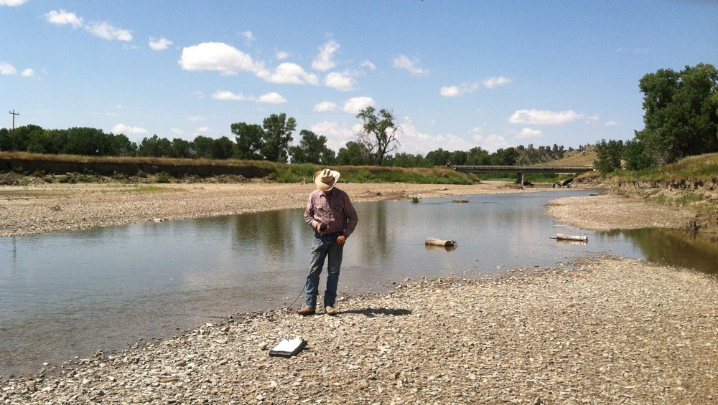

Revised 3/13/2019

Prepared by Brian Hauschild, Mitchell Hoffman, Andrew Horvath, John Lange, Travis Wilson, Matthew Schmidt, David Stout, Robby Robertson, Luke Stappler with the Musselshell Watershed Coalition and the Big Sky Watershed Corps

With support from Adam Sigler, Katie Kaylor, Erin Wall, and Claire Bickford of MSU Extension Water Quality
Approval Signatures MWC – Laura Nowlin

MDEQ – Darrin Kron

TABLE OF CONTENTS
- INTRODUCTION 3
Project Area Overview 3
Project Goals and Objectives 3
- SAMPLING PROCESS 4
Study Design 4
Sampling Locations (Table 1.) 4
2017 Musselshell Salinity Monitoring Sites 6
Sampling Methods 6
YSI Pro 30 System Specifications (Table 2.) 7
YSI Pro Plus System Specifications (Table 3.) 7
Photo Monitoring Setup 7
Types of Photographs 8
Photograph Metadata 8
- PROJECT TEAM RESPONSIBILITIES 9
- QUALITY ASSURANCE, DATA MANAGEMENT AND COMMUNICATION 10
Quality Assurance 10
Instrument Calibration and Maintenance 10
Training 10
Datasheets and Review 10
Data Entry and Storage 10
Pre/Post Season Checklists 11
- REFERENCES 12
- APPENDICES 13
Appendix (A). – Standard Operating Procedures (SOPs) 13
Appendix (B). – Site Specific Sampling and Analysis Plans (SAPs) 22
Appendix (C). – Site Specific Photo-point Procedures 35
Appendix (D). – Data Sheets 48
Appendix (E). – End of Season Protocol 63
Appendix (F). – Maintenance & Incident Log 64

Introduction

Project Area Overview
The Musselshell River is part of a unique combination of mountain and prairie stream watershed systems located in Central Montana. Originating in the Crazy, Castle, and Little Belt Mountains, the Musselshell flows over 300 miles from its source near Martinsdale, MT to its confluence with the Missouri at Fort Peck Reservoir. Late spring rainfall and snowmelt from the valley's bordering mountain ranges are responsible for the majority of the Musselshell's in-stream flows throughout the year. The 9,500 square mile drainage in the Musselshell encompasses a varied landscape including ponderosa pine woodlands, sagebrush dominated plateaus, short grass prairie, and a thin ribbon of riparian corridor characterized by cottonwood galleries and thickets of willow.
The valley's economy is centered on agriculture with dry-land farming and ranching operations representing the majority of agricultural production. Mineral extraction has also long been present in the valley, namely coal mining in the Bull Mountains south of Roundup, MT. Since the late 19th century, many significant alterations have been made to the Musselshell River floodplain. Most significantly, the now defunct “Milwaukee Road” railway running adjacent to the Musselshell for a large extent of its reach shortened the river's original channel length and prohibited it from accessing its floodplain. Historically, the Mussellshell was commonly dewatered during late summer months due to irrigation withdrawals. In 2011, the Mussellshell River encountered unprecedented flooding (the largest measured flood since recording began in 1946) which saw flows over 15,000 cfs at Roundup and 25,100 cfs at Mosby (Boyd et al. 2012). The biggest flood prior to 2011 saw flows around 9,600 cfs at Roundup. The impact from the flooding drastically changed the geomorphologic conditions and caused extensive damage to infrastructure and property in the river corridor (Boyd et al. 2012).
The Musselshell has been listed on the 303d list of impaired waterbodies by the Montana Department of Environmental Quality (MDEQ) as impaired for alterations to stream-side or littoral vegetation, low flow alterations, nitrogen, phosphorus, substrate alterations and sediment (MDEQ, 2014). The river is not listed as impaired for salinity, but increasing salinity in the lower reaches of the river near and below Melstone is of concern to local irrigators.

Project Goals and Objectives
The goal of this monitoring project is to simultaneously collect credible, useful data while also providing a method for education and outreach about water resources. Salinity, sedimentation/erosion, and weeds have been raised as topics of concern and will be monitored alongside salinity. Salinity is addressed by using specific conductance meters, while erosion/sedimentation and weeds are addressed through photo point monitoring. Monitoring efforts seek to meet the following basic objectives:
  - To collect salinity data that can help inform sustainable irrigation practices. Examples include adjusting the quantity or timing of irrigation sessions, or conducting shoreline or ecological restoration in areas identified as problematic.
  - To collect photo documentation of bank condition changes through time. The emphasis will be placed on sedimentation/erosion and weeds, and could help MWC identify areas in need of shoreline or ecological restoration.
  - To engage local water users in data collection to increase awareness about water quality.
  - To produce locally collected data that can be used in public education efforts to foster stewardship and increase communication about water resources.

Sampling Process

Study Design
Sampling will be conducted on the Musselshell River and one of its tributaries from the confluence of its north and south forks to its confluence with Flatwillow Creek upstream from Fort Peck Reservoir. The tributary, Careless Creek, will be monitored at its confluence with the Musselshell. There will be 12 sites monitored in total. Most sample sites are laid out above and below major points of diversion and confluences; others are laid out above and below human developments. The Musselshell River differs significantly from its upper to lower reaches, transitioning from a mountain to a prairie stream system, with the sites laid out to capture those differences. Proximity of sites to USGS gaging stations was also taken into account, such as the Mosby and Musselshell bridge stations.
Before the start of the sampling season, meters will be calibrated with fresh calibration solution (to be obtained by MWC), then tested together after the sampling season with at least 15 saline solutions ranging from 500-5000 μS/cm to confirm that the probes stay within a 5% margin of error. Volunteers will receive training from the volunteer coordinator. Sample collection will occur twice per month within a 3-day window and will bracket the irrigation season to the degree possible. The volunteer will let the coordinator know if they will not be able to take a sample within the 3-day window. Ideally, sampling will occur during the first and third weeks of the month starting in mid-April and ending mid-October. If possible, higher frequency sample collection, especially during or after storm events, will be encouraged. Volunteers will conduct data collection with meters and cameras provided by the MWC. The volunteer coordinator will maintain contact with these volunteers throughout the season to ensure timely collection of measurements and photo data.
Data will be managed via paper records completed on site, and an online database to be updated immediately after site visit. Data sheets will be collected, scanned, and stored by MWC at the end of the monitoring season. All meters will be collected and recalibrated at the end of each sampling season. Online data will be corrected for any possible calibration drift. Hard copies of data will be stored by MWC for a minimum of five years.

Sampling Locations (Table 1.)
Site # | Site Name/Site ID | Lat/Long | Site Description | Sampler | Notes
1 | Musselshell at Two Dot  Bridge | 46.430172 | Musselshell River at NW side of bridge leading into Two Dot from Harlowton | Craig (last name removed for web) | Represents water quality flowing out of Martinsdale  reservoir.
 | MWC_MSSL_TwoDot | -110.072134
2 | Musselshell East of  Harlowton | 46.425111 | Musselshell River at SW side of bridge downstream from Harlowton | Craig (last name removed for web) | Represents water quality downstream of  Harlowton, MT.
 | MWC_MSSL_EHarlow | -109.799982
3 | Musselshell Above  Careless Confluence | 46.293983 | Musselshell River south of Ryegate near city water building | Leon (last name removed for web) | Representative of Musselshell before the Careless Creek confluence.
 | MWC_MSSL_Abv-  Careless | -109.25867
4 | Musselshell Below Careless Confluence | 46.3151 | Musselshell River downstream from Careless Creek, just off of the parking area south of the Hwy on the north side  of the river | Leon (last name removed for web) | Musselshell where Careless Creek, Deadman’s, and Barber Canal water returns to the  stream.
 | MWC_MSSL_Blw- Careless | -109.183957

Site # | Site Name/Site ID | Lat/Long | Site Description | Sampler | Notes
5 | Careless Creek at Musselshell  Confluence | 46.315299 | Careless Creek just above confluence of Musselshell River on the NW side of the Hwy | Leon (last name removed for web) | Deadman’s basin water reaching Musselshell mixed with more saline Careless Creek  water.
 | MWC_Careless_Abv- Mssl | -109.185769
6 | Musselshell at Hwy 87  Bridge near Roundup | 46.427732 | Musselshell River at NW side of Hwy 87 Bridge on north side of the river just  west of Roundup | Donna (last name removed for web) | Upstream of Roundup.
 | MWC_MSSL_Round-  upHwy87 | -108.570852
7 | Musselshell at County  Road 4 Bridge | 46.446475 | Musselshell at County Road number 4 bridge east of Roundup on the  northeast corner of bridge | Donna (last name removed for web) | Downstream from Roundup Lagoons.
 | MWC_MSSL_CoRd4 | -108.512595
8 | Musselshell at Bridge  at Musselshell | 46.519962 | Musselshell River at bridge north of Musselshell town on the south side of river | Ken (last name removed for web) | Quality of water going into south and north of canal of Delphia/  Melstone Canals.
 | MWC_MSSL_Mussel- shell | -108.091637
9 | Musselshell Above Melstone South Canal  Return | 46.720 | Musselshell River above Delphia/Melstone South Canal at SW side of the county bridge | Ken (last name removed for web) | Quality above confluence.
 | MWC_MSSl_Abv-  MelCanal | -107.8225183
10 | Musselshell Below  Melstone South Canal Return | 46.725532 | Musselshell River below confluence with Delphia/Melstone South Canal | Ken (last name removed for web) | Represents quality of river water after mixing with Canal water.
 | MWC_MSSL_Blw-  MelCanal | -107.8275953
11 | Musselshell Above  Flatwillow Creek | 46.918315 | Musselshell at Woodford ranch above Flatwillow Creek on south side of the river | Brian Hauschild | River above Flatwillow Creek. Potentially lots of alkaline inflow between here and  Delphia.
 | MWC_MSSL_Abv- Flatwillow | -107.927954
12 | Musselshell Below  Flatwillow Creek | 46.948842 | Musselshell at Rowton Ranch below Flatwillow Creek | Brian Hauschild | Represents water quality post Flatwillow and  irrigation returns.
 | MWC_MSSL_Blw-  Flatwillow | -107.913507

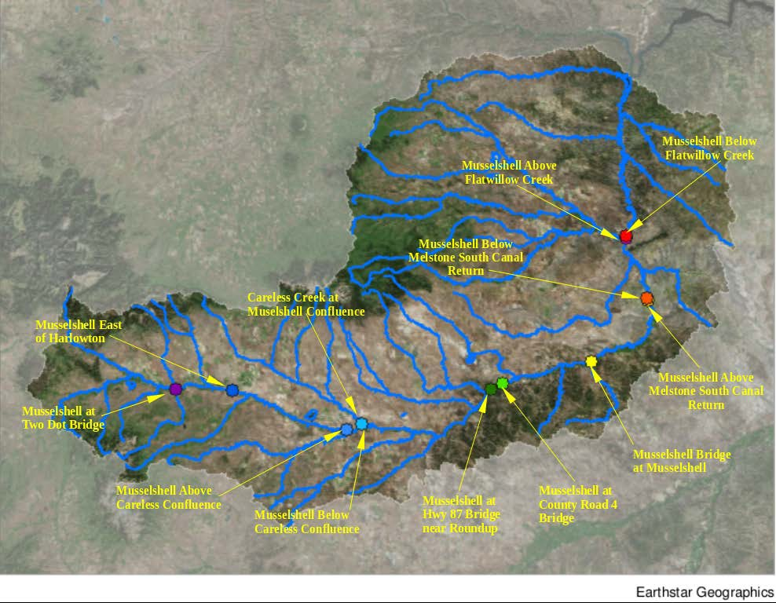
2020 Musselshell Salinity Monitoring Sites

Sampling Methods

Sampling will be conducted for in-stream temperature and electrical conductivity with four YSI Pro 30 multi-meters and one YSI Pro Plus multi-meter. Photo-point photographs will be documented at each sample site using a digital camera. Each of these methods will be conducted in accordance with SOPs outlined in the appendices. A data sheet will be filled out at each site during each monitoring period. Site locations will be corroborated using the site list and photos in Appendix A and/or a GPS. The GPS coordinate system datum will be NAD 1983 State Plane Montana, in decimal degrees to at least the fourth decimal. Data collection will be supplemented by use of discharge from USGS gaging stations within the reach and sediment load reduction analyses will quantify stream bank changes over time. The Musselshell River Distribution Project and the Musselshell Watershed Coalition use the gaging stations extensively. Sites were chosen in part because of their proximity to these established gaging stations.

YSI Pro 30 System Specifications (Table 2.)

 | Sensor Type | Range | Accuracy | Resolution
Conductivity (mS, μS) | Four- electrode cell | 0 to 200 mS/cm (auto range) | 1- or 4-m cable, ±1.0% of the reading or 1.0 μS/cm, whichever is greater  10-, 20-, or 30-m cable, ±2.0% of the reading or 1.0 μS/cm, whichever is greater | 0.0001 to 0.1 mS/cm (range dependent)
Temperature | Thermistor | -5 to +55°C (23 to 131°F) | ±0.2°C | 0.1°C

YSI Pro Plus System Specifications (Table 3.)

 | Sensor Type | Range | Accuracy | Resolution | Units | Calibration
Conductivity | Four electrode cell | 0 to 200 mS/cm (auto range) | ±0.5% of reading or 0.001 mS/cm, whichever is greater (1-, 4-m cable) ±1% of reading or 0.001 mS/cm, whichever is greater (20-m cable) | 0 to 0.500 mS/cm =  0.001  0.501 to 50.00 mS/cm = 0.01  50.01 to 200 mS/cm  = 0.1  (range dependent) | µS, mS | 1 point
Temperature |  | -10 to 100.00°C | ±0.2% FS ±1 digit | 0.1°C | °C, °F, K

Photo Monitoring Setup
Landscape photographs can offer a qualitative and, in some situations, quantitative evaluation of the current and trending conditions in a watershed or on a waterbody when cross referenced with more concrete information such as bankfull dimensions. The details contained within photographs provide insight into a number of ecological parameters and environmental conditions that can be logistically challenging to measure, thus making photo monitoring cost effective. The parameters and conditions that can be documented with photographs range from stream bank erosion and riparian vegetation regeneration to assessing restoration effectiveness and consequences of natural disasters. If repeated for sufficient period of time, these photos can be used to evaluate resource conditions over time and help inform management decisions. Modern camera technology is inexpensive, widely available, and simple to operate. In addition to

being valuable pieces of scientific data, photographs can also be used in reports and presentations as a powerful tool to explain what is going on in the field.

Types of Photographs
- Photo-points
Photo-points are photographs that are taken at a specific location to address a specific objective. These photographs will always be taken from the same position and oriented in the same direction with the same vertical angle. The goal is to recreate the same scene within the picture to track changes through time. Camera operators must take extra precaution when taking photo-points to ensure they are in the correct location and are pointing the camera in the correct direction, as well as recording the necessary information about the photograph (metadata).
- Supplementary Photos
Supplementary photos can be taken of features or evidence of activity within the stream and riparian area that are either unusual or of interest. These photos do not need to be taken in any particular position, but should be documented with the same information (metadata) used with the photo- points. In the extreme case of an extraordinary finding, such as Bigfoot, GPS coordinates should be recorded in the photo description section of the datasheet. Examples of supplementary photos include:

- Evidence of flood damage | - Irrigation structure damage
- Invasive plants | - Turbidity events
- Unidentifiable plants or animals | - Trash dumps
- Extreme erosion | - Happy volunteers

Photograph Metadata
For long term monitoring, it is critical to document factors about the photograph that are not contained within the picture. Some metadata should be recorded when sending photographs to the monitoring coordinator.
The following information should be recorded with all photo-points and supplementary photographs:

- Photo file name (.jpeg) – to be recorded when saving photos to flash drive
- Date and time when photograph was taken
- Name of photographer
- Location (site and stream)
- Description of photograph
- Examples
o Musselshell River, looking upstream at site MWC_MSSL_CoRd4 showing bank erosion due to flooding.

Project Team Responsibilities

Person | Role | Probe | Contact Info | Responsibilities
Brian Hauschild BSWC 2020 | Volunteer Coordinator | LMCD 2 | PetroleumBSWCtwo@macdnet.org | Ensure field sheets are complete and accurate. Publish and compile salinity and photo-point data.  Manage GIS database. Author preliminary and final reports on  monitoring program.
 |  |  | Office: (406) 429-6646 ext. 105
 |  |  | Cell: (603) 724-8007
Claire Bickford and Adam Sigler | Technical Assistance | N/A | ExtensionWater@montana.edu | Assistance with SAP/SOP modifications when necessary.
 |  |  | asigler@montana.edu
 |  |  | (406) 994-7381
Leon (last name removed for web) | Volunteer | LMCD 4 | Removed for web version | Take salinity measurements and photos points
 |  |  | Removed for web version | (See Table 1. for  locations)
Craig (last name removed for web) | Volunteer | LMCD 1 | Removed for web version | Take salinity measurements and photo points
(See Table 1. for
locations)
Donna (last name removed for web) | Volunteer | LMCD 3 | Removed for web version | Take salinity measurements and photo points
 |  |  | Removed for web version | (See Table 1. for  locations)
Ken (last name removed for web) | Volunteer | ProPlus | Removed for web version | Take salinity measurements and photo points
(See Table 1. for
locations)

Quality Assurance, Data Management and Communication
Quality Assurance
Data needs to accurately represent the conditions in the watershed in order to be informative. Quality Assurance (QA) is a system used to ensure that data is of sufficient quality to be useful for the intended purpose. This includes having protocols in place, ensuring people are properly trained and following protocols, making sure meters are calibrated, ensuring datasheets are filled out correctly, and entering data into a database for long term storage.

Instrument Calibration and Maintenance
Volunteer coordinator will calibrate instruments at the beginning and at the end of the sampling season. Any anomalies in calibration will be addressed by correcting the season’s data in linear fashion. Instruments will be cleaned and maintained during winter storage in the Winnett field office.

Training
The volunteer coordinator will be trained by MSUEWQ on instrument calibration, use of field meters, and data management. The volunteer coordinator will subsequently train the volunteers on use of instruments and data management including updating the online database and collection of photo point data.

Datasheets and Review
Datasheets for specific conductance and photos are completed in the field and maintained by volunteers. The volunteer coordinator will collect hard copies of datasheets from volunteers at the conclusion of the sampling season and will review them for completeness. Issues with datasheet completeness will be addressed with the volunteers.

Data Entry and Storage
Volunteers will input data and upload photos using their provided user account on the MSUEWQ volunteer monitoring web portal, found at:

(http://django.msu.montana.edu/msuewq/entry/login/?next=/msuewq/entry/)

At least one face-to-face meeting between volunteers and coordinator is necessary during the field season. Data sheets will be saved by volunteers for collection at the season’s completion, and volunteers are encouraged to save backups of site photos in case of online database issues. Specific conductance and temperature data will be plotted as time series in our online database which will be updated in real time (as entries are made) to track the behavior of salinity through time at the different locations on the river. An excel worksheet will be updated at the end of the sampling season by the volunteer coordinator will house all calibration and all collected salinity, temperature, and photo data. At the end of the monitoring season (in October), all data will be checked for completeness and accuracy, and presented to the MWC group.

Pre/Post Season Checklists:
At the end of each year, the program coordinator will fill out an annual data collection summary. This will include information about how many measurements were taken at each site, instrument calibration anomalies, how many photos were taken, etc.

Pre-Season Checklist:

- Read Appendix G for instructions from previous BSWC member
- Update SAP/SOP/Site-Specific SAP.
- Purchase calibration solution and new batteries for probes.
- Calibrate probes and log calibration information.
- Produce volunteer folders with SAP, Site-Specific SAP, and datasheets.
- Recruit/train volunteers.
- Distribute probes/folders.
- Take measurements on sediment load calculations.

Post-Season Checklist:

- Collect probes, datasheets, and photopoints from volunteers.
- File datasheets, organize photopoints, and store probes safely.
- Produce post-season report.

References

Boyd et al. 2012. Musselshell River Flood Rehabilitation River Assessment Triage Team (RATT) Summary Report. July 17, 2012.

Montan a Department of Environmental Quality. 2005. Quality Assurance Project Plan (QAPP) Sampling and Water Quality Assessment of Streams and Rivers in Montana Revision 03. Helena, MT: Montana Dept. of Environmental Quality. May 2005. Available at:
https://deq.mt.gov/Portals/112/Water/WQPB/QAProgram/Documents/PDF/WQPBQAP-02.pdf

Montana Department of Environmental Quality. 2012. Planning Prevention and Assistance Division, Water Quality Planning Bureau, Water Quality Standards Section. DEQ-7 Montana Numeric Water Quality Standards. Helena, MT: Montana Dept. of Environmental Quality. Available at: https://deq.mt.gov/Portals/112/Water/WQPB/Standards/PDF/DEQ7/FinalApprovedDEQ7.pdf

Montana Department of Environmental Quality. 2012. Water Quality Planning Bureau Field Procedures Manual for Water Quality Assessment Monitoring Version 3.0. Helena, MT: Montana Dept. of Environmental Quality. Available at: https://deq.mt.gov/Portals/112/Water/WQPB/QAProgram/Documents/PDF/SOPs/WQPBWQM-020.pdf

Montana Department of Environmental Quality. 2014. Clean Water Act Information Center. Musselshell River AUID MT40A001_020 assessment summary. Available at: https://iaspub.epa.gov/waters10/attains_waterbody.control?p_list_id=MT40A001_020&p_cycle=2014

Suplee, M.W., and V. Watson, 2013. Scientific and Technical Basis of the Numeric Nutrient Criteria for Montana’s Wadeable Streams and Rivers—Update 1. Helena, MT: Montana Dept. of Environmental Quality. Available at: https://deq.mt.gov/Portals/112/Water/WQPB/Standards/PDF/ScienceTech2013FNLcom.pdf

Appendices

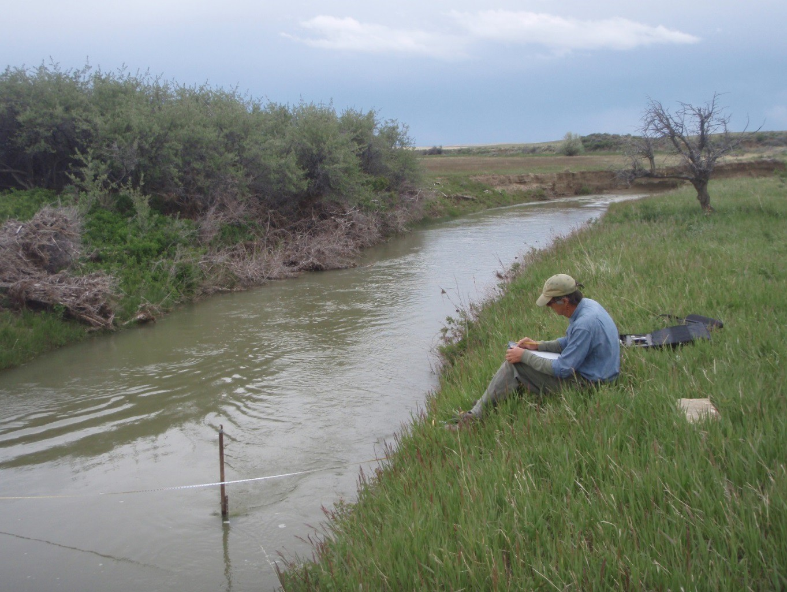
Appendix (A). – Standard Operating Procedures (SOPs)
Revised on 3/13/2020
Prepared by:
Brian Hauschild, BSWC Member
Mitch Hoffman, former BSWC Member
Andrew Horvath, WWF, former BSWC Member
Travis Wilson, Sun River Watershed Coordinator, former BSWC Member David Stout, former MWC Project Coordinator, former BSWC Member William Robertson, MSU Extension Water Quality, former BSWC Member Adam Sigler, MSU Extension Water Quality, Water Quality Associate Specialist Katie Kaylor, MSU Extension Water Quality, Research Associate
Luke Stappler, former MWC Project Coordinator; former BSWC Member

Contents
Introduction 15
Measuring Salinity with the YSI Pro30 15
Photo Point Monitoring 17
YSI Pro30 Calibration Instructions 18
YSI Pro 30 and Pro Plus: Information, Usage, and Maintenance 19
YSI Pro30 Care Instructions 20

Introduction
This document outlines data collection methods for salinity and photo point monitoring for the Musselshell Watershed Coalition’s Water Quality Volunteer Monitoring Program. Original efforts began in 2009 on Careless Creek, where trained members of the community collected a suite of water quality data. In 2013, the volunteer program was revamped and only required volunteers to collect salinity and photo point data along the Musselshell River. This was coordinated by Big Sky Watershed Corp members David Stout in 2013, Luke Stappler in 2014, Matthew Schmidt in 2015, Travis Wilson in 2016, John Lang in 2017, Andrew Horvath in 2018, Mitch Hoffman in 2019, and Brian Hauschild in 2020. Technical assistance was provided by MSU Extension Water Quality.

Measuring Salinity with the YSI Pro30
Unlike other water quality parameters, the conductivity sensor of the YSI Pro30 meter will provide readings that equilibrate quickly. The sensor must be fully submerged in a well circulated section of the steam with no air bubbles trapped in the space between the sensor’s anode and cathode. In addition to regular calibration, the sensor should be cleaned occasionally to maintain accuracy and increase the responsiveness.
The following steps should be followed when taking a conductivity measurement with the YSI Pro30:

  - Plug connecting cable into the YSI handheld meter

  - Turn on the device by selecting the white power button

  - In a well circulated section of stream, fully submerge the meter into the water

    - Be sure you are downstream of the sensor to avoid influencing the measurements

    - Initially agitate the sensor to release any air bubbles, and then leave it undisturbed to facilitate equilibration
  - An auto-stabilize function is function on each field meter to minimize drift during equilibration. After the sensor has been equilibrating for at least 5 minutes, look to see if the conductivity measurement is accompanied by the ‘AS’ symbol (indicating the measurement has stabilized). If so, record the following on the next available row on the data sheet:
    - Date

    - Time

    - Specific Conductivity Reading

    - Temperature Reading

  - Once the instrument has equilibrated and the data sheet has been properly filled out, remove the device from the stream.
  - Shut down and properly store the device.

  - Check the data sheet for completion.

- 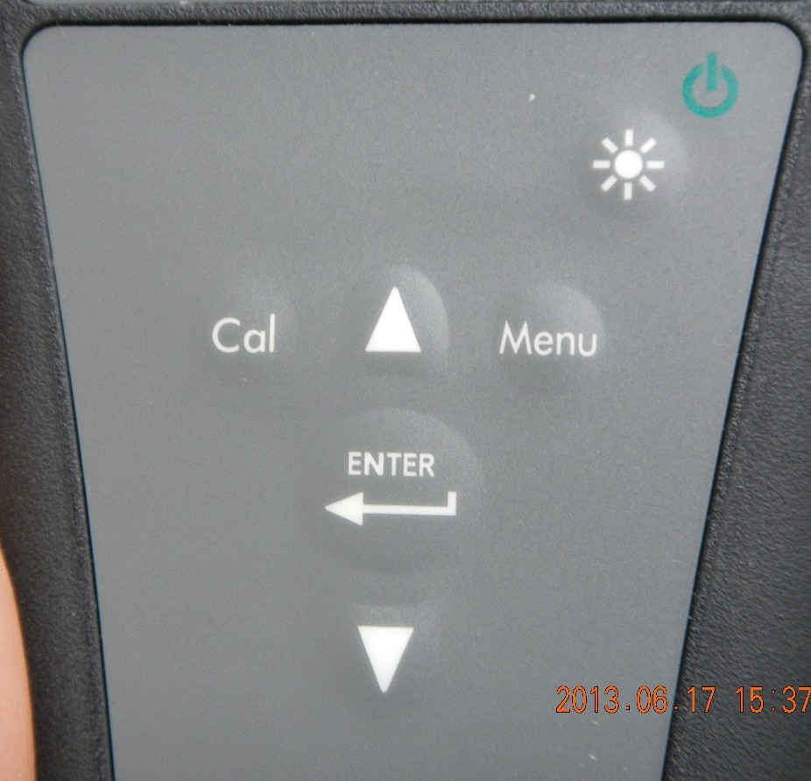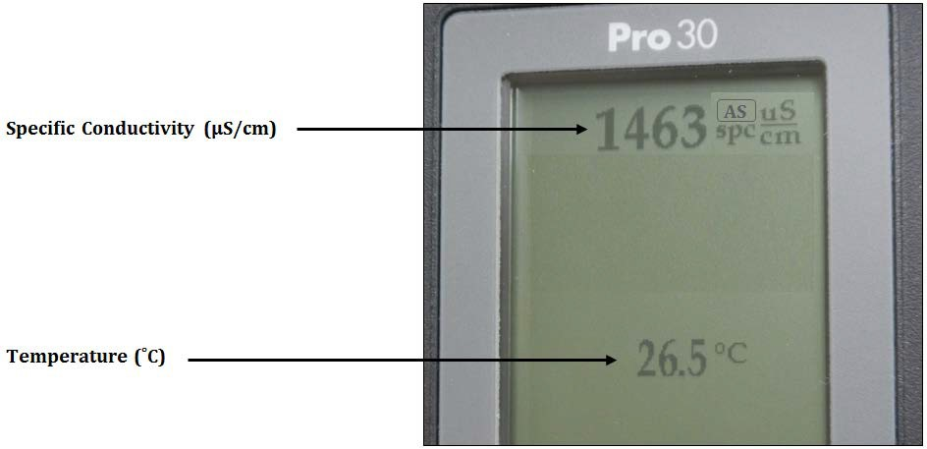Power and Backlight: press once to turn on instrument. Press a second time to turn
1
backlight on. Press a third time to turn
backlight off. Press and hold for three seconds to turn off instrument
2

- Up Arrow: use to navigate through menus,
to navigate through box options along the 3 4
bottom of the Run screen and to increase numeric inputs
- Calibrate: Press and hold for three 5
seconds to calibrate. Opens calibrate menus from the run screen
- Menu: use to enter the system setup 6
menus from the Run screen
- Enter: press to confirm entries and selection
- Down Arrow: use to navigate through menus, to navigate through box options along the bottom of the Run screen and to decrease numeric inputs

Photo-point monitoring
Equipment list:
  - Camera.
  - Photo-monitoring SAP.
  - Extra batteries (or ensure battery is charged beforehand).
  - Timepiece (or ensure camera's internal time/date is accurate beforehand).
  - Photo data sheets.
  - Any necessary camera stabilization tripod or staff (used at volunteer's discretion).
  - Dry erase whiteboard or laminated sheet of white paper.
  - Dry erase marker.

Considerations When Taking Photographs

For the entire duration of the stream photograph documentation project, always take photo-points from established sites at the same location with identical vertical angles, and definitive feature(s). Multiple photo-points may be taken at a selected monitoring site. Upon arrival a monitoring site, refer to Appendix (C): Site Specific Photo-point Procedures for instructions on what specific photo-points are to be taken at each site. Supplementary photographs can be taken at the photographer’s specific discretion.
Once at a monitoring site, the following steps should be performed:

  - Confirm you are at the correct location with either existing marker (on the landscape such as steel fence post) or with GPS.
  - Locate the definitive feature for the given photo-point and correctly align the feature within the camera’s view.
  - Take a photograph.
  - With digital cameras, confirm photograph is as close to a complete duplication as possible to the original photograph.
  - Record the appropriate metadata on the datasheet.

YSI Pro30 Calibration Instructions
Adapted from YSI Pro30 User Manual
The following instructions should be used for calibrating the YSI Pro30 in lieu of YSI’s provided instructions. Subtle amendments have been made to the calibration process, which are not outlined in YSI’s guidance manual. Temperature calibration is not required for the YSI Pro30.
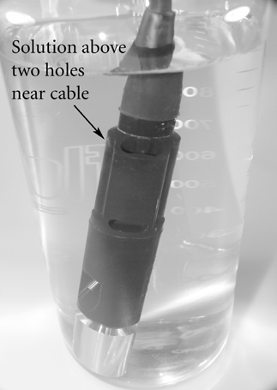
Calibration of field meters should be performed once at the beginning of the year by the volunteer coordinator. Follow the steps below to calibrate conductivity on the YSI
Pro30:
- Replace all batteries in the YSI Pro30 and Pro30 Plus.

- Clean the probe with tap water and pipe cleaners as outlined in the Temperature Sensor Maintenance and Conductivity Sensor Maintenance sections.

- Rinse the probe with used calibration solution (preferably KCl 1413 us/cm) to avoid contamination of conductivity standard.
- Fill a clean container (glass beaker, graduated cylinder) with fresh conductivity calibration solution and place the sensor into the solution. The solution must cover the holes of the conductivity sensor that are closest to the cable (figures at right). Ensure the
entire conductivity sensor is submerged in the solution or the instrument will read approximately half the expected value. Gently move the probe up and down to remove any air bubbles from the conductivity sensor.
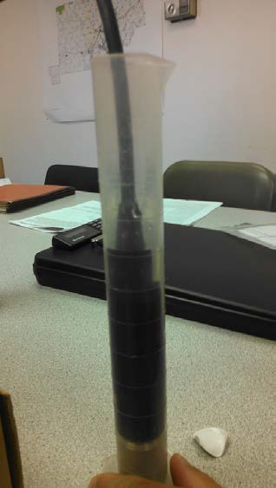
- Turn the instrument on and allow the conductivity and temperature readings to stabilize. Record the conductivity measurement (prior to calibration) in the calibration
log.

- Press and hold the Cal key for 3 seconds. Highlight Specific Conductivity and press enter.
- Highlight uS/cm and press enter. Next, use the up or down arrow key to adjust the value on the display to match the value of the conductivity calibration solution. This value will always be 1413. The Pro30 will remember the entered calibration value and display it the next time a conductivity calibration is performed.
- After 3 seconds press enter to complete the calibration. Or, press Cal to cancel the calibration and return to the Run screen. ‘Calibration Successful’ will display for a few seconds to indicate a successful calibration and then the instrument will return to the Run screen. If the calibration is unsuccessful, an error message will display on the screen. Press the Cal key to exit the calibration error

message and return to the Run screen.

- Empty the used calibration solution into the rinse vessel so the solution can be recycled.

YSI Pro 30 and Pro Plus: Information, Usage, and Maintenance
The collection of water quality data will be conducted using the YSI Pro30 and the YSI Pro Plus. Both instruments are handheld meters encased in impact resistant and waterproof cases. Each meter features a rugged cable connector that is linked to one or more probes. When submerged in water, the probe(s) will measure the water quality parameter it is able to detect.
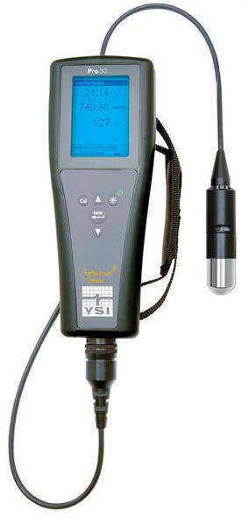The YSI Pro30 measures electrical conductivity and temperature. The meter’s computer uses these values to calculate specific conductivity, salinity, and total dissolved solids.
YSI Pro30
It’s important to be able to make the distinction between what is being measured and what is being calculated. The calculated values require the use of user-selectable coefficients, constants, and reference temperatures. For the purposes of this project, the default coefficients and constants will be used. Submitting grab samples to a lab can be done to determine the relationship between electrical conductivity and the calculated parameters, and thus, the ideal coefficients and constants for the Musselshell. Default values and conversion equations are as follows:
- Specific conductance (SPC) default reference temperature = 25˚C

- Specific conductance default temperature coefficient = 1.91%

  - Specific conductance (25˚C) = Electrical Conductivity

1 + 0.0191 * (T – 25)

- Total dissolved solid default constant = 0.65

  - TDS (mg/L) = SPC (µS/cm) * 0.65

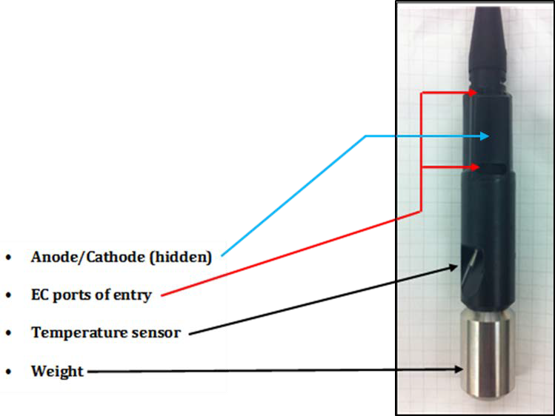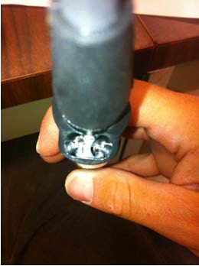The YSI Pro Plus is more versatile with a 4-port probe, which measures temperature, electrical conductivity, dissolved oxygen, pH, oxidation reduction potential, ammonium,
chloride, and nitrate. Volunteers will use the YSI Pro30’s and the project coordinator will use the Pro Plus when a larger suite of water quality parameters are needed. Information on using the Pro Plus is not included in this document.
Looking down at the probe’s anode and cathode

Musselshell Watershed Coalition Sampling and Analysis Plan Page 20

YSI Pro30 Care Instructions
- Temperature Sensor Maintenance
The sensor must be inspected before use to ensure that is it free of debris and build up. A toothbrush can be used to clean the sensor if necessary.
- Conductivity Sensor Maintenance
The access ports that allow stream water access to the conductivity electrodes need to be inspected and cleaned regularly. Over time, deposits can form on the electrodes and affect the readings on the meter. This build up will be uncommon when conducting measurement in snowmelt fed mountain streams, but expected in prairie streams with elevated levels of salt and other dissolved solids. A small pipe cleaning brush can be used to gently clean the meters electrodes. In the event that deposits need to be removed, mild detergent should be used. Rinse thoroughly with clean water, then check the response and accuracy of the probe with calibration solution.
- Short and Long Term Storage
  - For both short and long term storage, the conductivity sensor should be stored clean and dry. Do not allow the probe to sit for long periods with deposits built up on the electrodes.
  - For short term storage and during transportation, the meter should be kept in a closed protective case (pelican case).
  - Remove batteries from the instruments when storing for long periods of time (>30 days)

  - Long term storage temperature: -5 to 70 ˚C (23 to 158 ˚F)

  - During long term storage, the meter’s dry case should be kept open to eliminate humidity.

Appendix (B). – Site Specific Sampling and Analysis Plans (SAPs)
(Note: Open the proceeding slide objects in Powerpoint for editing and/or printing by right clicking and selecting “slide object,” then “open.”)

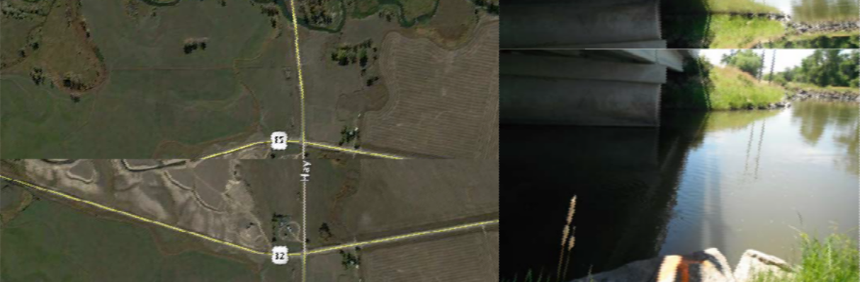

Directions: Take Hwy 12 west from Harlowton. Travel about 12 miles and turn left (south) on Two Dot Hwy (the town of Two Dot turn off). Continue to the bridge, and park at pullout next to bridge.
Access & Monitoring: River access and sampling site is at the northwest side of the bridge. This reach is frequently de-watered in the late-summer months and flows are highly influenced by discharge from the nearby Martinsdale Reservoir. Monitoring access is just under bridge.

SITE ID:
MWC_MSSL_TwoDot

LAT/LONG: 46.430172, -110.072134

Musselshell Watershed Coalition Salinity Monitoring Site #1: Musselshell At Two Dot Bridge
2020 sampling dates:
Apr. 21-23 Jun. 02-04
May 05-07 Jun. 16-18
May 19-21 Jun. 30-Jul. 02
Jul. 14-16
Jul. 28-30
Aug. 11-13
Aug. 25-27
Sep. 08-10
Sep. 22-24
Oct. 06-08
SAFETY is our priority. If you cannot safely approach the river to take measurements, DO NOT SAMPLE. Call your volunteer coordinator to let MWC know conditions are unsafe and note it on your data sheet.
Thank you for participating in your local watershed! PLEASE REMEMBER TO UPLOAD YOUR DATA immediately @:
http://django.msu.montana.edu/msuewq/entry/login/?next=/msuewq/entry/

USERNAME: PASSWORD:

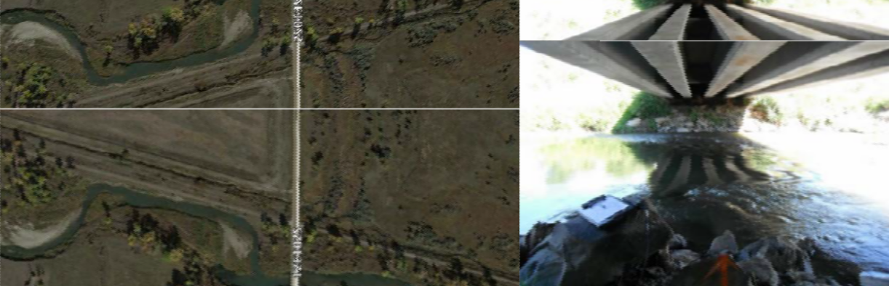

Directions: Take Hwy 12 east from Harlowton. Turn right (south) on Red Bridge Rd (at sewer lagoons) and continue to the bridge, and park at pullout next to bridge.
Access & Monitoring: River access is off bridge to the south west. Reach frequently becomes de-watered in the late-summer months. Monitoring is just under bridge.

SITE ID:
MWC_MSSL_EHarlow

LAT/LONG: 46.425111, -109.799982

Musselshell Watershed Coalition Salinity Monitoring Site #2: Musselshell East of Harlowton

2020 sampling  Apr. 21-23  May 05-07  May 19-21 | dates:  Jun. 02-04  Jun. 16-18  Jun. 30-Jul. 02 | Jul. 14-16  Jul. 28-30  Aug. 11-13 | Aug. 25-27  Sep. 08-10  Sep. 22-24 | Oct. 06-08
SAFETY is our priority. If you cannot safely approach the river to take measurements, DO NOT SAMPLE. Call your volunteer coordinator to let MWC know conditions are unsafe and note it on your data sheet.
Thank you for participating in your local watershed! PLEASE REMEMBER TO UPLOAD YOUR DATA immediately @:
http://django.msu.montana.edu/msuewq/entry/login/?next=/msuewq/entry/

USERNAME: PASSWORD:

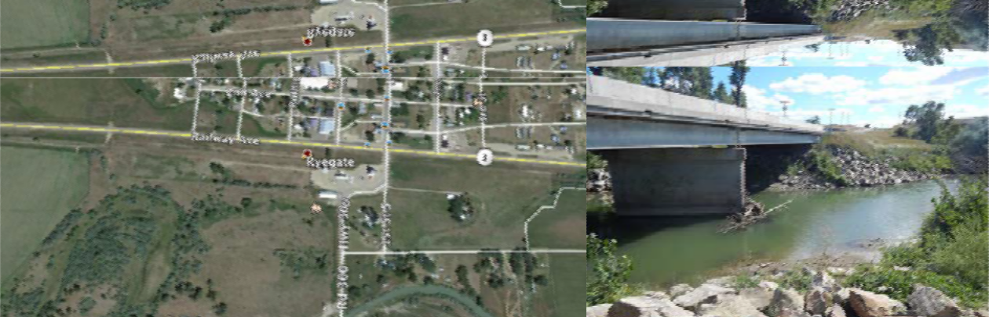

Directions: From Ryegate, head south on 1st St S, follow the curve to the right, and park in front of the water building before the bridge. The monitoring site is immediately upstream from the bridge.
Access & Monitoring: This sampling site is upstream from the Careless Creek confluence just south of Ryegate. It represents the water quality of the Musselshell River before the discharges from Careless Creek. It is beneath the bridge south of Ryegate near the city water building.

SITE ID:
MWC_MSSL_AbvCareless

LAT/LONG: 46.293983, -109.25867

Musselshell Watershed Coalition Salinity Monitoring Site #3: Musselshell Above Careless Confluence

SAFETY is our priority. If you cannot safely approach the river to take measurements, DO NOT SAMPLE. Call your volunteer coordinator to let MWC know conditions are unsafe and note it on your data sheet.
Oct. 06-08
Aug. 25-27
Sep. 08-10
Sep. 22-24
Jul. 14-16
Jul. 28-30
Aug. 11-13
2020 sampling dates:
Apr. 21-23 Jun. 02-04
May 05-07 Jun. 16-18
May 19-21 Jun. 30-Jul. 02
Thank you for participating in your local watershed! PLEASE REMEMBER TO UPLOAD YOUR DATA immediately @:
http://django.msu.montana.edu/msuewq/entry/login/?next=/msuewq/entry/

USERNAME: ___________________ PASSWORD: ___________________

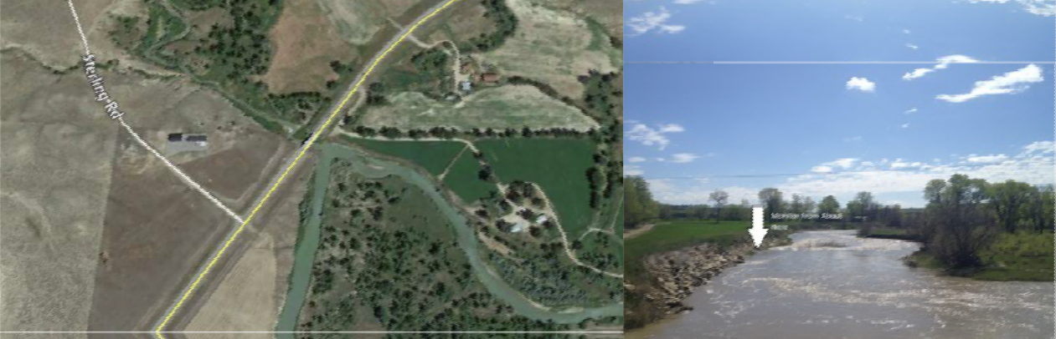

Directions: From Ryegate, drive approximately five miles east to the bridge just after Sterling Rd. Pull into the dirt drive immediately after the bridge on the right, and park in the small dirt pullout to the right of the gate. To walk into the monitoring site, cross the barbed wire at the Hwy and walk down the rip rap or on top of the bank to the site.
Access & Monitoring: Access is downstream (east) from Careless Creek, just off the parking area south of the highway on the north side of the river. This site monitors the water returning to the Musselshell from Deadman's basin. Receives discharge from Careless, Deadman's, and Barber Canal.

2020 sampling  Apr. 21-23  May 05-07  May 19-21 | dates:  Jun. 02-04  Jun. 16-18  Jun. 30-Jul. 02 | Jul. 14-16  Jul. 28-30  Aug. 11-13 | Aug. 25-27  Sep. 08-10  Sep. 22-24 | Oct. 06-08
SAFETY is our priority. If you cannot safely approach the river to take measurements, DO NOT SAMPLE. Call your volunteer coordinator to let MWC know conditions are unsafe and note it on your data sheet.
Thank you for participating in your local watershed! PLEASE REMEMBER TO UPLOAD YOUR DATA immediately @:
SITE ID:
MWC_MSSL_BlwCareless

LAT/LONG: 46.3151, -109.183957

Musselshell Watershed Coalition Salinity Monitoring Site #4: Musselshell Below Careless Confluence
http://django.msu.montana.edu/msuewq/entry/login/?next=/msuewq/entry/

USERNAME: ___________________ PASSWORD: ___________________

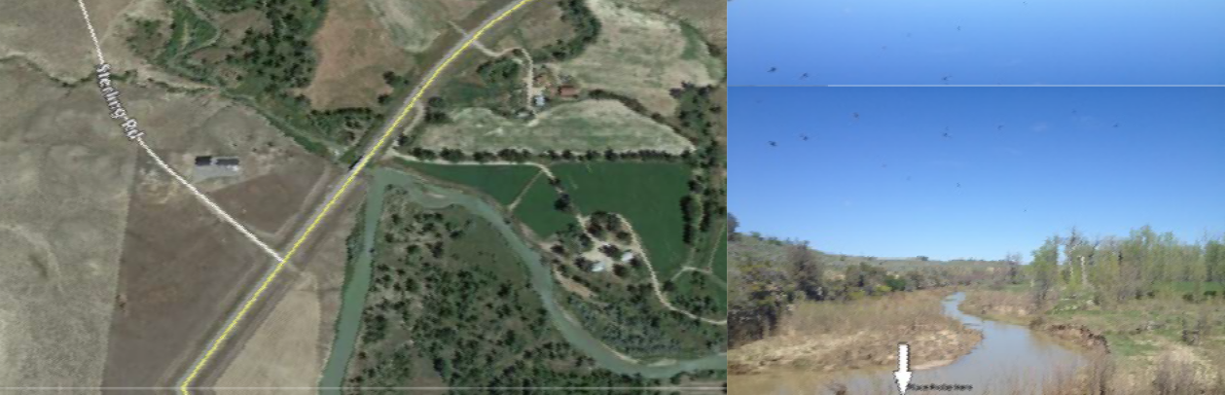

Directions: From Ryegate, drive approximately five miles east to the bridge just after Sterling Rd. Pull into the dirt drive immediately after the bridge on the right, and park in the small dirt pullout to the right of the gate. Cross barbed wire fence from south side of the highway. Walk under the bridge and open fence at loose panel held on by piece of wire. Walk to site from there.
Access & Monitoring: This site monitors Careless Creek at the highway just above its confluence with the Musselshell.

SITE ID:
MWC_Careless_AbvMssl

LAT/LONG: 46.315299, -109.185769

Musselshell Watershed Coalition Salinity Monitoring Site #5: Careless Creek at Musselshell Confluence

2020 sampling  Apr. 21-23  May 05-07  May 19-21 | dates:  Jun. 02-04  Jun. 16-18  Jun. 30-Jul. 02 | Jul. 14-16  Jul. 28-30  Aug. 11-13 | Aug. 25-27  Sep. 08-10  Sep. 22-24 | Oct. 06-08
SAFETY is our priority. If you cannot safely approach the river to take measurements, DO NOT SAMPLE. Call your volunteer coordinator to let MWC know conditions are unsafe and note it on your data sheet.

Thank you for participating in your local watershed! PLEASE REMEMBER TO UPLOAD YOUR DATA immediately @:
http://django.msu.montana.edu/msuewq/entry/login/?next=/msuewq/entry/

USERNAME: ___________________ PASSWORD: ___________________

Musselshell Watershed Coalition Salinity | SITE ID:  MWC_MSSL_RoundupHwy
Monitoring Site #6: Musselshell at Hwy | 87
87 Bridge near Roundup | LAT/LONG: 46.427732, -108.570852

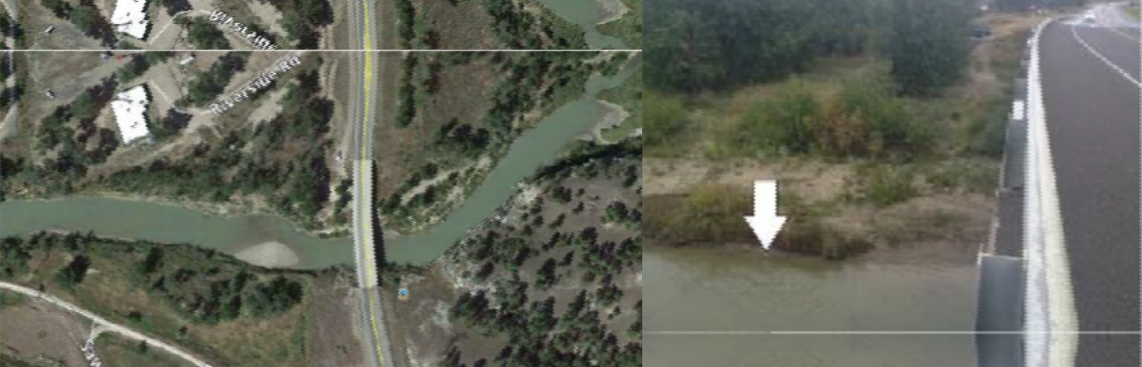Directions: From Roundup, drive 2 miles south to the Hwy 87s bridge, and pull off on the road immediately before the bridge on the right side of road. Turn left on the dirt road that runs parallel to the Hwy. Park, walk down, and monitor upstream from the bridge.
Access & Monitoring: River access is on the north west side of the bridge over Hwy 87. Site is close to private property. This site is upstream of Roundup.
Monitoring should be done upstream of the bridge and not under it to avoid inaccurate in-stream temperature readings.

2020 sampling  Apr. 21-23  May 05-07  May 19-21 | dates:  Jun. 02-04  Jun. 16-18  Jun. 30-Jul. 02 | Jul. 14-16  Jul. 28-30  Aug. 11-13 | Aug. 25-27  Sep. 08-10  Sep. 22-24 | Oct. 06-08
SAFETY is our priority. If you cannot safely approach the river to take measurements, DO NOT SAMPLE. Call your volunteer coordinator to let MWC know conditions are unsafe and note it on your data sheet.
Thank you for participating in your local watershed! PLEASE REMEMBER TO UPLOAD YOUR DATA immediately @:
http://django.msu.montana.edu/msuewq/entry/login/?next=/msuewq/entry/

USERNAME: ___________________ PASSWORD: ___________________

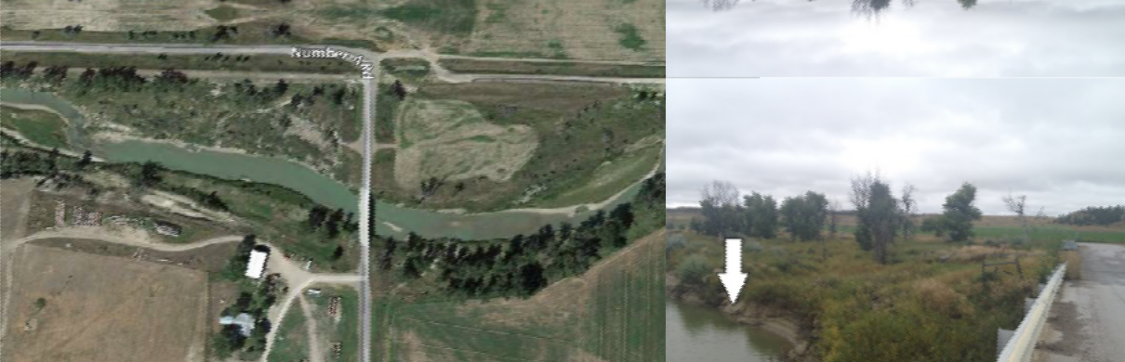

Directions: In Roundup, head east on 2nd Ave East until it forks. Take #4 Rd (the left fork) until the bridge over the Musselshell (approximately 2 miles). Park in the pull off on the right before the bridge. Enter through the barbed wire fence on the same side, and walk to the site. Monitor approximate 20 feet upstream from the bridge.
Access & Monitoring: Access is on the northeast end of the bridge over the Musselshell. Monitoring site is on the north side of the river. Access is made somewhat difficult by cattle fence. Monitoring should be done upstream of the bridge and not under it to avoid inaccurate in- stream temperature readings.

SITE ID: MWC_MSSL_CoRd4

LAT/LONG: 46.446475, -108.512595

Musselshell Watershed Coalition Salinity Monitoring Site #7: Musselshell at County Road 4 Bridge
2020 sampling  Apr. 21-23  May 05-07  May 19-21 | dates:  Jun. 02-04  Jun. 16-18  Jun. 30-Jul. 02 | Jul. 14-16  Jul. 28-30  Aug. 11-13 | Aug. 25-27  Sep. 08-10  Sep. 22-24 | Oct. 06-08
SAFETY is our priority. If you cannot safely approach the river to take measurements, DO NOT SAMPLE. Call your volunteer coordinator to let MWC know conditions are unsafe and note it on your data sheet.
Thank you for participating in your local watershed! PLEASE REMEMBER TO UPLOAD YOUR DATA immediately @:
http://django.msu.montana.edu/msuewq/entry/login/?next=/msuewq/entry/

USERNAME: PASSWORD:

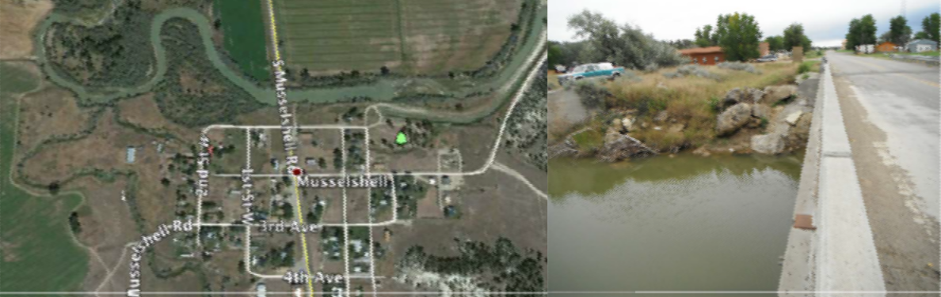

Directions: Musselshell Bridge - Take Hwy 12 east from Roundup to the Musselshell turnoff.
Continue towards Musselshell and cross the Musselshell River on the bridge. On the south side of the river to the left there is a parking spot. Park here.
Access & Monitoring: Musselshell River at bridge north of Musselshell is accessible from the bridge to the south east. This site monitors the quality of water going into the north and south canals. Monitoring should take place on the south bank of the river and should not take place under the bridge.

SITE ID:
MWC_MSSL_Musselshell

LAT/LONG: 46.519962, -108.091637

Musselshell Watershed Coalition Salinity Monitoring Site #8: Musselshell at Bridge at Musselshell

SAFETY is our priority. If you cannot safely approach the river to take measurements, DO NOT SAMPLE. Call your volunteer coordinator to let MWC know conditions are unsafe and note it on your data sheet.
Oct. 06-08
Aug. 25-27
Sep. 08-10
Sep. 22-24
Jul. 14-16
Jul. 28-30
Aug. 11-13
2020 sampling dates:
Apr. 21-23 Jun. 02-04
May 05-07 Jun. 16-18
May 19-21 Jun. 30-Jul. 02
Thank you for participating in your local watershed! PLEASE REMEMBER TO UPLOAD YOUR DATA immediately @:
http://django.msu.montana.edu/msuewq/entry/login/?next=/msuewq/entry/

USERNAME: ___________________ PASSWORD: ___________________

SITE ID:
MWC_MSSl_AbvMelCanal

LAT/LONG: 46.720, -107.8225183

Musselshell Watershed Coalition Salinity Monitoring Site #9: Musselshell Above Melstone South Canal Return

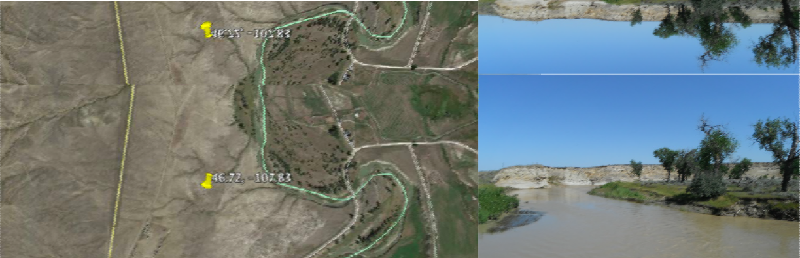Directions: Return to Hwy 12 from Musselshell and head east. Go past the town of Melstone about a mile and turn north onto Hwy 500. After about 8 miles you will find a county road that goes east. It is almost to the end of the pavement. If you leave the pavement you have gone too far. After you head east you will find a bridge that crosses the Musselshell River. Park on the east side of the bridge and monitor.
SAFETY is our priority. If you cannot safely approach the river to take measurements, DO NOT SAMPLE. Call your volunteer coordinator to let MWC know conditions are unsafe and note it on your data sheet.
Oct. 06-08
Aug. 25-27
Sep. 08-10
Sep. 22-24
Jul. 14-16
Jul. 28-30
Aug. 11-13
2020 sampling dates:
Apr. 21-23 Jun. 02-04
May 05-07 Jun. 16-18
May 19-21 Jun. 30-Jul. 02
Access & Monitoring: The monitoring site is on the shore off the left side of this picture, just down from the bridge. Monitor water quality on the Musselshell above Delphia/Melstone South Canal.

Thank you for participating in your local watershed! PLEASE REMEMBER TO UPLOAD YOUR DATA immediately @:
http://django.msu.montana.edu/msuewq/entry/login/?next=/msuewq/entry/

USERNAME: PASSWORD:

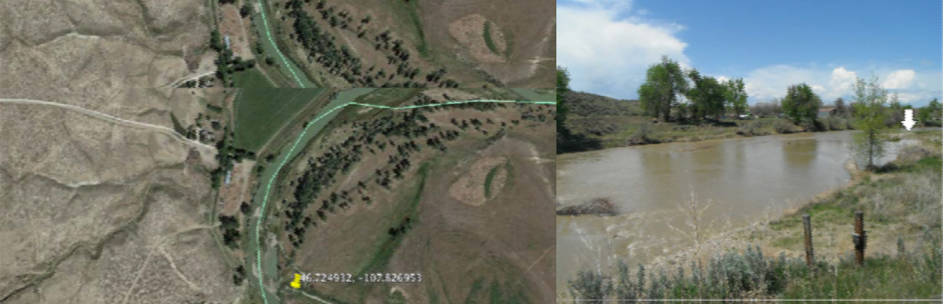
SITE ID:
MWC_MSSL_BlwMelCanal

LAT/LONG: 46.725532, -107.8275953

Musselshell Watershed Coalition Salinity Monitoring Site #10: Musselshell Below Melstone South Canal Return

Directions: Continue east about ¼ mile from the “above Melstone canal” location. There will be an old feedlot on your left. Turn into feedlot and go north through the feedlot until you come to the gate/fence. Turn left toward the river. Just before you reach the river take the dirt road to your right. Travel downstream along the river ¼ of a mile until you reach the South Canal. Park here.
Access & Monitoring: Monitor at approximately where the arrow is. It’s on the same side of the river as the photo point. Site monitors water quality on the Delphia/Melstone South Canal above its confluence with the Musselshell.

SAFETY is our priority. If you cannot safely approach the river to take measurements, DO NOT SAMPLE. Call your volunteer coordinator to let MWC know conditions are unsafe and note it on your data sheet.
Oct. 06-08
Aug. 25-27
Sep. 08-10
Sep. 22-24
Jul. 14-16
Jul. 28-30
Aug. 11-13
2020 sampling dates:
Apr. 21-23 Jun. 02-04
May 05-07 Jun. 16-18
May 19-21 Jun. 30-Jul. 02
Thank you for participating in your local watershed! PLEASE REMEMBER TO UPLOAD YOUR DATA immediately @:
http://django.msu.montana.edu/msuewq/entry/login/?next=/msuewq/entry/

USERNAME: ___________________ PASSWORD: ___________________

Musselshell Watershed Coalition Salinity | SITE ID:  MWC_MSSL_AbvFlat-
Monitoring Site #11: Musselshell Above | willow
Flatwillow Creek | LAT/LONG: 46.918315, -107.927954

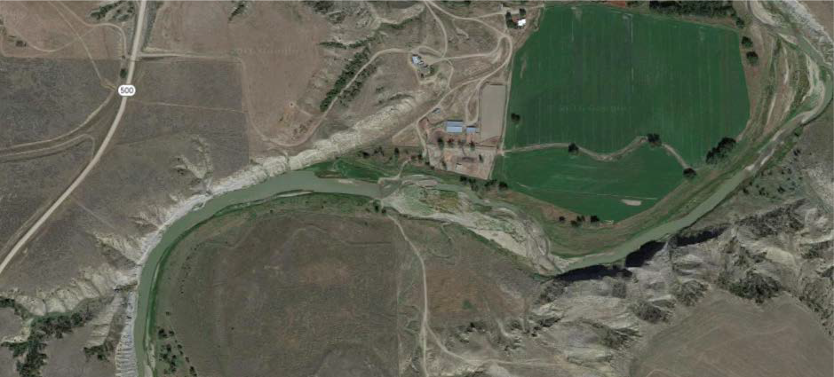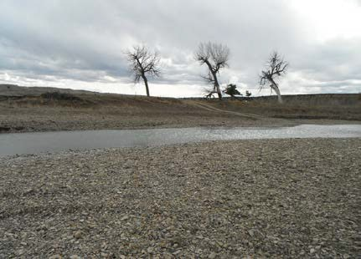Directions: From Hwy 200, turn south on Hwy 500/Melstone Rd. and drive approximately 5 miles. Turn left at the sign for the Woodford Ranch, and follow the road that curves to the right along the base of the hill past where the house is located. The road will take you past a pen and stables, and will curve around the right side of these to a gate. Drive through the gate and continue about 300 feet to the low water crossing. Monitor and take photo points there.

Access & Monitoring: Monitor near the water crossing anywhere there is sufficient depth and flow. The river is somewhat shallow in this stretch, so your exact sampling spot may change each time depending on the water level. Site is located on the Musselshell above its confluence with Flatwillow Creek.

SAFETY is our priority. If you cannot safely approach the river to take measurements, DO NOT SAMPLE. Call your volunteer coordinator to let MWC know conditions are unsafe and note it on your data sheet.
Oct. 06-08
Aug. 25-27
Sep. 08-10
Sep. 22-24
Jul. 14-16
Jul. 28-30
Aug. 11-13
2020 sampling dates:
Apr. 21-23 Jun. 02-04
May 05-07 Jun. 16-18
May 19-21 Jun. 30-Jul. 02
Thank you for participating in your local watershed! PLEASE REMEMBER TO UPLOAD YOUR DATA immediately @:
http://django.msu.montana.edu/msuewq/entry/login/?next=/msuewq/entry/

USERNAME: PASSWORD:

Musselshell Watershed Coalition Salinity | SITE ID:  MWC_MSSL_BlwFlat-
Monitoring Site #12: Musselshell Below | willow
Flatwillow Creek | LAT/LONG: 46.948842, -107.913507

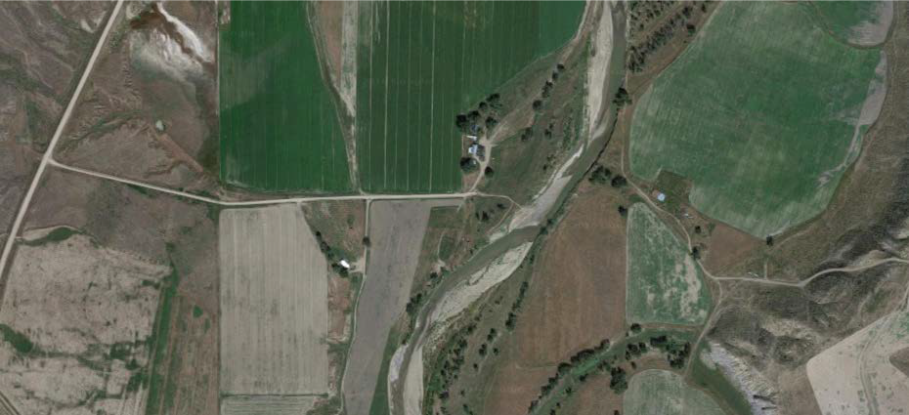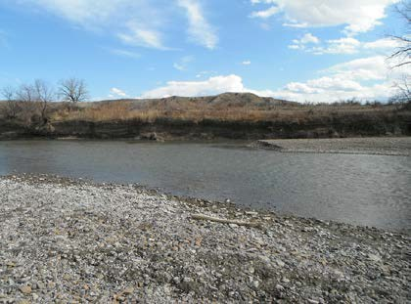Directions: From the Woodford Ranch, return to Hwy 500 and turn north toward Hwy 200. After approximately 1.8 miles, turn right on a dirt driveway and follow it through the Rowton Ranch. Continue straight and go through the barbed wire cattle gate as you get near the river. Park where the road ends at the river.
Access & Monitoring: Walk down water crossing road to the flat pebbly bank.
Monitor downstream of the water crossing anywhere there is sufficient depth and flow. The river is somewhat shallow in this stretch, so your exact sampling spot may change each time depending on the water level. Site is located on the Musselshell below its confluence with Flatwillow Creek.

2020 sampling  Apr. 21-23  May 05-07  May 19-21 | dates:  Jun. 02-04  Jun. 16-18  Jun. 30-Jul. 02 | Jul. 14-16  Jul. 28-30  Aug. 11-13 | Aug. 25-27  Sep. 08-10  Sep. 22-24 | Oct. 06-08
SAFETY is our priority. If you cannot safely approach the river to take measurements, DO NOT SAMPLE. Call your volunteer coordinator to let MWC know conditions are unsafe and note it on your data sheet.
Thank you for participating in your local watershed! PLEASE REMEMBER TO UPLOAD YOUR DATA immediately @:
http://django.msu.montana.edu/msuewq/entry/login/?next=/msuewq/entry/

USERNAME: PASSWORD:

Appendix (C). – Site Specific Photo-point Procedures
(Note: Open the proceeding slide objects in Powerpoint for editing and/or printing by right clicking and selecting “slide object,” then “open.” Slides are still in draft form, but will be finalized once all field visits are complete.)

Musselshell at Two Dot Bridge Photo-point Monitoring Guide

Power
Photo-point location: 46.430260, -110.072192
Figure 1. (top left) Photographer location and position while taking photo-point photograph. Place the camera facing upstream in the rectangle painted on the northwestern bridge foundation to replicate the photo shown in
figure 2.
Figure 2. (middle left) Photo-point taken from position demonstrated in figure 1. Key features must be positioned within the frame as shown here to ensure repeatable photos. In this photo you can also see a fly-fisherman enjoying the river. Feel free to include members of the public recreating on the river.
The volunteer will be provided a white board & dry erase marker. The first photo taken on site will be of the white board with the information displayed in figure 3. (bottom left). Primary photo-point photograph and any supplemental photographs (detailed photos of interesting or significant subjects) will be taken while the salinity sensor is equilibrating. The final photo taken will be of the white board with the information displayed in figure 4. (bottom

pole

Stream bank
Upper 1/3 sky

Feel free to include members of the public if they happen to be in the frame.

Fence
right). These two photos of the white board will bracket all the photos taken during each site visit, which will ease post-season photo file archiving. Be sure your camera's internal time and date settings are accurate so they will match your written notes. Record pertinent data, such as camera used and .jpg #'s on your data sheet. Photos get uploaded to the same website as the salinity data. Upload photo-point photos under the “Repeat photo-point” tab, and any other site photos under the “General site photos” tab.

Photo tips: Look at photos from previous site visits to refresh your memory on what the photo-point should look like. Use the same camera every time. Do not zoom in.

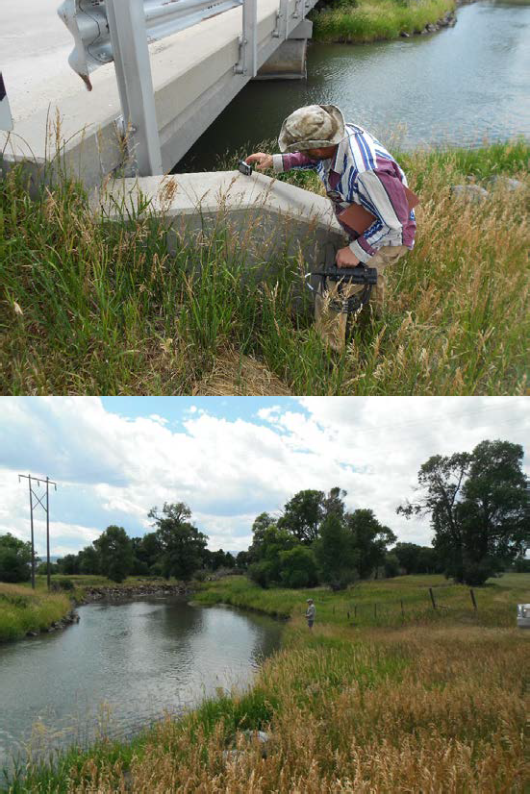Musselshell Salinity MWC_MSSL_TwoDot mm/dd/yyyy Volunteer name
Start: hh:mm AM/PM

First photo

Last photo
Musselshell Salinity MWC_MSSL_TwoDot mm/dd/yyyy
Volunteer name End: hh:mm AM/PM # of photos taken: XX

Musselshell East of Harlowton Photo-point Monitoring Guide

Photo-point location: 46.425053, -109.799826
Figure 1. (top left) Photographer location and position while taking photo-point photograph. Place the camera facing upstream in the rectangle painted on the southwestern bridge foundation to replicate the photo shown in figure 2.
Figure 2. (middle left) Photo-point taken from position demonstrated in figure 1. Key features must be positioned within the frame as outlined and noted here to ensure repeatable photos. Feel free to include members of the public recreating on the river.
Volunteer will be provided a white board & dry erase marker. The first photo taken on site will be of the white board with the information displayed in figure 3. (bottom left). Primary photo-point photograph and any supplemental photographs (detailed photos of interesting or significant subjects) will be taken while the salinity sensor is equilibrating. The final photo taken will be of the white board with the information displayed in figure 4. (bottom right). These two photos of the white board

Larger trees

Bridge foundation
Upper 1/3 sky
will bracket all the photos taken during each site visit, which will ease post-season photo file archiving. Be sure your camera's internal time and date settings are accurate so they will match your written notes. Record pertinent data, such as camera used and .jpg #'s on your data sheet. Photos get uploaded to the same website as the salinity data. Upload photo-point photos under the “Repeat photo-point” tab, and any other site photos under the “General site photos” tab.

Photo tips: Look at photos from previous site visits to refresh your memory on what the photo-point should look like. Use the same camera every time. Do not zoom in.

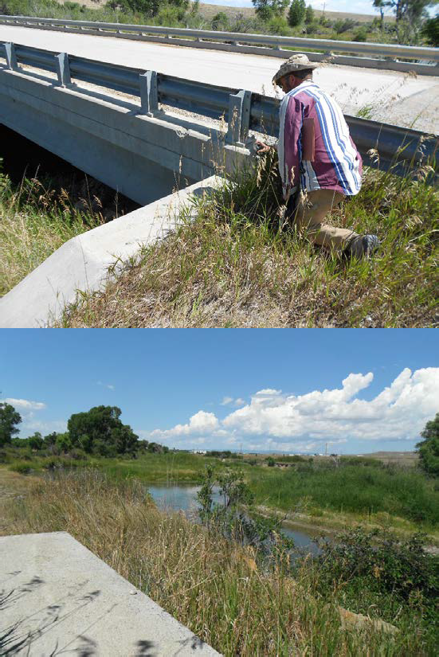Musselshell Salinity MWC_MSSL_EHarlow mm/dd/yyyy
Volunteer name Start: hh:mm AM/PM

First photo

Last photo
Musselshell Salinity MWC_MSSL_EHarlow mm/dd/yyyy
Volunteer name End: hh:mm AM/PM # of photos taken: XX

Musselshell Above Careless Confluence Photo-point Monitoring Guide

Photo-point location: 46.293916, -109.257892

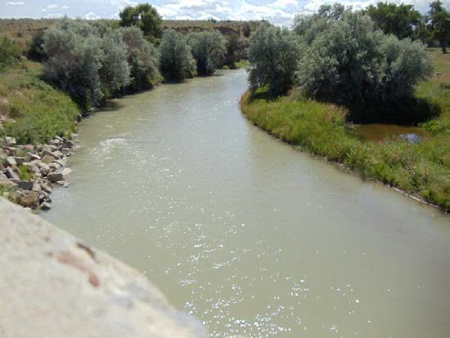Section of sky

Rip Rap

Pond
Figure 1. (top left) Photographer location and position while taking photo-point photograph. Place the camera in the rectangle painted on the western bridge guardrail facing upstream to replicate the photo shown in figure 2.

Figure 2. (middle left) Photo-point taken from position demonstrated in figure 1. Key features must be positioned within the frame as outlined and noted here to ensure repeatable photos. Feel free to include members of the public recreating on the river.

Volunteer will be provided a white board & dry erase marker. The first photo taken on site will be of the white board with the information displayed in figure 3. (bottom left). Primary photo-point photograph and any supplemental photographs (detailed photos of interesting or significant subjects) will be taken while the salinity sensor is equilibrating. The final photo taken will be of the white board with the information displayed in figure 4. (bottom right). These two photos of the white board will bracket all the photos taken during each site visit, which will ease post-season photo file archiving. Be sure your camera's internal time and date settings are accurate so they will match your written notes. Record pertinent data, such as camera used and .jpg #'s on your data sheet. Photos get uploaded to the same website as the salinity data. Upload photo-point photos under the “Repeat photo-point” tab, and any other site photos under the “General site photos” tab.

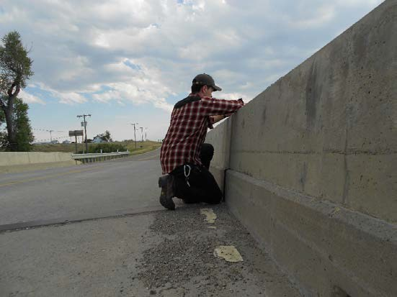
Bridge guard rail

Musselshell Salinity MWC_MSSL_AbvCarless mm/dd/yyyy
Volunteer name Start: hh:mm AM/PM

First photo

Last photo
Photo tips: Look at photos from previous site visits to refresh your memory on what the photo-point should look like. Use the same camera every time. Do not zoom in.

Musselshell Salinity MWC_MSSL_AbvCareless mm/dd/yyyy
Volunteer name End: hh:mm AM/PM # of photos taken: XX

Musselshell Below Careless Confluence Photo-point Monitoring Guide

Photo-point location: 46.315362, -109.185337
Figure 1. (top left) Photographer location and position while taking photo-point photograph. Place the camera in the rectangle painted on the eastern bridge guardrail facing downstream to replicate the photo shown in figure 2.

Figure 2. (middle left) Photo-point taken from position demonstrated in figure 1. Key features must be positioned within the frame as outlined and noted here to ensure repeatable photos. Feel free to include members of the public recreating on the river.

Section of sky

Small island

Bank and vegetation

Russian Olive

Bank and vegetation
Volunteer will be provided a white board & dry erase marker. The first photo taken on site will be of the white board with the information displayed in figure 3. (bottom left). Primary photo-point photograph and any supplemental photographs (detailed photos of interesting or significant subjects) will be taken while the salinity sensor is equilibrating. The final photo taken will be of the white board with the information displayed in figure 4. (bottom right). These two photos of the white board will bracket all the photos taken during each site visit, which will ease post-season photo file archiving. Be sure your camera's internal time and date settings are accurate so they will match your written notes. Record pertinent data, such as camera used and .jpg #'s on your data sheet. Photos get uploaded to the same website as the salinity data. Upload photo-point photos under the “Repeat photo-point” tab, and any other site photos under the “General site photos” tab.

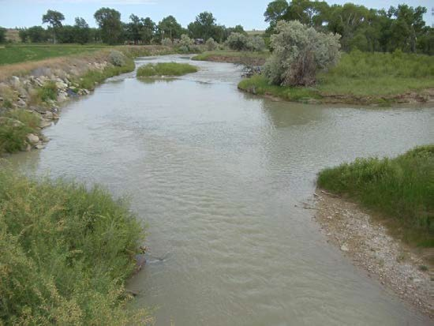Photo tips: Look at photos from previous site visits to refresh your memory on what the photo-point should look like. Use the same camera every time. Do not zoom in.

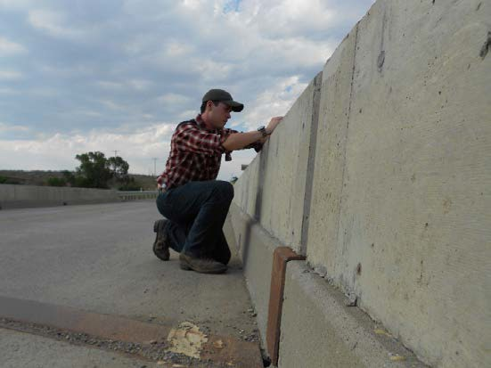Musselshell Salinity MWC_MSSL_BlwCareless mm/dd/yyyy
Volunteer name Start: hh:mm AM/PM

First photo

Last photo
Musselshell Salinity MWC_MSSL_BlwCareless mm/dd/yyyy
Volunteer name End: hh:mm AM/PM # of photos taken: XX

Careless Creek at Musselshell Confluence Photo-point Monitoring Guide

Cut Bank
Photo-point location: 46.315418, -109.185445

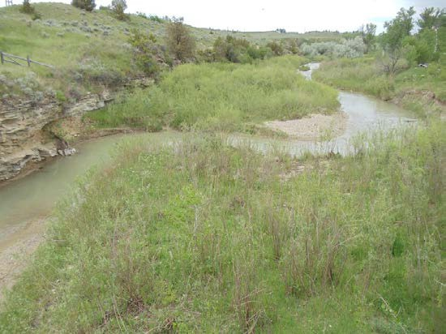Sky

Gravel bar
Figure 1. (top left) Photographer location and position while taking photo-point photograph. Place the camera in the rectangle painted on the western bridge guardrail facing upstream of Careless Creek to replicate the photo shown in figure 2.

Figure 2. (middle left) Photo-point taken from position demonstrated in figure 1. Key features must be positioned within the frame as outlined and noted here to ensure repeatable photos. Feel free to include members of the public recreating on the river.

Volunteer will be provided a white board & dry erase marker. The first photo taken on site will be of the white board with the information displayed in figure 3. (bottom left). Primary photo-point photograph and any supplemental photographs (detailed photos of interesting or significant subjects) will be taken while the salinity sensor is equilibrating. The final photo taken will be of the white board with the information displayed in figure 4. (bottom right). These two photos of the white board will bracket all the photos taken during each site visit, which will ease post-season photo file archiving. Be sure your camera's internal time and date settings are accurate so they will match your written notes. Record pertinent data, such as camera used and .jpg #'s on your data sheet. Photos get uploaded to the same website as the salinity data. Upload photo-point photos under the “Repeat photo-point” tab, and any other site photos under the “General site photos” tab.

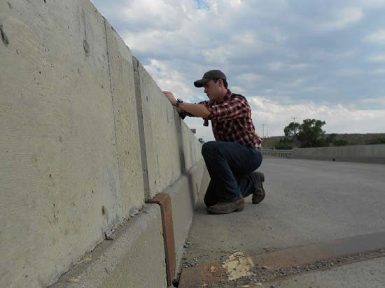Bank line

Musselshell Salinity MWC_Careless_AbvMssl mm/dd/yyyy
Volunteer name Start: hh:mm AM/PM

First photo

Last photo

Photo tips: Look at photos from previous site visits to refresh your memory on what the photo-point should look like. Use the same camera every time. Do not zoom in.

Musselshell Salinity MWC_Careless_AbvMssl mm/dd/yyyy
Volunteer name End: hh:mm AM/PM # of photos taken: XX

Musselshell at Hwy 87 Bridge near Roundup Photo-point Monitoring Guide

Gravel bar
Photo-point location: 46.4278, -108.570266

Arc of sky
Figure 1. (top left) Photographer location and position while taking photo-point photograph. Place the camera in the rectangle painted on the upstream side bridge guardrail and angle it slightly down to replicate photo shown in figure 2.
Figure 2. (middle left) Photo-point taken from position demonstrated in figure 1. Key features must be positioned within the frame as outlined and noted here in order to ensure repeatable photos. Feel free to include members of the
public recreating on the river.
Volunteer will be provided a white board & dry erase marker. The first photo taken on site will be of the white board with the information displayed in figure 3. (bottom left). Primary photo-point photograph and any supplemental photographs (detailed photos of interesting or significant subjects) will be taken while the salinity sensor is equilibrating. The final photo taken will be of the white board with the information displayed in figure 4. (bottom right). These two photos of the white board will bracket all the photos taken during each site visit, which will ease post-season photo file archiving. Be sure your camera's internal time and date settings are accurate so they will match your written notes. Record pertinent data, such

(when visible)

North bank angle
as camera used and .jpg #'s on your data sheet. Photos get uploaded to the same website as the salinity data. Upload photo-point photos under the “Repeat photo-point” tab, and any other site photos under the “General site photos” tab.

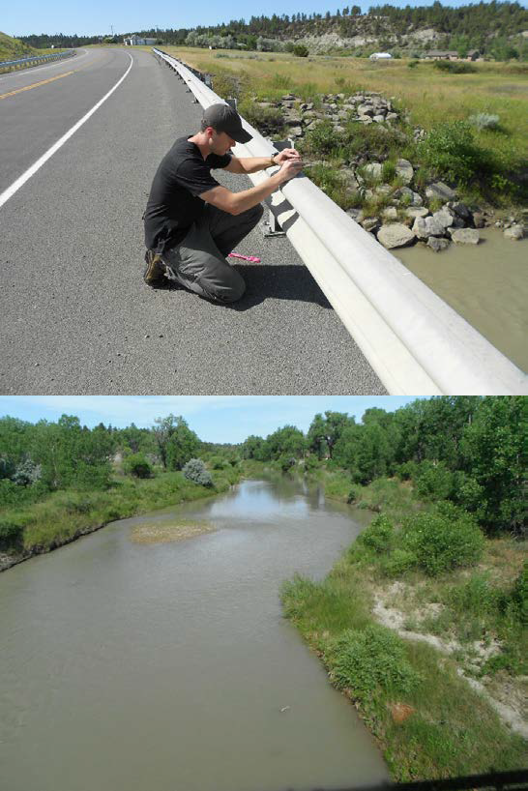

Musselshell Salinity MWC_MSSL_RoundupHwy87 mm/dd/yyyy
Volunteer name Start: hh:mm AM/PM

First photo

Last photo
Photo tips: Look at photos from previous site visits to refresh your memory on what the photo-point should look like. Use the same camera every time. Do not zoom in.

Musselshell Salinity MWC_MSSL_RoundupHwy87 mm/dd/yyyy
Volunteer name End: hh:mm AM/PM # of photos taken: XX

Musselshell at County Road 4 Bridge Photo-point Monitoring Guide

Photo-point location: 46.446583, -108.5125
Figure 1. (top left) Photographer location and position while taking photo-point photograph. Place the camera in the rectangle painted on the upstream side bridge guardrail and angle it slightly down to replicate photo shown in figure 2.
Figure 2. (middle left) Photo-point taken from position demonstrated in figure 1. Key features must be positioned within the frame as outlined and noted here in order to ensure repeatable photos. Feel free to include members of the
public recreating on the river.
Volunteer will be provided a white board & dry erase marker. The first photo taken on site will be of the white board with the information displayed in figure 3. (bottom left). Primary photo-point photograph and any supplemental photographs (detailed photos of interesting or significant subjects) will be taken while the salinity sensor is equilibrating. The final photo
Tree Grouping

Tree Grouping

South bank
Upper 1/5 sky
taken will be of the white board with the information displayed in figure 4. (bottom right). These two photos of the white board will bracket all the photos taken during each site visit, which will ease post-season photo file archiving. Be sure your camera's internal time and date settings are accurate so they will match your written notes. Record pertinent data, such as camera used and .jpg #'s on your data sheet. Photos get uploaded to the same website as the salinity data. Upload photo-point photos under the “Repeat photo-point” tab, and any other site photos under the “General site photos” tab.

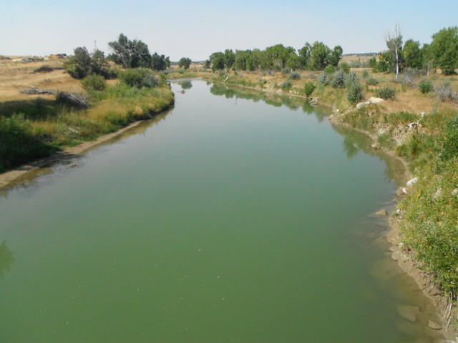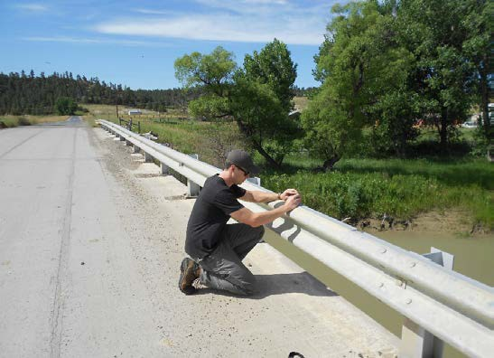

Musselshell Salinity MWC_MSSL_CoRd4
mm/dd/yyyy Volunteer name
Start: hh:mm AM/PM

First photo

Last photo
Photo tips: Look at photos from previous site visits to refresh your memory on what the photo-point should look like. Use the same
camera every time. Do not zoom in.

Musselshell Salinity MWC_MSSL_CoRd4
mm/dd/yyyy Volunteer name
End: hh:mm AM/PM # of photos taken: XX

Musselshell at Bridge at Musselshell Photo-point Monitoring Guide

Photo-point location: 46.520317, -108.091583
Figure 1. (top left) Photographer location and position while taking photo-point photograph. Place the camera in the rectangle painted on the downstream bridge guardrail and point it toward the diversion dam to replicate photo shown in figure 2.
Figure 2. (middle left) Photo-point taken from position demonstrated in figure 1. Key features must be positioned within the frame as outlined and noted here to ensure repeatable photos. Feel free to include members of the public recreating on the river.
Volunteer will be provided a white board & dry erase marker. The first photo taken on site will be of the white board with the information displayed in figure 3. (bottom left). Primary photo-point photograph and any supplemental photographs (detailed photos of interesting or significant subjects) will be taken while the salinity sensor is equilibrating. The final photo taken will be of the white board with the information displayed in figure 4. (bottom
right). These two photos of the white board

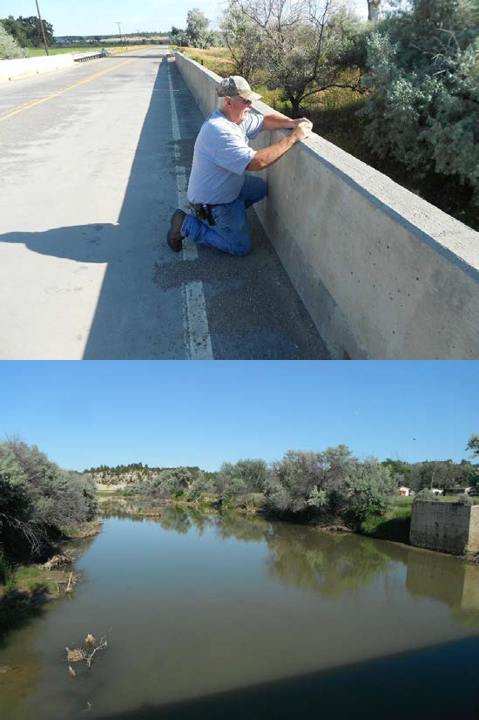Upper 1/3 sky

Musselshell Salinity MWC_MSSL_Musselshell mm/dd/yyyy
Volunteer name Start: hh:mm AM/PM
Mid-frame

Concrete foundation

Mid-frame

First photo

Last photo
will bracket all the photos taken during each site visit, which will ease post-season photo file archiving. Be sure your camera's internal time and date settings are accurate so they will match your written notes. Record pertinent data, such as camera used and .jpg #'s on your data sheet. Photos get uploaded to the same website as the salinity data. Upload photo-point photos under the “Repeat photo-point” tab, and any other site photos under the “General site photos” tab.

Photo tips: Look at photos from previous site visits to refresh your memory on what the photo-point should look like. Use the same camera every time. Do not zoom in.

Musselshell Salinity MWC_MSSL_Musselshell mm/dd/yyyy
Volunteer name End: hh:mm AM/PM # of photos taken: XX

Musselshell Above Melstone South Canal Return Photo-point Monitoring Guide

Photo-point location: 46.719920, -107.822157

Upper 1/3 sky
Figure 1. (top left) Photographer location and position while taking photo-point photograph. Place camera in the rectangle painted on the eastern bridge guardrail facing upstream toward the large cut bank to replicate the photo shown in figure 2.
Figure 2. (middle left) Photo-point taken from position demonstrated in figure 1. Key features must be positioned within the frame as outlined and noted here to ensure repeatable photos. Feel free to include members of the public recreating
on the river.
Volunteer will be provided a white board & dry erase marker. The first photo taken on site will be of the white board with the information displayed in figure 3. (bottom left). Primary photo-point photograph and any supplemental photographs (detailed photos of interesting or significant subjects) will be taken while the salinity sensor is equilibrating. The final photo taken will be of the white board with the information displayed in figure 4. (bottom right). These two photos of the white board will bracket all the photos taken during each site visit, which will ease post-season photo file archiving. Be sure your camera's internal time and date settings are accurate so they will match

Cut bank
Two trees
your written notes. Record pertinent data, such as camera used and .jpg #'s on your data sheet. Photos get uploaded to the same website as the salinity data. Upload photo-point photos under the “Repeat photo-point” tab, and any other site photos under the “General site photos” tab.

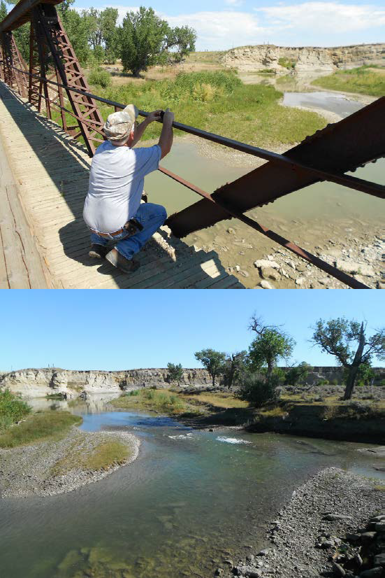
Gravel bar

Musselshell Salinity MWC_MSSL_AbvMelCanal mm/dd/yyyy
Volunteer name Start: hh:mm AM/PM

First photo

Last photo
Photo tips: Look at photos from previous site visits to refresh your memory on what the photo-point should look like. Use the same camera every time. Do not zoom in.

Musselshell Salinity MWC_MSSL_AbvMelCanal mm/dd/yyyy
Volunteer name End: hh:mm AM/PM # of photos taken: XX

Musselshell Below Melstone South Canal Return Photo-point Monitoring Guide

Photo-point location: 46.725019, -107.827087

Upper 1/3 sky

Far bank

Tree

Two posts
Figure 1. (top left) Photographer location and position while taking photo-point photograph. Place camera facing downstream in the rectangle painted on the vertical pipe at the end of the canal to replicate the photo shown in figure 2.
Figure 2. (middle left) Photo-point taken from position demonstrated in figure 1. Key features must be positioned within the frame as outlined and noted here to ensure repeatable photos. Feel free to include members of the public recreating on the river.
Volunteer will be provided a white board & dry erase marker. The first photo taken on site will be of the white board with the information displayed in figure 3. (bottom left). Primary photo-point photograph and any supplemental photographs (detailed photos of interesting or significant subjects) will be taken while the salinity sensor is equilibrating. The final photo taken will be of the white board with the information displayed in figure 4. (bottom right). These two photos of the white board will bracket all the photos taken during each site visit, which will ease post-season photo file archiving. Be sure your camera's internal time and date settings are accurate so they will match your written notes. Record pertinent data, such as camera used and .jpg #'s on your data sheet. Photos get uploaded to the same website as the salinity data. Upload photo-point photos under the “Repeat photo-point” tab, and any other site photos under the “General site photos” tab.

Photo tips: Look at photos from previous site visits to refresh your memory on what the photo-point should look like. Use the same camera every time. Do not zoom in.

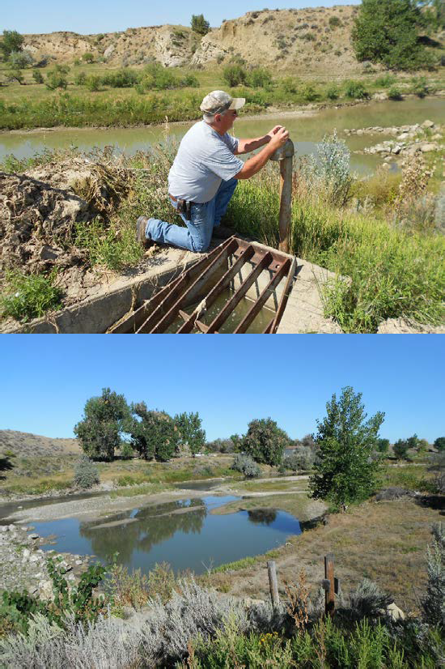Musselshell Salinity MWC_MSSL_BlwMelCanal mm/dd/yyyy
Volunteer name Start: hh:mm AM/PM

First photo

Last photo
Musselshell Salinity MWC_MSSL_BlwMelCanal mm/dd/yyyy
Volunteer name End: hh:mm AM/PM # of photos taken: XX

Musselshell Above Flatwillow Creek Photo-point Monitoring Guide

Photo-point location: 46.918425, -107.928062
Figure 1. (top left) Photographer location on bank. Photographer places a 4 ft. dowel, held plumb, on the rock with the painted circle and points the camera in the direction of the painted arrow to replicate the photo shown in figure 2.
Figure 2. (middle left) Photo-point taken from position demonstrated in figure 1. Key features must be positioned within the frame as outlined and noted here to ensure repeatable photos. Feel free to include members of the public recreating on the river.

Gray dead tree & shed

Upper 1/3 sky

Hill
Volunteer will be provided a white board & dry erase marker. The first photo taken on site will be of the white board with the information displayed in figure 3. (bottom left). Primary photo-point photograph and any supplemental photographs (detailed photos of interesting or significant subjects) will be taken while the salinity sensor is equilibrating. The final photo taken will be of the white board with the information displayed in figure 4. (bottom right). These two photos of the white board will bracket all the photos taken during each site visit, which will ease post-season photo file archiving. Be sure your camera's internal time and date settings are accurate so they will match your written notes. Record pertinent data, such as camera used and .jpg #'s on your data sheet. Photos get uploaded to the same website as the salinity data. Upload photo-point photos under the “Repeat photo-point” tab, and any other site photos under the “General site photos” tab.

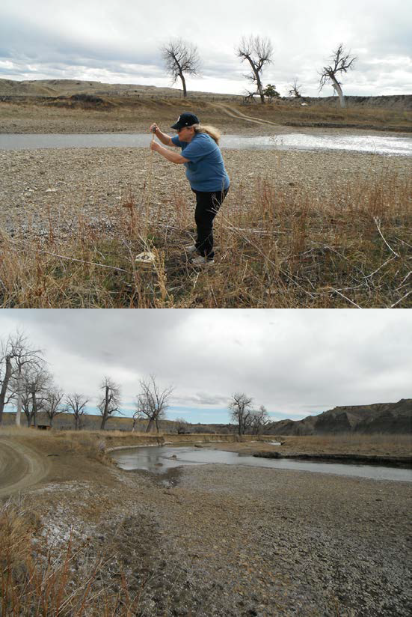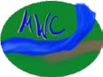

Musselshell Salinity MWC_MSSL_AbvFlatwillow mm/dd/yyyy
Volunteer name Start: hh:mm AM/PM

First photo

Last photo
Photo tips: Look at photos from previous site visits to refresh your memory on what the photo-point should look like. Use the same camera every time. Do not zoom in.

Musselshell Salinity MWC_MSSL_AbvFlatwillow mm/dd/yyyy
Volunteer name End: hh:mm AM/PM # of photos taken: XX

Musselshell Below Flatwillow Creek Photo-point Monitoring Guide

Photo-point location: 46.948836, -107.913864

Upper 1/3 sky
Figure 1. (top left) Photographer location on bank. Photographer places a 4 ft. dowel, held plumb, on the rock with the painted circle and points the camera in the direction of the painted arrow to replicate the photo shown in figure 2.
Figure 2. (middle left) Photo-point taken from position demonstrated in figure 1. Key features must be positioned within the frame as outlined and noted here to ensure repeatable photos. Feel free to include members of the public recreating on the river.
Volunteer will be provided a white board & dry erase marker. The first photo taken on site will be of the white board with the information displayed in figure 3. (bottom left). Primary photo-point photograph and any supplemental photographs (detailed photos of interesting or significant subjects) will be taken while the salinity sensor is equilibrating. The final photo taken will be of the white board with the information displayed in figure 4. (bottom right). These two photos of the white board will bracket all the photos taken during each site visit, which will ease post-season photo file archiving. Be sure your camera's internal time and date settings are accurate so they will match your written notes. Record pertinent data, such as camera used and .jpg #'s on your data sheet.

Four trees Lone tree
Hill
Photos get uploaded to the same website as the salinity data. Upload photo-point photos under the “Repeat photo-point” tab, and any other site photos under the “General site photos” tab.

Bank edge
Stump
Photo tips: Look at photos from previous site visits to refresh your memory on what the photo-point should look like. Use the same camera every time. Do not zoom in.

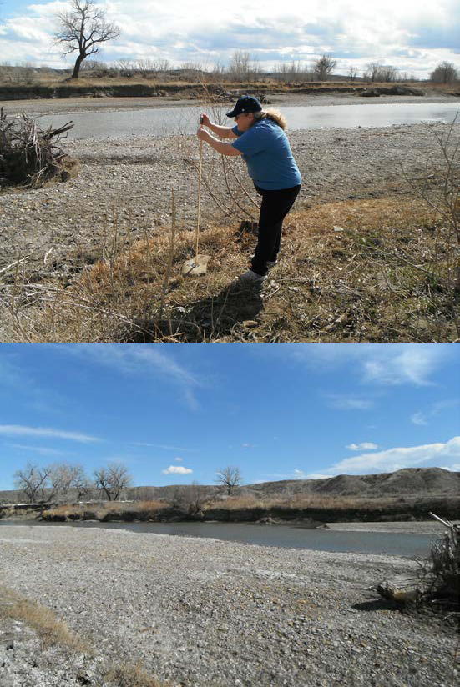Musselshell Salinity MWC_MSSL_BlwFlatwillow mm/dd/yyyy
Volunteer name Start: hh:mm AM/PM

First photo

Last photo
Musselshell Salinity MWC_MSSL_BlwFlatwillow mm/dd/yyyy
Volunteer name End: hh:mm AM/PM # of photos taken: XX

Appendix (D). – Data Sheets
(Note: Open the proceeding word objects for editing and/or printing by right clicking and selecting “document object,” then “open.”)

Site #1:
Musselshell at Two Dot Bridge
2020 Sampling Season

Date (mm/dd/yyyy) | Time (hh:mm) | SC  (μS/cm) | Temperature (°C) | Camera Used (Mfg./model) | Photo JPG #'s
 |  |  |  |  | Start | End

Site #2:
Musselshell East of Harlowton
2020 Sampling Season

Date (mm/dd/yyyy) | Time (hh:mm) | SC  (μS/cm) | Temperature (°C) | Camera Used (Mfg./model) | Photo JPG #'s
 |  |  |  |  | Start | End

Site #3:
Musselshell Above Careless Confluence
2020 Sampling Season

Date (mm/dd/yyyy) | Time (hh:mm) | SC  (μS/cm) | Temperature (°C) | Camera Used (Mfg./model) | Photo JPG #'s
 |  |  |  |  | Start | End

Site #4:
Musselshell Below Careless Confluence
2020 Sampling Season

Date (mm/dd/yyyy) | Time (hh:mm) | SC  (μS/cm) | Temperature (°C) | Camera Used (Mfg./model) | Photo JPG #'s
 |  |  |  |  | Start | End

Site #5:
Careless Creek at Musselshell Confluence
2020 Sampling Season

Date (mm/dd/yyyy) | Time (hh:mm) | SC  (μS/cm) | Temperature (°C) | Camera Used (Mfg./model) | Photo JPG #'s
 |  |  |  |  | Start | End

Site #6:
Musselshell at Hwy 87 Bridge
2020 Sampling Season

Date (mm/dd/yyyy) | Time (hh:mm) | SC  (μS/cm) | Temperature (°C) | Camera Used (Mfg./model) | Photo JPG #'s
 |  |  |  |  | Start | End

Site #7:
Musselshell at County Rd 4 Bridge
2020 Sampling Season

Date (mm/dd/yyyy) | Time (hh:mm) | SC  (μS/cm) | Temperature (°C) | Camera Used (Mfg./model) | Photo JPG #'s
 |  |  |  |  | Start | End

Site #8:
Musselshell at Musselshell Bridge
2020 Sampling Season

Date (mm/dd/yyyy) | Time (hh:mm) | SC  (μS/cm) | Temperature (°C) | Camera Used (Mfg./model) | Photo JPG #'s
 |  |  |  |  | Start | End

Site #9:
Musselshell Above Melstone South Canal Return
2020 Sampling Season

Date (mm/dd/yyyy) | Time (hh:mm) | SC  (μS/cm) | Temperature (°C) | Camera Used (Mfg./model) | Photo JPG #'s
 |  |  |  |  | Start | End

Site #10:
Musselshell Below Melstone South Canal Return
2020 Sampling Season

Date (mm/dd/yyyy) | Time (hh:mm) | SC  (μS/cm) | Temperature (°C) | Camera Used (Mfg./model) | Photo JPG #'s
 |  |  |  |  | Start | End

Site #11:
Musselshell Above Flatwillow Creek
2020 Sampling Season

Date (mm/dd/yyyy) | Time (hh:mm) | SC  (μS/cm) | Temperature (°C) | Camera Used (Mfg./model) | Photo JPG #'s
 |  |  |  |  | Start | End

Site #12:
Musselshell Below Flatwillow Creek
2020 Sampling Season

Date (mm/dd/yyyy) | Time (hh:mm) | SC  (μS/cm) | Temperature (°C) | Camera Used (Mfg./model) | Photo JPG #'s
 |  |  |  |  | Start | End

Photo Metadata
Please record notes and photo information for all site visit photos. Any interesting or significant events/changes to your site should also be photo-documented and noted.
Site |  | Photographer
Date |  | Notes:
Time
Camera
.jpg #

Site |  | Photographer
Date |  | Notes:
Time
Camera
.jpg #

Site |  | Photographer
Date |  | Notes:
Time
Camera
.jpg #

Site |  | Photographer
Date |  | Notes:
Time
Camera
.jpg #

Site |  | Photographer
Date |  | Notes:
Time
Camera
.jpg #

EC Calibration Log Sheets
Date: 3/10/2020
Name: Brian Hauschild
Location (where instrument is being calibrated): NRCS Office Meter#: LMCD 1 Time: 13:30
Cal. Solution Standard |  | Reading Before Calibration |  | Set To |  | Reading After Calibration |  | Expiration Date of Calibration  Solution/Lot # | Temperature of Calibration  Solution
1413 | µS/cm^{c} | 1434 | µS/cm^{c} | 1413 | µS/cm^{c} | 1413 | µS/cm^{c} | 10/30/20 CC17803 | 21.5 | °C

Meter#: LMCD 2 Time: 13:45

Cal. Solution Standard |  | Reading Before Calibration |  | Set To |  | Reading After Calibration |  | Expiration Date of Calibration  Solution/Lot # | Temperature of Calibration  Solution
1413 | µS/cm^{c} | 1395 | µS/cm^{c} | 1413 | µS/cm^{c} | 1413 | µS/cm^{c} | 10/30/20 CC17803 | 22.7 | °C

Meter#: LMCD 3 Time: 14:00

Cal. Solution Standard |  | Reading Before Calibration |  | Set To |  | Reading After Calibration |  | Expiration Date of Calibration  Solution/Lot # | Temperature of Calibration  Solution
1413 | µS/cm^{c} | 1411 | µS/cm^{c} | 1413 | µS/cm^{c} | 1413 | µS/cm^{c} | 10/30/20 CC17803 | 22.1 | °C

Meter#: LMCD 4 Time:14:15

Cal. Solution Standard |  | Reading Before Calibration |  | Set To |  | Reading After Calibration |  | Expiration Date  of Calibration Solution/Lot # | Temperature of  Calibration Solution
1413 | µS/cm^{c} | 1405 | µS/cm^{c} | 1413 | µS/cm^{c} | 1413 | µS/cm^{c} | 10/30/20 CC17803 | 22.1 | °C

Meter#: Plus Time: 14:30

Cal. Solution Standard |  | Reading Before Calibration |  | Set To |  | Reading After Calibration |  | Expiration Date  of Calibration Solution/Lot # | Temperature of  Calibration Solution
1413 | µS/cm^{c} | 1489 | µS/cm^{c} | 1413 | µS/cm^{c} | 1413 | µS/cm^{c} | 10/30/20 CC17803 | 21.7 | °C

Appendix (E). – End of Season Protocol
Salinity Monitoring End of Season Protocol
Musselshell Watershed Coalition
Updated 3 February 2016

In 2015, MWC decided to calibrate at the beginning and end of the season instead of having their volunteers calibrate the meters before sampling. This helped streamline the sampling process for the volunteers, and a protocol was written to assess any differences between the meters and to see if this change made any significant differences in data collection.
The following protocol is to be done by the coordinator at the end of the sampling season.

Determining Drift between Meters
- Assess the condition of meters before any modifications are made. Do not replace batteries unless the meter is completely dead.
- Gather salt and a bucket that is large enough to test all of the meters together. Fill the bucket about halfway with water to ensure that the meters will be submerged.
- Place all meters in tap water at the same time and allow the meters to equilibrate for 10 minutes. Record the values for all meters every few minutes while they are equilibrating.
- Add some salt in a bottle and fill with water. Shake the bottle to dissolve and thoroughly mix the salt. Note: ½ teaspoon of table salt (NaCl) in 1L of tap water from Marsh Labs produces an SC of ~6,900 uS/cm.
- Pour the salt water into the bucket of water. Record the values for all meters every few minutes until the meters have equilibrated.
- Repeat Step 5 two more times.
- Calculate the average SC for the five meters for each time values were recorded.
- Using the average, calculate a relative percent difference (RPD) for each meter.
RPD = (Meter-AVG) x 100 AVG

Calibration Check
- Place each uncleaned meter into fresh calibration solution and record values every few minutes until meters equilibrates.
- Clean each meter with pipe cleaners on the contacts and retest in fresh calibration solution. Record values every few minutes until meters equilibrate.
- Assess drift between the uncleaned and cleaned meter from the calibration solution used at the start of the season by calculating a RPD value. DO NOT recalibrate the probes. This will be done separately during the recalibration process.

Appendix (F). – Maintenance & Incident Log

Date | Event

Appendix (G). – Pre-Season BSWC Protocol
Salinity Monitoring Pre-Season Protocol
Musselshell Watershed Coalition
Updated 10 October 2019

  - Start contacting previous years volunteers in March to confirm they are willing to continue being a volunteer for the 2019 sampling season, they all expressed interest except for Faith, who may or may not be willing to volunteer again
  - Print out Volunteer Service Agreements and have Volunteer Surveys prepared to distribute at the end of the season
  - Purchase calibration fluid (1413 us/cm conductivity standard) as soon as possible to calibrate the YSI meters. The EOY drift assessment is completed, so you just need to calibrate them and organize everything.
  - Distribute the materials to the volunteers the first week of April before the sampling season begins.
  - Sometimes it is difficult to reach the volunteers as they have full-time jobs, so it is important to start trying to contact them early and check in with them on a monthly basis.
  - Donna has asked to move her sampling sites, as the current ones are difficult to get to. Go down and help her find better spots. It doesn’t matter too much where the samples are taken; as long as there is moving water and they aren’t too far away from the current sites (ask Adam if you have any questions). Make sure to document the new sites in SOPs. Do not move her photo points unless it’s a safety concern.
  - If you have time, take a day to visit all the sites before the start of the season. Take photo points and drone shots. This really helped me understand the sites in relation to each other.
  - Scott Graham with the DEQ has offered to lend us a logging probe (Exo Handheld). I envision using this to fill in the gap between Careless and Roundup. Specifically below Painted Robe Creek, but above Currant Creek would be saucy. Sherly from MWC has land there and I’m sure she would love to have a logger out there. It might work best for all parties if you put it at her diversion site so her and her husband can use the data. I think you will only have it for part of the year, I would recommend irrigation season if possible. Work with Sherly (or whomever you deem best) and Scott to make this happen (March would be a good time to make headway on this). Talk with Adam when you see him in February about how to put this new site and parameters (this probe does way more than just salinity) on the website.

